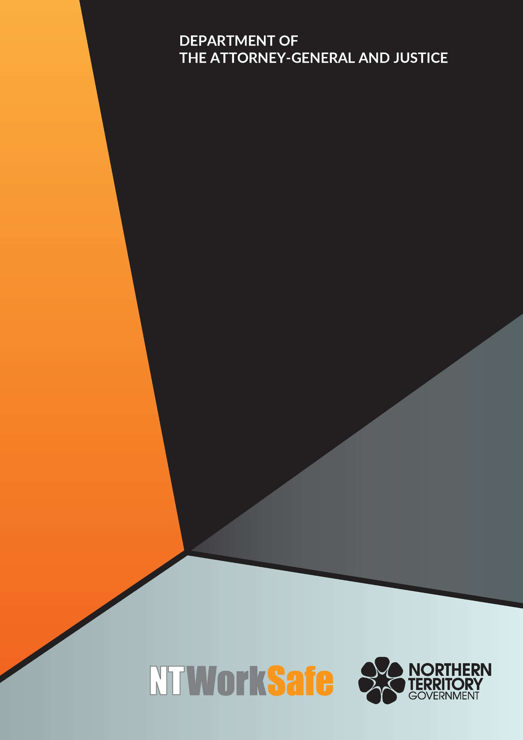
Workers Rehabilitation and Compensation Advisory Council
  - Annual Report
  - 2019-20

Contents
Function and Purpose of the Advisory Council 3
Membership of the Advisory Council 4
Council Members for 2019-2020 4
Activities of the Advisory Council 2019-2020 7
Planned Activities of the Advisory Council for 2020-2021 9

Function and Purpose of the Advisory Council
In accordance with section 9 of the Return to Work Act 1986, the functions of the Council are to:
- keep the operation of the Return to Work Act 1986 under review;
- make recommendations to the Minister on possible improvements to the administration of the Return to Work Act 1986, or the statutory scheme for the rehabilitation and compensation of injured workers in the Northern Territory;
- carry out investigations, at the request of the Minister, into questions about the rehabilitation and compensation of injured workers and to report to the Minister on the results of the investigations; and
- perform any other advisory functions relating to workers’ rehabilitation and compensation as the Minister directs.
The Council comprises the person constituting the Work Health Authority under section 4(3) of the Work Health Administration Act 2011 and up to 10 other members appointed by the Minister.
Council members must represent stakeholders of the Northern Territory Workers’ Compensation Scheme, including balanced representation from a wide range of industry sectors, employer and worker interests, and insurers. Membership of the Council must also include persons with expertise in the rehabilitation of injured workers.

Membership of the Advisory Council

Council Members for 2019-2020
Ms Cathy Spurr, Halfpennys Lawyers – Chair
(Reappointed 19 March 2019)
Ms Spurr has been a member of the Workers Rehabilitation and Compensation Advisory Council since 2009 and is the current Chair of the Council. Ms Spurr is a partner at Halfpenny’s Lawyers and works predominantly on cases related to workplace injury, personal injury and medical negligence. Ms Spurr acts on behalf of workers and unions and plays a key role in representing the interests of injured workers. Ms Spurr has extensive experience dealing with complex workers compensation matters.
Ms Peggy Cheong, Hunt & Hunt – Deputy Chair
(Reappointed 19 March 2019)
Ms Cheong is the Director of Hunt & Hunt Lawyers and has practiced in the Northern Territory for over 20 years. Ms Cheong has an interest in the ongoing development and evolution of work health and safety, workers compensation and rehabilitation. Ms Cheong is the current Chair of the Ethics Committee of the Law Society of the Northern Territory.
Ms Melissa Garde, NT WorkSafe – Acting Work Health Authority
Ms Garde was appointed as the Acting Work Health Authority on 29 January 2019 and is also the Acting Executive Director of NT WorkSafe, the Electricity Safety Regulator and the Chief Inspector under the Radioactive Ores and Concentrates (Packaging and Transport) Act 1980. Ms Garde is also the Northern Territory member of Safe Work Australia and the Heads of Workplace Safety Authorities.
Mr George Roussos, Roussos Legal Advisory – Member
(Reappointed 19 March 2019)
Mr Roussos is a partner of Roussos Legal Advisory and a strong advocate of the Northern Territory workers’ rehabilitation and compensation system. He is a current member of the Scheme Monitoring Committee; a past president of the NT Chamber of Commerce and Industry; former Chair of the Workers Rehabilitation and Compensation Advisory Council and was one of the consultants engaged to undertake a review of the (now repealed) Workers Rehabilitation and Compensation Act.

Mr Colin Chilcott, Insurance Council of Australia – Member
(Reappointed 19 March 2019)
Mr Chilcott is the Regional Underwriting Manager, Workers Compensation for QBE Insurance and the nominee of the Insurance Council of Australia. Mr Chilcott has been a member of the Council since 2010 and was Deputy Chair from 2015 to 2017. Mr Chilcott has extensive experience with the Northern Territory workers compensation scheme.
Dr Gerry A Goodhand, Australian Medical Association - Member
(Reappointed 19 March 2019)
Dr Goodhand has been the Australian Medical Association nominee on Council since 2011. He is a general practitioner who regularly works with patients who are workers’ compensation claimants.
Mr Robb Moffat, Insurance Council of Australia – Member
(Reappointed 19 March 2019)
Mr Moffat is the Executive Manager, Western Region Workers Compensation Claims for GIO and the nominee of the Insurance Council of Australia. Mr Moffat has over 26 years of experience within the Northern Territory and Western Australian Personal Injury Schemes with particular focus on Workers Compensation.
Mr Brett Hagan, Chamber of Commerce - Member
(Reappointed 19 March 2019)
Mr Hagan was nominated by the Chamber of Commerce NT to represent employer interests on the Council. Mr Hagan has been involved with the Chamber of Commerce NT since the mid 1980’s and has held a position on their board since 2012. Mr Hagan has worked in the insurance industry since 1980 and has experience with claims, underwriting and account management.
Ms Erina Early, United Voice NT – Member
(Reappointed 19 March 2019)
Ms Early is employed as the Secretary for United Workers Union NT. United Workers Union is the largest union in the Northern Territory (NT) representing workers in areas of security, disability, hospitality, health and aged care, corrections, paramedics, fire fighters, early childcare, aboriginal health, NT Public Sector health services, regional councils, mining and Aboriginal organisations. Ms Early is also the Secretary of Unions NT the peak body of the Union movement in the NT.

Ms Angela Pilcher, Rehab Management - Member
(Appointed 30 April 2020)
Ms Pilcher is the Group State Manager for Rehab Management. Ms Pilcher has 15 years’ experience as an allied health professional within workers compensation and rehabilitation in the Northern Territory. Ms Pilcher holds a Master of Occupational Health and Safety and Environment Management.
Ms Donna-Lee Mewburn, Advanced Personnel Management - Member
(Resigned 4 November 2019)
Ms Mewburn is an occupational therapist who has worked as the Northern Territory Manager for Advanced Personnel Management (APM) since 2006. Ms Mewburn has developed her knowledge and skills within the workers’ compensation and rehabilitation industry in her role with APM, providing support to relevant stakeholders such as injured workers, employers, treatment providers and insurers. Ms Mewburn has been a National Council Member of the Australian Rehabilitation Providers Association (APRA) since 2009. This position has provided opportunities to gain understanding of workers’ compensation issues within other jurisdictions across Australia.
Mr Joel Bowden, Unions NT – Member
(Resigned 20 March 2020)
Mr Bowden is the General Secretary for Unions NT, a peak body for unions in the Northern Territory. Mr Bowden hold a Bachelor of Education and Masters in Business Administration and is currently studying a Bachelor of Law.

Activities of the Advisory Council 2019-2020
The Council met on four occasions during 2019-2020:
- 05 September 2019;
- 05 December 2019;
- 05 March 2020; and
- 04 June 2020.
Key issues and items the Council addressed or considered included the:
- National Consistent Approval Framework for Workplace Rehabilitation Providers;
- Return to Work Legislation Amendment Bill 2020;
- Recommendations from the Best Practice Review of Workplace Health and Safety in the Northern Territory;
- Death claims;
- Regulations and Recovery for medical fees for Workers Comp – Hospital;
- National Return to Work Strategy;
- National Certificate of Capacity;
- Interstate/Overseas Claims processing; and
- Workers Compensation premiums.

Committees
Section 14 of the Return to Work Act 1986, the Council may establish subcommittees to assist or advise the Council in carrying out any aspect of the Council’s functions.
A subcommittee may consist entirely of Council members, partly of Council members and partly of member drawn from outside the Council, or entirely of members drawn from outside the Council. The terms and conditions of appointment of a member of a subcommittee are to be determined by the Minister.
The procedures of a subcommittee are, subject to any direction by the Council or the Minister, to be as determined by the subcommittee.
The Workers Rehabilitation and Compensation Advisory Council established the following subcommittee and working group during 2019-2020:
- Review into Premium Increases; and
- Injured Workers and Family Forum

Review into Premium Increases
Membership of the Review into Premium Increases Working Group for 2019-2020 comprised of:
Ms Cathy Spurr (Chair)
Mr Brett Hagan
Ms Peggy Cheong
Ms Kerry Barnaart
The Review into Premium Increases Working Group met on one occasion during 2019-2020:
- 5 September 2019
In 2019-2020, the Review into Premium Increases Working Group were to ascertain if there is a relevance to the concerns in relation to employer premiums being increased greater than 75% on renewal.
Injured Workers and Family Forum
Membership of the Injured Workers and Family Forum Committee comprised of members from the Workers Rehabilitation and Compensation Advisory Council and the Work Health and Safety Advisory Council.
Members:
Ms Cathy Spurr (Co-Chair)
Ms Andrea Moriarty Co-(Chair)
Mr Adam Giuliani
Mr Brett Hagan
Ms Erina Early
Ms Kirrily Freson
The Injured Workers and Family Forum Committee met on one occasion during 2019-2020:
- 16 March 2020
The Committee considered the following recommendations from the ‘Best Practice Review of Workplace Health and Safety in the Northern Territory’:
Recommendation 4: That an Injured Workers and Family Forum be established, actively supported, and consulted by both NT WorkSafe and the Work Health and Safety Advisory Council.
Recommendation 5: That NT WorkSafe develop a more effective system to ensure that the families and victims of fatalities are supported, modelled on best practice used by police services.

Planned Activities of the Advisory Council for 2020-2021
Proposed work to be undertaken by the Council in 2020-2021 includes:
- Monitoring Return to Work legislative changes;
- Recommended rates on premium percentage increases;
- Hospital fees charged to injured workers prior to acceptance of claim; and
- Recommendations from the Best Practice Review of Workplace Health and Safety in the Northern Territory.

