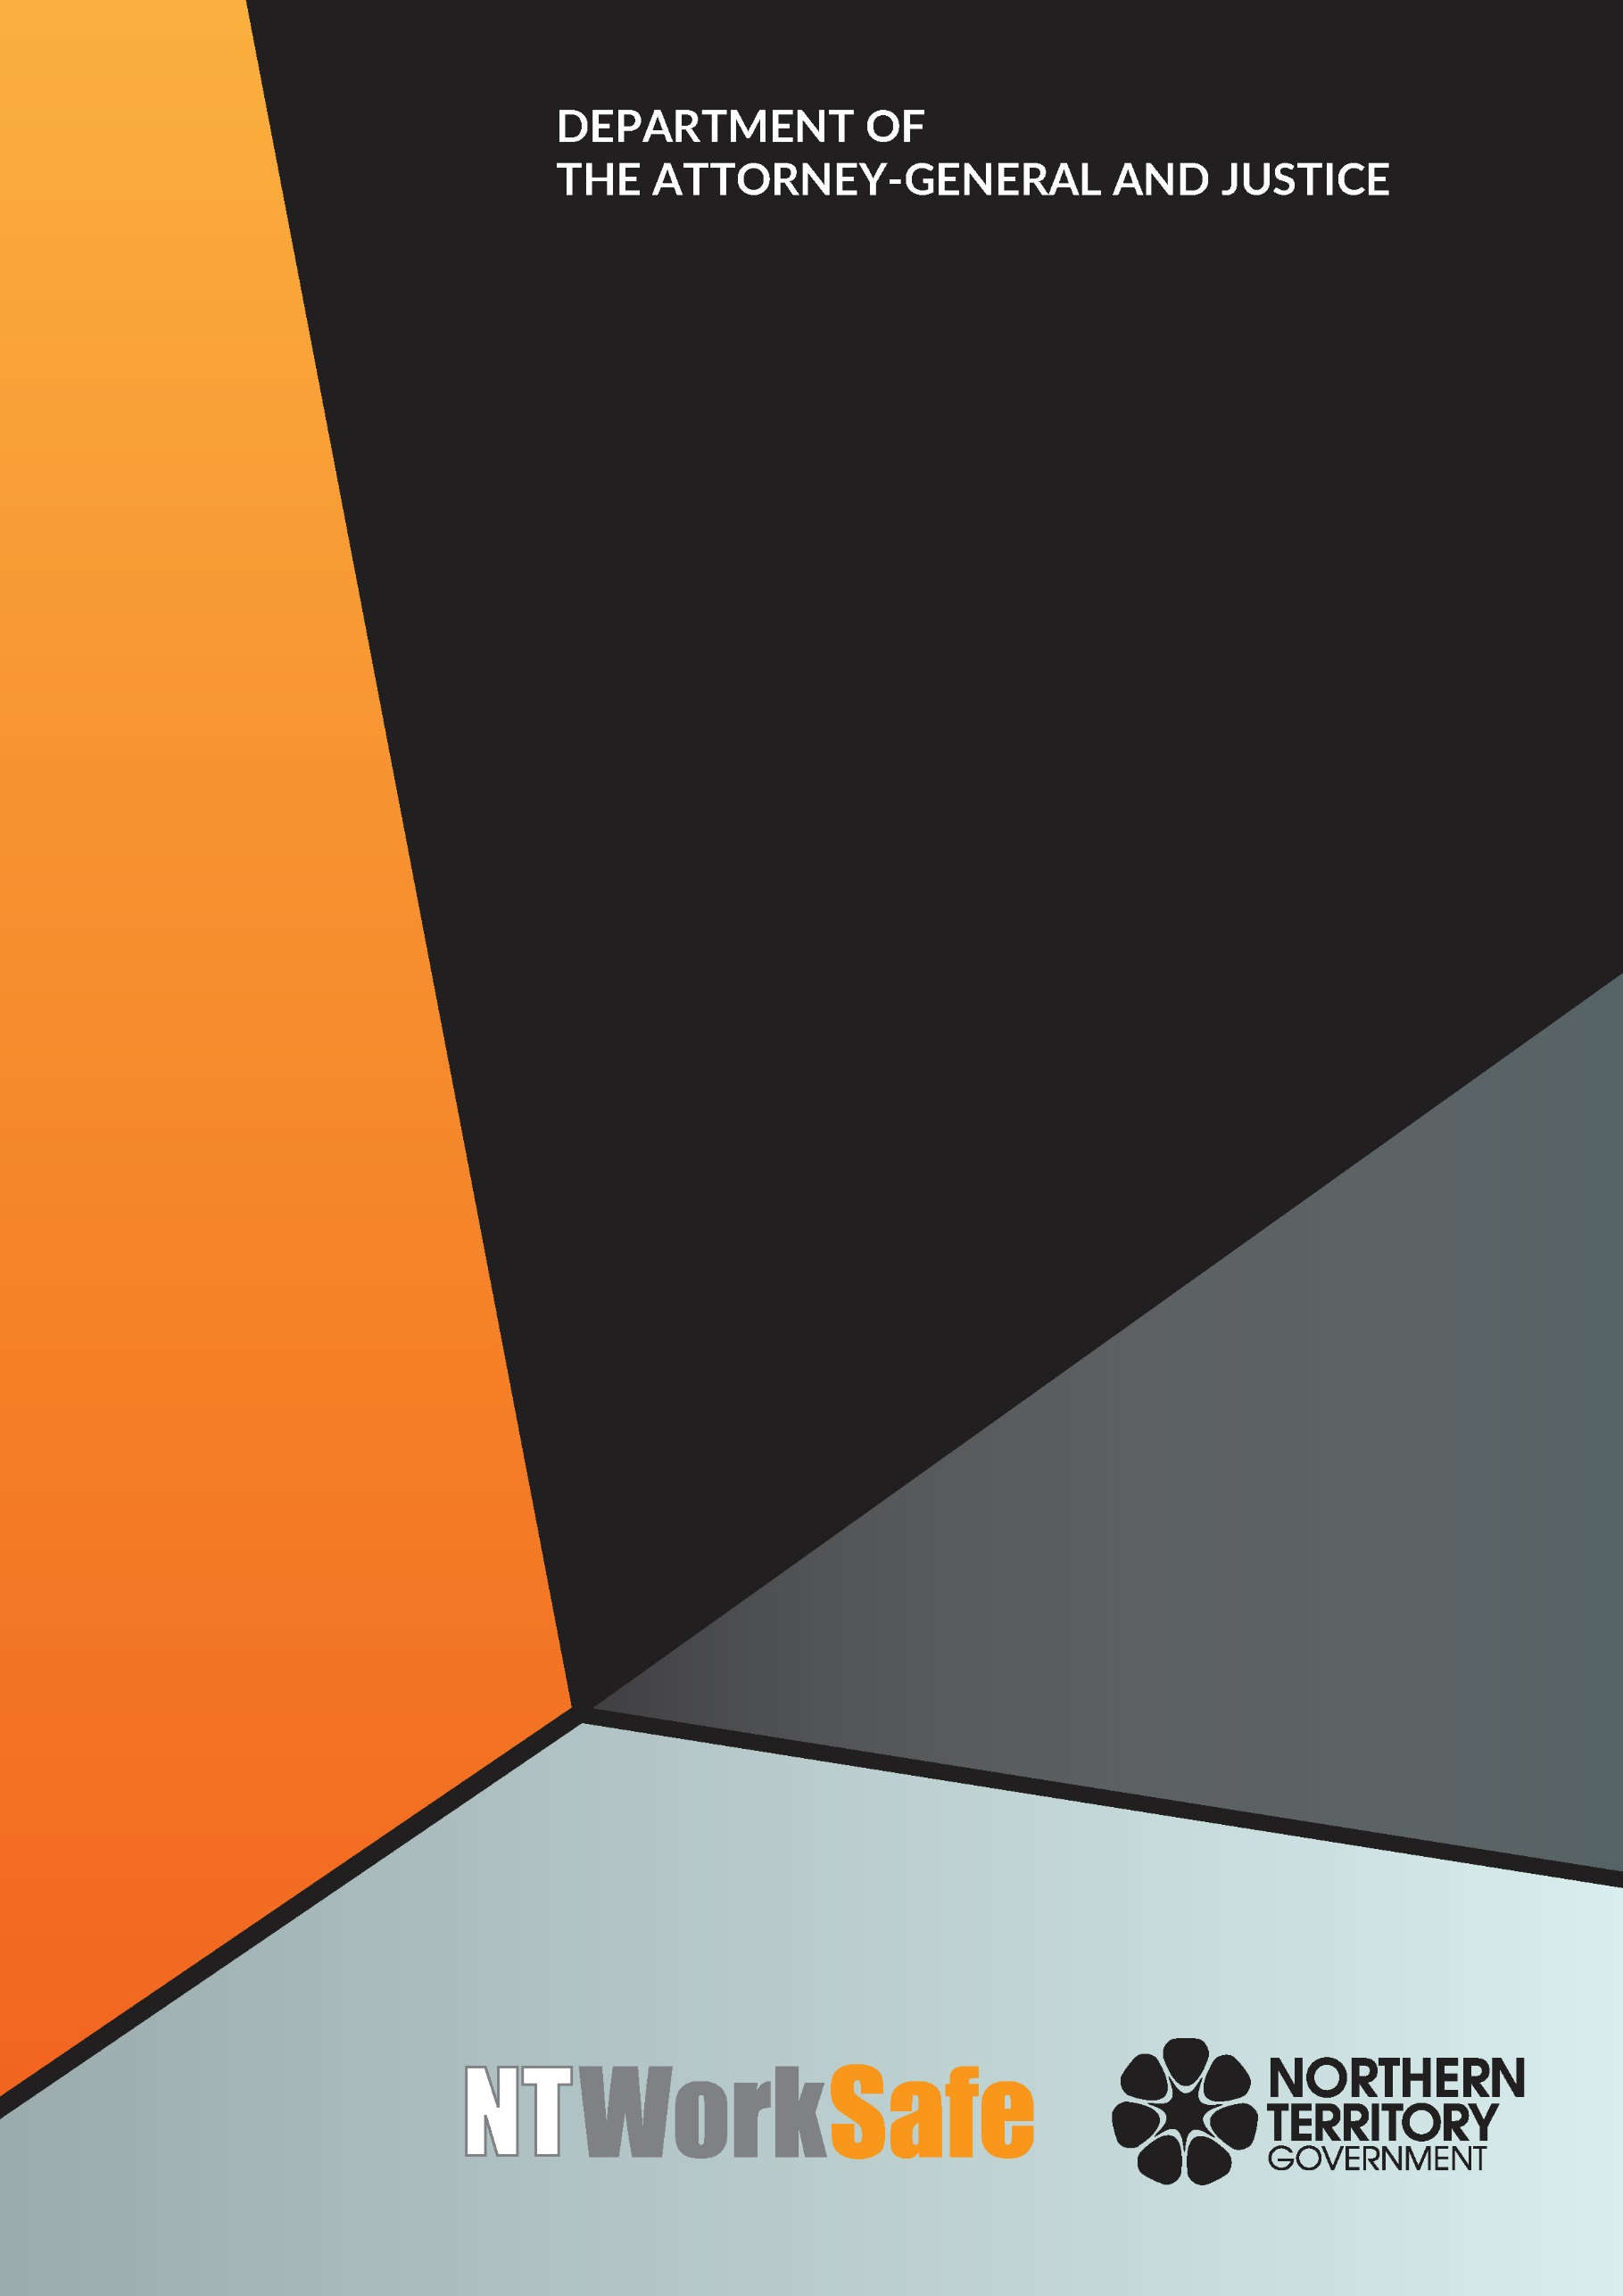
Workers Rehabilitation and Compensation Advisory Council
  - Annual Report
  - 2017-18

Contents
Function and Purpose of the Advisory Council 3
Membership of the Advisory Council 4
Council Members for 2017-2018 4
Ms Cathy Spurr, Halfpennys Lawyers – Chair 4
Mr George Roussos, Roussos Legal Advisory – Deputy Chair 4
Mr Stephen Gelding, NT WorkSafe – Work Health Authority 4
Mr Colin Chilcott, Insurance Council of Australia – Member 5
Dr Gerry A Goodhand, Australian Medical Association - Member 5
Ms Sharon Roxby, Insurance Council of Australia – Member 5
Mr Robb Moffat, Insurance Council of Australia – Member 5
Mr Brett Hagan, Chamber of Commerce - Member 5
Ms Donna-Lee Mewburn, Advanced Personnel Management - Member 6
Mr Bryan Wilkins, Australian Manufacturing Workers Union – Member 6
Ms Jaylene Patten, United Voice NT – Member 6
Ms Erina Early, United Voice NT – Member 7
Mr Thomas Mayor, Construction, Forestry, Maritime, Mining and Energy Union - Member 7
Activities of the Advisory Council 2017-2018 8
Planned Activities of the Advisory Council for 2018-2019 9

Function and Purpose of the Advisory Council
In accordance with section 9 of the Return to Work Act, the functions of the Council are to:
- keep the operation of the Return to Work Act under review;
- make recommendations to the Minister on possible improvements to the administration of the Return to Work Act, or the statutory scheme for the rehabilitation and compensation of injured workers in the Northern Territory;
- carry out investigations, at the request of the Minister, into questions about the rehabilitation and compensation of injured workers and to report to the Minister on the results of the investigations; and
- perform any other advisory functions relating to workers’ rehabilitation and compensation as the Minister directs.
The Council comprises the person constituting the Work Health Authority under section 4(3) of the Work Health Administration Act and up to 10 other members appointed by the Minister.
Council members must represent stakeholders of the Northern Territory Workers’ Compensation Scheme, including balanced representation from a wide range of industry sectors, employer and worker interests, and insurers. Membership of the Council must also include persons with expertise in the rehabilitation of injured workers.

Membership of the Advisory Council

Council Members for 2017-2018

Ms Cathy Spurr, Halfpennys Lawyers – Chair
(Reappointed 14 March 2017)
Ms Spurr was a member of the Workers Rehabilitation and Compensation Advisory Council between 2009 and 2014 and held the position of Chair from 2009 to 2012. Ms Spurr is a partner at Halfpenny’s Lawyers and works predominantly on cases related to workplace injury, personal injury and medical negligence. Ms Spurr acts on behalf of workers and unions and plays a key role in representing the interests of injured workers. Ms Spurr has extensive experience dealing with complex workers compensation matters.

Mr George Roussos, Roussos Legal Advisory – Deputy Chair
(Reappointed 14 March 2017)
Mr Roussos is a partner of Roussos Legal Advisory and a strong advocate of the Northern Territory workers’ rehabilitation and compensation system. He is a current member of the Scheme Monitoring Committee; a past president of the NT Chamber of Commerce and Industry; former Chair of the Workers Rehabilitation and Compensation Advisory Council and was one of the consultants engaged to undertake a review of the (now repealed) Workers Rehabilitation and Compensation Act.

Mr Stephen Gelding, NT WorkSafe – Work Health Authority
Mr Gelding was appointed as the Work Health Authority on 16 August 2014. He is the Executive Director of NT WorkSafe, the Electricity Safety Regulator and the Chief Inspector under the Radioactive Ores and Concentrates (Packaging and Transport) Act. Mr Gelding is also the Northern Territory member of Safe Work Australia and the Heads of Workplace Safety Authorities.

Mr Colin Chilcott, Insurance Council of Australia – Member
(Reappointed 14 March 2017)
Mr Chilcott is the State Manager - NT for QBE Insurance and the nominee of the Insurance Council of Australia. Mr Chilcott has been a member of Council since 2010 and was Deputy Chair from 2015 to 2017. Mr Chilcott has extensive experience with the Northern Territory workers compensation scheme.

Dr Gerry A Goodhand, Australian Medical Association - Member
(Reappointed 14 March 2017)
Dr Goodhand has been the Australian Medical Association nominee on Council since 2011. He is a general practitioner who regularly works with patients who are workers’ compensation claimants.

Ms Sharon Roxby, Insurance Council of Australia – Member
(Resigned 2 August 2017)
Ms Roxby is the Workers’ Compensation Manager NT for Allianz and has extensive experience in leading Workers’ Compensation claims teams with in New South Wales and the Northern Territory. Ms Roxby has specific expertise in the management of long claims and has had active involvement in personal injury claims management with particular focus on workers’ compensation.

Mr Robb Moffat, Insurance Council of Australia – Member
(Appointed 9 October 2017)
Mr Moffat is the Regional Technical Manager for Allianz Australia and the nominee of the Insurance Council of Australia. Mr Moffat has over 26 years of experience within the Northern Territory and Western Australian Personal Injury Schemes with particular focus on Workers Compensation.

Mr Brett Hagan, Chamber of Commerce - Member

(Reappointed 14 March 2017)
Mr Hagan was nominated by the Chamber of Commerce NT to represent employer interests on the Council. Mr Hagan has been involved with the Chamber of Commerce NT since the mid 1980’s and has held a position on their board since 2012. Mr Hagan has worked in the insurance industry since 1980 and has experience with claims, underwriting and account management.

Ms Donna-Lee Mewburn, Advanced Personnel Management - Member
(Appointed 14 March 2017)
Ms Mewburn is an occupational therapist who has worked as the Northern Territory Manager for Advanced Personnel Management (APM) since 2006. Ms Mewburn has developed her knowledge and skills within the workers’ compensation and rehabilitation industry in her role with APM, providing support to relevant stakeholders such as injured workers, employers, treatment providers and insurers. Ms Mewburn has been a National Council Member of the Australian Rehabilitation Providers Association (APRA) since 2009. This position has provided opportunities to gain understanding of workers’ compensation issues within other jurisdictions across Australia.

Mr Bryan Wilkins, Australian Manufacturing Workers Union – Member
(Resigned 14 February 2018)
Mr Wilkins is employed by the Australian Manufacturing Workers Union (AMWU) as the Northern Territory Organiser, representing workers in manufacturing, automotive, mining, printing and technical services. Mr Wilkins has held this position since 2008 following a career as a boilermaker in the NT working in mining and construction industries. Mr Wilkins is also a member of the Work Health and Safety Advisory Council.
Ms Justine Searle, Statewide Superannuation – Member
(Resigned 18 January 2018)
Ms Searle was a previous member of the Workers Rehabilitation and Compensation Advisory Council, sitting for four years between 2008 and 2012. Ms Searle is the Regional Manager for Statewide Superannuation for the past year and has worked in financial services for four years.

Ms Jaylene Patten, United Voice NT – Member
(Resigned 9 May 2018)
Ms Patten has been working as the Member Assist Officer for United Voice NT for the past 8 years. United Voice is the largest union in the NT representing workers in security, disability, health and aged care, child services, corrections, paramedics, fire fighters, early childcare, aboriginal health practitioners, NTPS health services, shires and councils. Ms Patten represents members in workers compensation claims, workplace health and safety issues, workplace investigations, mediations, workplace disputes, conflict resolution and general industrial relation advice.

Ms Erina Early, United Voice NT – Member

(Appointed 16 April 2018)
Ms Early is employed as the Branch Secretary for United Voice NT. United Voice is the largest union in the Northern Territory (NT) representing workers in areas of security, disability, hospitality, health and aged care, corrections, paramedics, fire fighters, early childcare, aboriginal health, NT Public Sector health services, regional councils, mining and Aboriginal organisations.

Mr Thomas Mayor, Construction, Forestry, Maritime, Mining and Energy Union - Member

(Appointed 16 April 2018)

Mr Mayor has been working as the Northern Territory Branch Secretary for the Maritime Union of Australia a division of the Construction, Forestry, Maritime, Mining and Energy Union for the past 8 years. Maritime Union of Australia has a high union density in the maritime industries. Mr Mayor and his members are experienced in effectively managing work health and safety concerns in the marine related industry.

Activities of the Advisory Council 2017-2018
The Council met on four occasions during 2017-2018:
- 27 July 2017;
- 09 November 2017;
- 01 February 2018; and
- 03 May 2018
Key issues and items the Council addressed or considered included the:
- Permanent Impairment Guide;
- Statements of Fitness for Work;
- role of independent medical examiners and rehabilitation providers;
- national training package for the engagement and education of general practitioners;
- attendance of employers or rehabilitation providers at medical appointments;
- adjournment of mediations; and
- the Alternative Employer Incentive Scheme.

Planned Activities of the Advisory Council for 2018-2019
Proposed work to be undertaken by the Council in 2018-2019 includes:
- further consideration of Statements of Fitness for Work – e-Certificate;
- best practice guidelines:
- monitoring Return to Work legislative changes;
- assist with development of Return to Work Policy;
- review NT WorkSafe website (workers compensation);
- regulation and recovery of medical fees;
- the Alternative Employer Incentive Scheme;
- ongoing review of NT WorkSafe guidance material;
- ongoing review of claimant satisfaction levels; and
- consideration of any relevant issues that arise.

