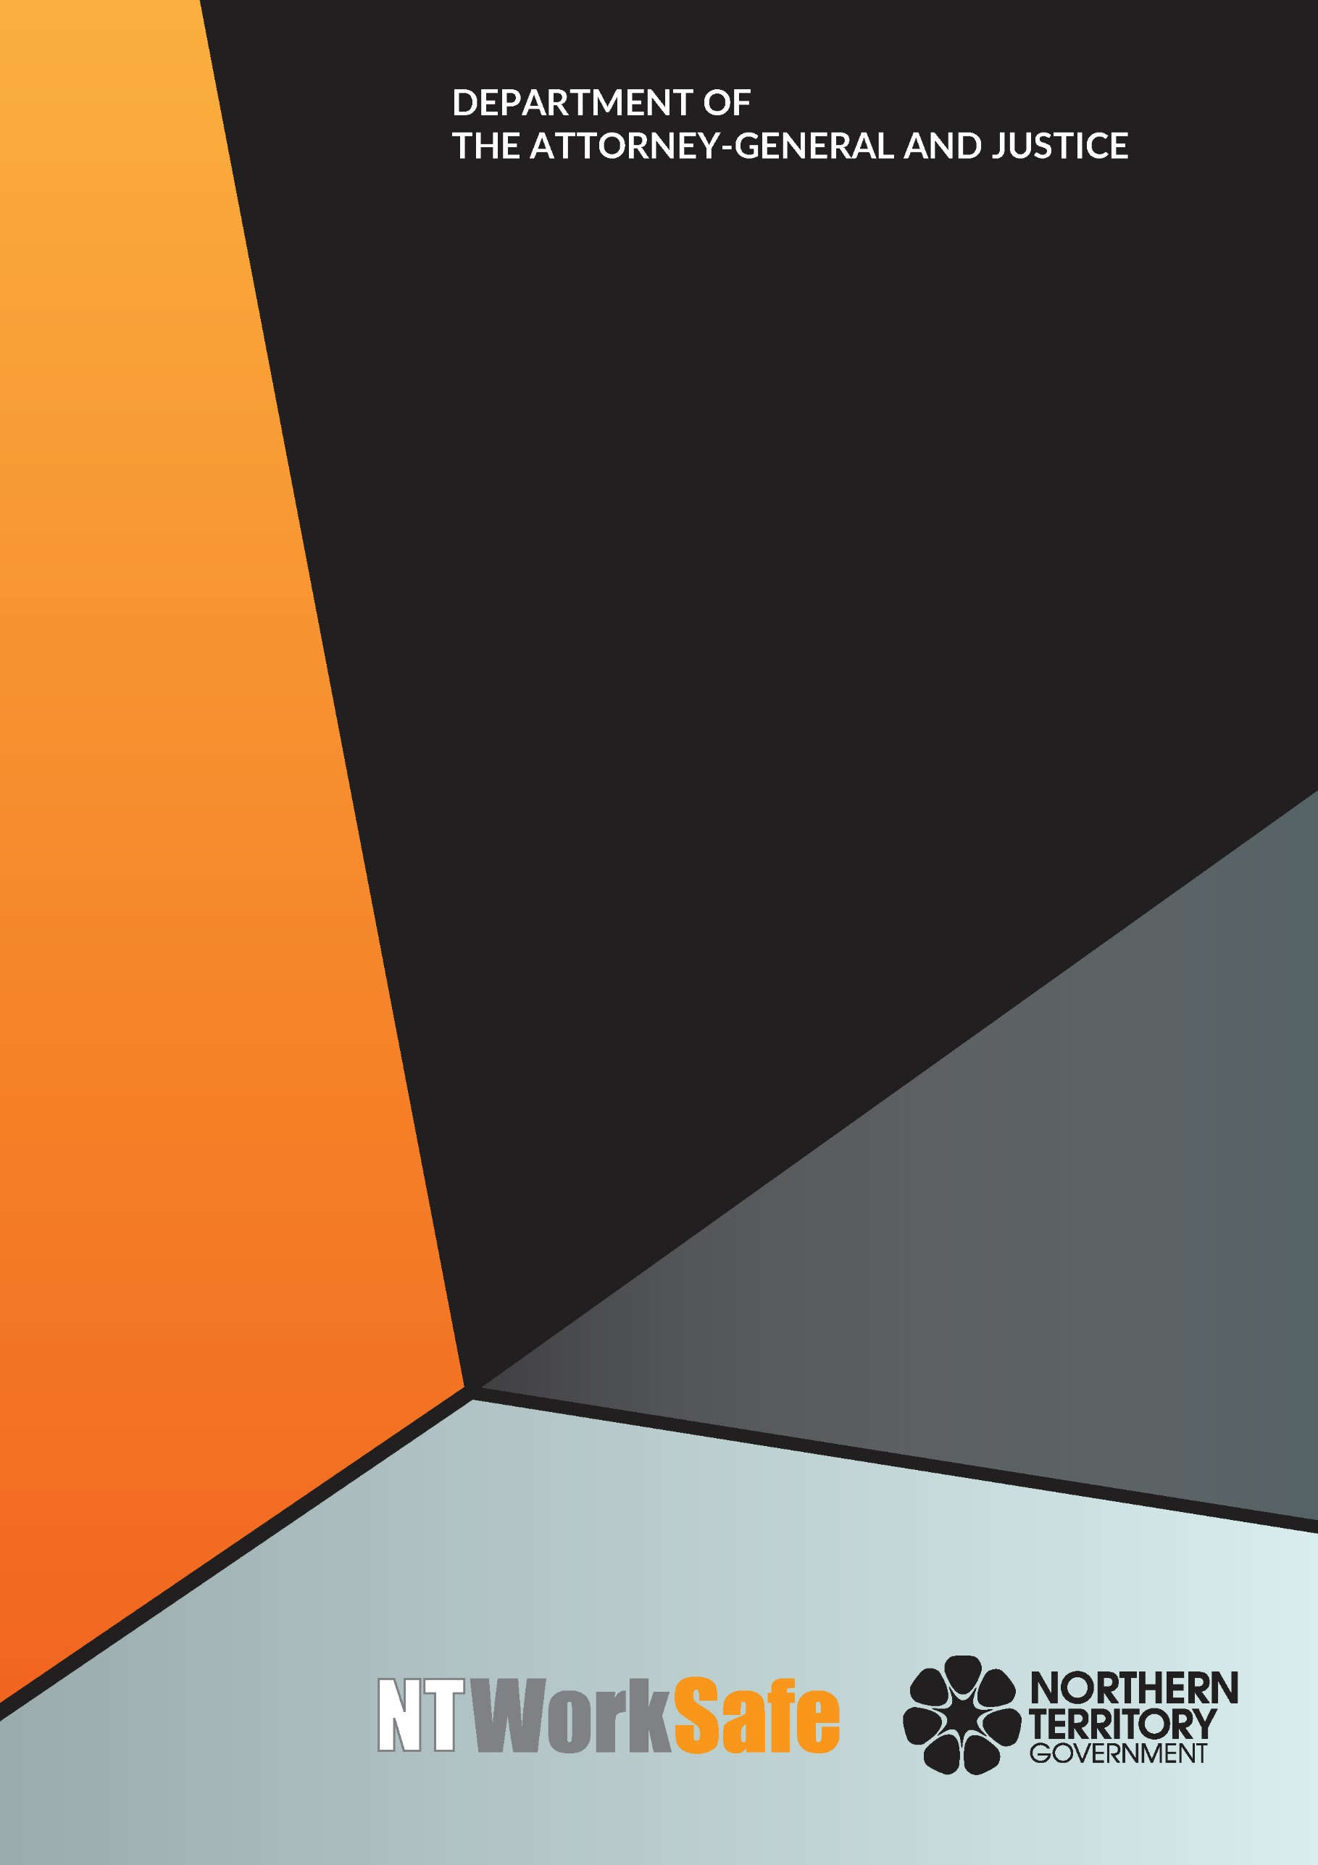
Work Health and Safety Advisory Council
  - Annual Report
  - 2019-20

Contents
Function and Purpose of the Advisory Council 3
Membership of the Advisory Council 3
Council Members for 2019-2020 3
Activities of the Advisory Council for 2019-2020 6
Committees 6
Injured Workers and Family Forum 7
Planned Activities of the Advisory Council for 2020-2021 7

Function and Purpose of the Advisory Council
The Work Health and Safety Advisory Council (WHSAC) is a tripartite body, established to provide advice on the administration of the Work Health and Safety (National Uniform Legislation) Act 2011 (the Act) and standards of work health and safety in the Northern Territory.
In accordance with schedule 2(3) of the Act, the functions of the Council are:
- to keep under review the operation of this Act;
- to make recommendations to the Minister on possible changes to:
- the administration of this Act; or
- standards of work health and safety in the Northern Territory;
- at the request of the Minister, to investigate and report to the Minister on matters relating to work health and safety; and
- to perform any other advisory functions relating to work health and safety as the Minister directs.

Membership of the Advisory Council
Schedule 2(4) of the Act outlines membership of the Council as follows:
  - The Council consists of:
    - the person constituting the Authority under section 4(3) of the Work Health Administration Act; and
    - not more than 10 other persons appointed by the Minister.
  - The members appointed under subclause (1)(b) must:
    - include persons with a wide range of experience extending as far as possible across all major industry sectors in the Territory; and
    - as far as practicable, consist of equal numbers of representatives of organisations representing employees.
There is no legislative requirement for meetings to be held on a regular basis.
During the 2019-2020 financial year the tenure of the presiding Council ended and a new Council was appointed on 24 June 2020. Five members from the former Council were reappointed along with five new members.

Council Members for 2019-2020
Ms Andrea Moriarty, Construction Industry – Chair
(Reappointed 24 June 2020)
Ms Moriarty is a Director of Kalo Real Estate and the current Vice President of the Master Builders Association NT. Ms Moriarty has been involved with residential construction for the past 11 years. Prior to this Ms Moriarty was a Registered Nurse with a focus on health education, earning a Graduate Diploma in Mental Health and Renal Health. Over the years Ms Moriarty has been involved with Workplace Health and Safety in both public and private enterprises.
Mr Thomas Mayor, Union Representative – Deputy Chair
(Appointed 3 May 2018 – 3 May 2020)
Mr Mayor has been working as the Northern Territory Branch Secretary for the Maritime Union of Australia a division of the Construction, Forestry, Maritime, Mining and Energy Union for the past 8 years. Maritime Union of Australia has a high union density in the maritime industries. Mr Mayor and his members are experienced in effectively managing work health and safety concerns in the marine related industry.
Ms Marita Wilson – Construction Industry - Deputy Chair
(Reappointed 24 June 2020)
Ms Wilson is the Work Health Safety and Environment Manager for the Halkitis Brothers Group. Ms Wilson has 13 years’ experience on major local projects including the Strategic Indigenous Housing and Infrastructure Project (SIHIP) and the Darwin Correctional Centre at Holtze.
Mr Adam Giuliani – Union Representative
(Reappointed 24 June 2020)
Mr Giuliani served in the Australian Defence Force for 20 years’, completing tours in East Timor and Iraq. Following voluntary discharge Mr Giuliani was employed in the Mining, Construction and LNG Construction industries. Mr Giuliani is currently employed with Unions NT as the Project Officer for Work Health and Safety.
Mr George Roussos – Legal Industry
(Appointed 3 May 2018 – 3 May 2020)
Mr Roussos is a partner of Roussos Legal Advisory and has a broad experience in matters including regulatory, insurance, compensation claims and commercial disputes. Mr Roussos holds degrees in Law, Economics and Business Administration. Mr Roussos has served on a number of Committees and Business Associations including a term as President of the Northern Territory Chamber of Commerce.
Mr Tim Loth – Aboriginal Health Industry
(Resigned 24 March 2020)
Mr Loth is the Human Resource Manager for Ngaanyatjarra Health Service in Alice Springs. Mr Loth is the Work Health and Safety lead within the organisation. Mr Loth has over 20 years’ experience in Human Resources, Work Health and Safety, Community and Indigenous Relations from the Aboriginal Health, Mining and Electricity Generation Industries.
Ms Tracy Allen – Construction Industry
(Appointed 3 May 2018 – 3 May 2020)
Ms Allen has over 10 years’ experience in the asbestos and demolition industry and is currently employed with Northern Trade Solutions (NTS) for the past five years. Ms Allen is the Work Health and Safety Manager for NTS and project manages in Asbestos removals. Ms Allen holds certification in Asbestos A and B class Supervision.

Ms Erina Early – Union Representative
(Reappointed 24 June 2020)
Ms Early is employed as the Secretary for United Workers Union NT. United Workers Union is the largest union in the Northern Territory (NT) representing workers in areas of security, disability, hospitality, health and aged care, corrections, paramedics, fire fighters, early childcare, aboriginal health, NT Public Sector health services, regional councils, mining and Aboriginal organisations. Ms Early is also the Secretary of Unions NT the peak body of the Union movement in the NT.
Ms Kirrily Freson – Community Services Industry
(Appointed 8 May 2019 – 3 May 2020)
Ms Freson is employed as the Human Resource Manager for Anglicare NT. Ms Freson has 15 years’ experience in the Human Resources industry with knowledge in the private, not for profit and community controlled sectors. Ms Freson holds qualifications and credentials in Social Science, Human Resources, Training and Assessment and Community Sector Management.
Mr John Christie – Construction Industry
(Appointed 24 June 2020)
Mr Christie is employed with Sunbuild Pty Ltd as the Health, Safety, Environment (HSEQ) and Quality and Training Manager. Mr Christies has over 24 years of strategic and hands on senior HSEQ and HR management. Mr Christies’ qualifications include a Masters’ Degree in Occupational and Environmental Health and Safety and a Post Graduate Certificate in Human Resource Management.
Mr Paul Connor – Construction Industry
(Appointed 24 June 2020)
Mr Paul Connor was previously employed with Halikos Construction Group Pty Ltd as the Safety, Environment and Quality Compliance Officer.
Mr Mark Davies - Consultancy
(Appointed 24 June 2020)
Mr Davies is the Director for EHS Essential Services. Mr Davies has 30 years’ experience in the work health and safety section. Mr Davies qualifications include a Master of Occupational Health Safety and Environment Management and a Graduate Certificate in Spatial Science.
Mr Christopher O’Brien – Entertainment Industry
(Appointed 24 June 2020)
Mr O’Brien is the Managing Director for Dreamedia.
Mr Lloyd Pumpa – Union Representative
(Appointed 24 June 2020)
Mr Pumpa is employed with Australian Manufacturing Workers Union. The union represents a diverse range of workers in mining, technical, mechanics and fitters and turners.
Ms Sandy Alp – Local Government
(Reappointed 24 June 2020)
Ms Alp is employed as the Work, Health and Safety (WHS) Business Partner for the City of Darwin. Ms Alp has over 16 years’ experience in WHS which included work in a regulatory role, the WHSE Manager in the commercial construction industry and a Work Health and Safety consultant. Prior to this Ms Alp was a Registered Nurse at the Royal Darwin Hospital. Ms Alp has served on a number of committees over the years including the Australian Institute of Health and Safety and the Rail Safety Committee.
Ms Melissa Garde, NT WorkSafe – Acting Work Health Authority
Ms Garde was appointed as the Acting Work Health Authority on 29 January 2019. She also acted as the Executive Director, NT WorkSafe, Acting Electricity Safety Regulator and the Chief Inspector under the Radioactive Ores and Concentrates (Packaging and Transport) Act 1980. Ms Garde also represented the NT at Safe Work Australia and the Heads of Workplace Safety Authorities meetings.

Activities of the Advisory Council for 2019-2020
The Council met on two occasions during 2019-2020:
- 27 September 2019; and
- 14 February 2020.
Key issues and items the Council addressed or considered included:
- Health and Safety Representative e-Learning training;
- Work Health and Safety Conference;
- Best Practice Review of Work Health and Safety in the NT;
- Silica Dust and associated diseases; and
- Reintroduction of communiques for public access.

Committees
Under section 10 of the Act:
  - The Council may establish committees to assist it to carry out its functions.
  - A committee has the functions conferred on it by the Council.
  - A committee may be constituted:
    - Entirely of members of the Council establishing it; or
    - Partly of members of the Council and partly of other persons; or
    - Entirely of other persons.
  - A committee member holds office on the conditions (including remuneration, expenses and allowances) determined by the Minister.
  - A committee must keep records of its proceedings.
  - Subject to this Act and any directions of the Council establishing it, a committee may determine its own procedures.
The Work Health and Safety Advisory Council established an Injured Workers and Family Forum during 2019-2020 as per Recommendation 4 of the Best Practice Review of Work Health and Safety in the NT:
- Recommendation 4: That an Injured Workers and Family Forum be established, actively supported, and consulted by both NT WorkSafe and the Work Health and Safety Advisory Council.

Injured Workers and Family Forum
Membership of the forum comprised of members from the Workers Rehabilitation and Compensation Advisory Council and the Work Health and Safety Advisory Council.
Members:
- Ms Andrea Moriarty (Chair);
- Ms Cathy Spurr (Deputy Chair);
- Mr Adam Giuliani;
- Mr Brett Hagan;
- Ms Erina Early; and
- Ms Kirrily Freson.
The forum met on one occasion during 2019-2020 ̶ 16 March 2020.

Planned Activities of the Advisory Council for 2020-2021
Proposed work to be undertaken by the Council in 2020-2021 includes:
- Continuing to consider and action four recommendations from the Best Practice Review of Work Health and Safety in the NT referred to the Council:
  - that an Injured Workers and Family Forum be established, actively supported, and consulted by both NT WorkSafe and the Work Health and Safety Advisory Council;
  - that NT WorkSafe develop a more effective system to ensure that the families of victims of fatalities are supported, modelled on best practice used by police services;
  - that the Work Health and Safety Advisory Council monitor trends in relation to prosecutions in relation to the number of proceedings, success rate and penalties awarded; and
  - that NT WorkSafe develop a comprehensive plan to support health and safety representatives and health and safety committees, an encourage uptake in industry, particularly within priority industry sectors.

