Power tool battery fires
The purpose of this Safety Alert is to highlight the risk of fires in vehicles and structures caused by the catastrophic failure of lithium-ion power tool batteries.
Lithium-ion batteries are sensitive to temperature, and flammable. They are a serious safety risk to health and safety if used, transported or stored incorrectly. Businesses using lithium-ion powered devices are urged to make sure their workers are provided with information, training, and instruction to minimise the risk of flash burns, explosion, and exposure to hazardous chemicals.
Background
On the afternoon of Sunday 23 January 2022, a lithium-ion battery attached to a cordless impact wrench exploded after it was left on the back seat of a vehicle over the weekend. The explosion ignited other material left on the seat and severely damaged the interior of the vehicle.
The incident occurred in Darwin where the outside temperature at the time was approximately 31°. The cordless impact wrench and battery was manufactured by a reputable company.
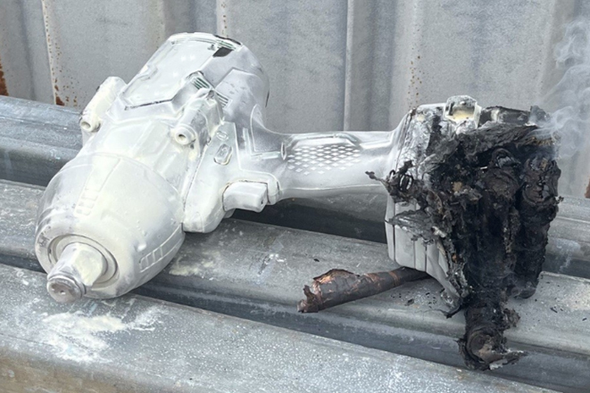
Image: The still smoking lithium-ion battery after being extinguished by a dry power extinguisher.
Possible contributing factors
- The power tool was left in the interior of a hot vehicle.
Action required
Businesses and workers who use any equipment fitted with lithium-ion batteries should consider the following control measures to prevent a similar incident from occurring.
- Do not store or leave lithium-ion power tool batteries in areas that can become hot or in direct sunlight.
- If you need to store lithium-ion power tool batteries in vehicles or areas that can become hot, undertake a risk assessment of available non-flammable storage options to contain a potential explosion of the battery and resulting fire.
- Provide appropriate information or training to all staff on the correct storage of battery operated power tools.
- Review where batteries are charged and stored and ensure flammable materials are not present.
- Follow the battery manufacturer’s advice.
- Discuss the storage and transportation of lithium-ion batteries with your insurer to ensure you are covered in the event of a battery fire.
Further information
For further information, please refer to the following:
Information bulletin
- Safe use of lithium-ion batteries at home and in the workplace
Disclaimer
This Safety Alert contains safety information following inquires made by NT WorkSafe about an incident or unsafe practice. The information contained in this Alert does not necessarily include the outcome of NT WorkSafe’s action with respect to an incident. NT WorkSafe does not warrant the information in this Alert is complete or up-to-date and does not accept any liability for the information in this report or as to its use.

