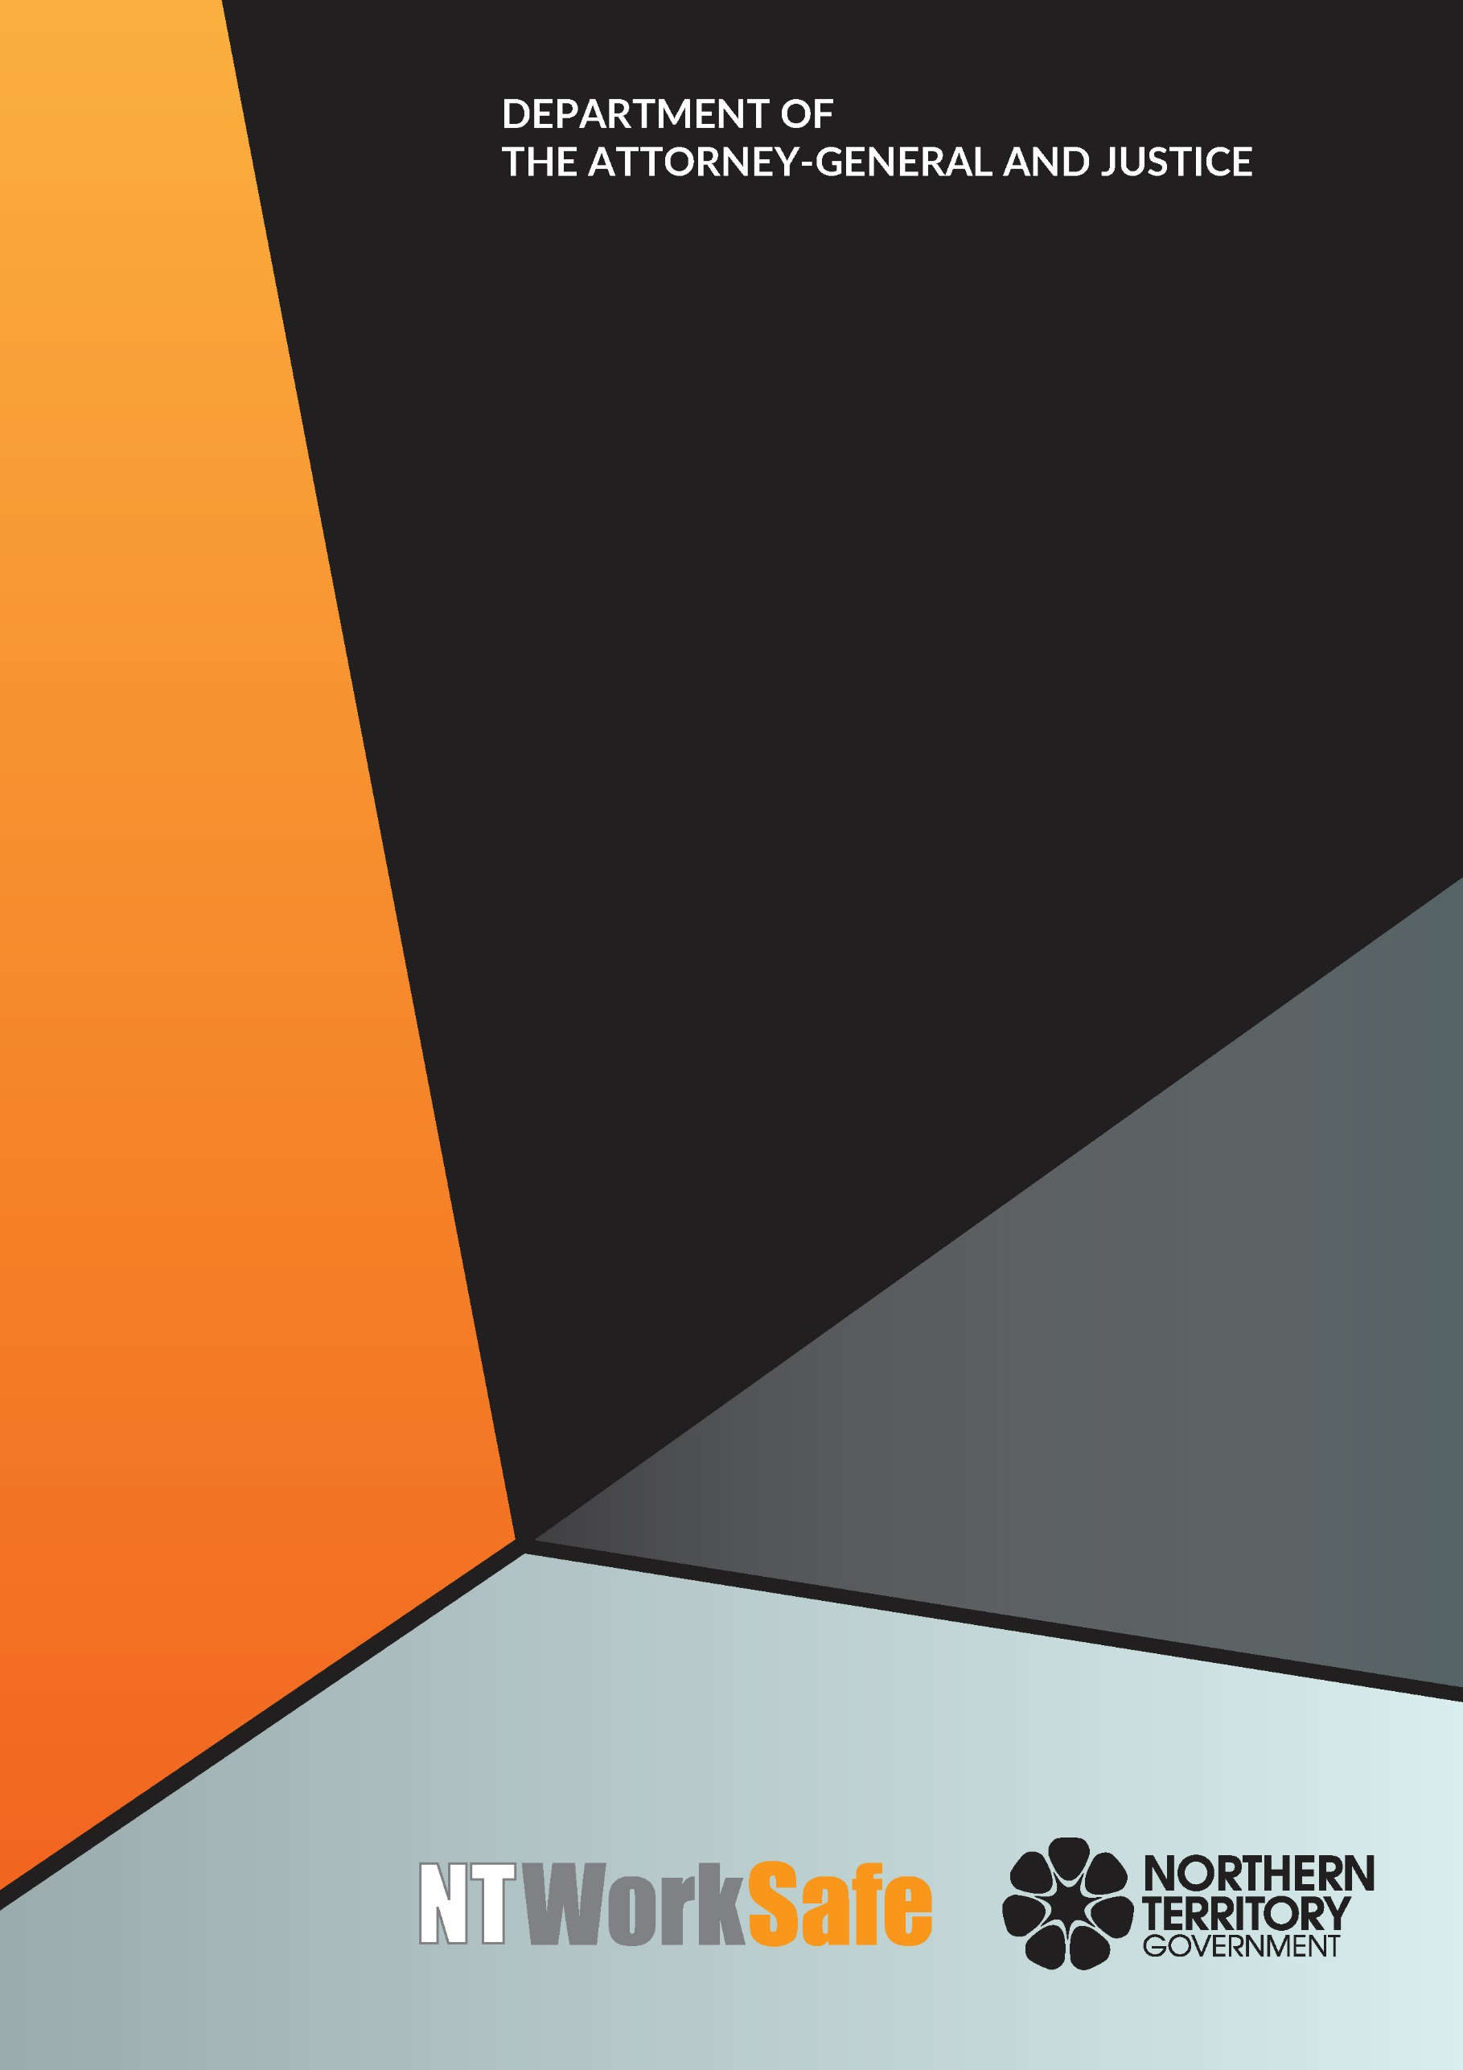
Work Health and Safety Advisory Council
  - Annual Report
  - 2016-17

Contents
Function and Purpose of the Advisory Council 3
Membership of the Advisory Council 3
Members of the Council for 2016-2017 4
Neilia Humphries, Housing Industry Association – Chair 4
Mr Stephen Gelding, NT WorkSafe – Work Health Authority 4
Marita Wilson – Construction Industry 4
Scott Lawton – Road Transport Industry 4
Jeff Huyben – Accommodation and Food Industry 5
Bryan Wilkins – Unions NT 5
Sean O’Connor – Remote and Indigenous Employment 5
Shenal Basnayake – Agriculture Industry 5
Bruce Anderson – Resource and Mining Industry 6
Skye Lee – Community Services Industry 6
Brian Fowler – Resource and Mining Industry 6
David Hayes – Electrical Trades Union 6
Activities of the Advisory Council for 2016-2017 7
Planned Activities of the Advisory Council for 2017-2018 7

Function and Purpose of the Advisory Council
The Work Health and Safety Advisory Council (WHSAC) is a tripartite body, established to provide advice on the administration of the Work Health and Safety (National Uniform Legislation) Act (the Act) and standards of work health and safety in the Northern Territory.
In accordance with schedule 2(3) of the Act, the functions of the Council are:
- to keep under review the operation of this Act;
- to make recommendations to the Minister on possible changes to:
- the administration of this Act; or
- standards of work health and safety in the Northern Territory;
- at the request of the Minister, to investigate and report to the Minister on matters relating to work health and safety; and
- to perform any other advisory functions relating to work health and safety as the Minister directs.

Membership of the Advisory Council
Schedule 2(4) of the Act outlines membership of the Council as follows:
  - The Council consists of:
    - the person constituting the Authority under section 4(3) of the Work Health Administration Act; and
    - not more than 10 other persons appointed by the Minister.
  - The members appointed under subclause (1)(b) must:
    - include persons with a wide range of experience extending as far as possible across all major industry sectors in the Territory; and
    - as far as practicable, consist of equal numbers of representatives of organisations representing employees.
There is no legislative requirement for meetings to be held on a regular basis.

Members of the Council for 2016-2017

Neilia Humphries, Housing Industry Association – Chair
(Appointed 22 April 2016)
Ms Humphries is the Executive Director of the Northern Territory branch of the Housing Industry Association (HIA), Australia’s peak residential building, renovation and development industry association. HIA has over 40,000 members nationally including builders, manufacturers, suppliers and building-related trades, with 400 members in the Northern Territory. Over many years Ms Humphries has been involved in the implementation and management of safety systems in industries including aviation, local government and vocational education and training.

Mr Stephen Gelding, NT WorkSafe – Work Health Authority
Mr Gelding was appointed as the Work Health Authority on 16 August 2014. He is the Executive Director of NT WorkSafe, the Electricity Safety Regulator and the Chief Inspector under the Radioactive Ores and Concentrates (Packaging and Transport) Act. Mr Gelding is also the Northern Territory member of Safe Work Australia and the Heads of Workplace Safety Authorities.

Marita Wilson – Construction Industry
(Appointed 22 April 2016)
Ms Wilson is the Work Health Safety and Environment Manager for the Halkitis Brothers Group. Ms Wilson has 10 years’ experience on major local projects including the Strategic Indigenous Housing and Infrastructure Project (SIHIP) and the Darwin Correctional Centre at Holtze.

Scott Lawton – Road Transport Industry
(Appointed 22 April 2016)
Mr Lawton brings 25 years of experience to the road transport industry. He was nominated by the Traffic Management Association of Australia, which has a particular focus on improving traffic safety in the Northern Territory. Mr Lawton is an experienced Site and Project Manager, Estimator and Operations Manager who has managed key sites in Darwin. Mr Lawton runs Diggamen Civil Contracting, which was founded in Darwin in 2006 and expanded into Alice Springs in 2009.

Jeff Huyben – Accommodation and Food Industry
(Appointed 22 April 2016)
Mr Huyben is the Resort General Manager at Chifley Alice Springs Resort, which comprises accommodation, conference and food business units. He is responsible for overseeing all operations including human resources, finance, payroll, sales and marketing and the day to day management of 70 staff.

Bryan Wilkins – Unions NT
(Appointed 22 April 2016)
Mr Wilkins is employed by Unions NT and was previously the NT organiser of the Australian Manufacturing Workers Union (AMWU). AMWU represents workers in a range of industries including manufacturing, automotive, construction, mining, printing and technical services. As an organiser with AMWU, Mr Wilkins provided advice to members on Work Health and Safety and Workers Compensation matters.

Sean O’Connor – Remote and Indigenous Employment
(Appointed 22 April 2016)
Mr O’Connor is based in remote Nhulunbuy, East Arnhem Land and has coordinated Work Health and Safety for Yolngu Business Enterprises for the past five years. He has diplomas in Occupational Health and Safety and Environmental Management. Mr O’Connor has ten years’ experience in the Northern Territory off-shore mining, gas and oil sector.

Shenal Basnayake – Agriculture Industry
(Resigned 20 March 2017)
Mr Basnayake was the Chief Executive Officer for NT Farmers Association, the peak industry body for plant based industries in the Northern Territory. He represented the interests of members at various forums in the Northern Territory and nationally.

Bruce Anderson – Resource and Mining Industry
(Appointed 22 April 2016)
Mr Anderson has worked as a health and safety professional for 27 years. His experience covers construction, mining and on and off-shore drilling. Mr Anderson has been with INPEX for the past 10 years and has recently relocated to the Northern Territory to take up the position of Onshore Health, Safety and Environment Manager at Bladin Point.

Skye Lee – Community Services Industry
(Appointed 22 April 2016)
Ms Lee is the Assets, Infrastructure and Maintenance Manager for Somerville Community Services. She oversees Work Health and Safety for the organisation including chairing quarterly meetings, reviewing and updating policies and procedures, and implementing changes where necessary. Ms Lee holds a Certificate IV in Occupational Health and Safety.

Brian Fowler – Resource and Mining Industry
(Appointed 22 April 2016)
Mr Fowler was nominated by the Minerals Council of Australia; he is the General Manager NT and Sustainability, Arafura Resources. Mr Fowler has an extensive knowledge of work health and safety matters in the Northern Territory minerals sector, and is able to network effectively with a diverse range of stakeholders.

David Hayes – Electrical Trades Union
(Appointed 22 May 2017)
Mr Hayes was nominated by Unions NT. He has extensive experience in the electrical industry having worked on domestic, commercial, industrial, hazardous facilities, mining and major project sites over his 25 years as a licenced electrician. Mr Hayes has a particular interest in work health and safety; has been an elected health and safety representative over many years; and holds a Certificate IV in Occupational Health and Safety.

Activities of the Advisory Council for 2016-2017
The Council met on four occasions during 2016-2017:
- 7 September 2016;
- 5 December 2016;
- 28 February 2017; and
- 30 May 2017.
Key issues and items the Council addressed or considered included:
- Traffic management standards in the Northern Territory;
- Work Health and Safety education for school students and young workers;
- Organisational culture of safety in the workplace;
- Nature of worker with a focus on low literacy and language barriers; and
- Health and wellbeing – monitoring the national approach by Heads of Workplace and Safety Australia.
The Council formed two committees to address the key issues raised by Council. These committees addressed the Traffic Management Standards and Work, Health and Safety education for school students and young workers.

Planned Activities of the Advisory Council for 2017-2018
Proposed work to be undertaken by the Council until the end of their two year term ending on 22 April 2018 includes:
- White Card Training Review - “a case for change” proposed nationally. The Council will identify industry specific requirements and concerns in relation to the current training system, and provide its outcomes and recommendations to the Minister.

