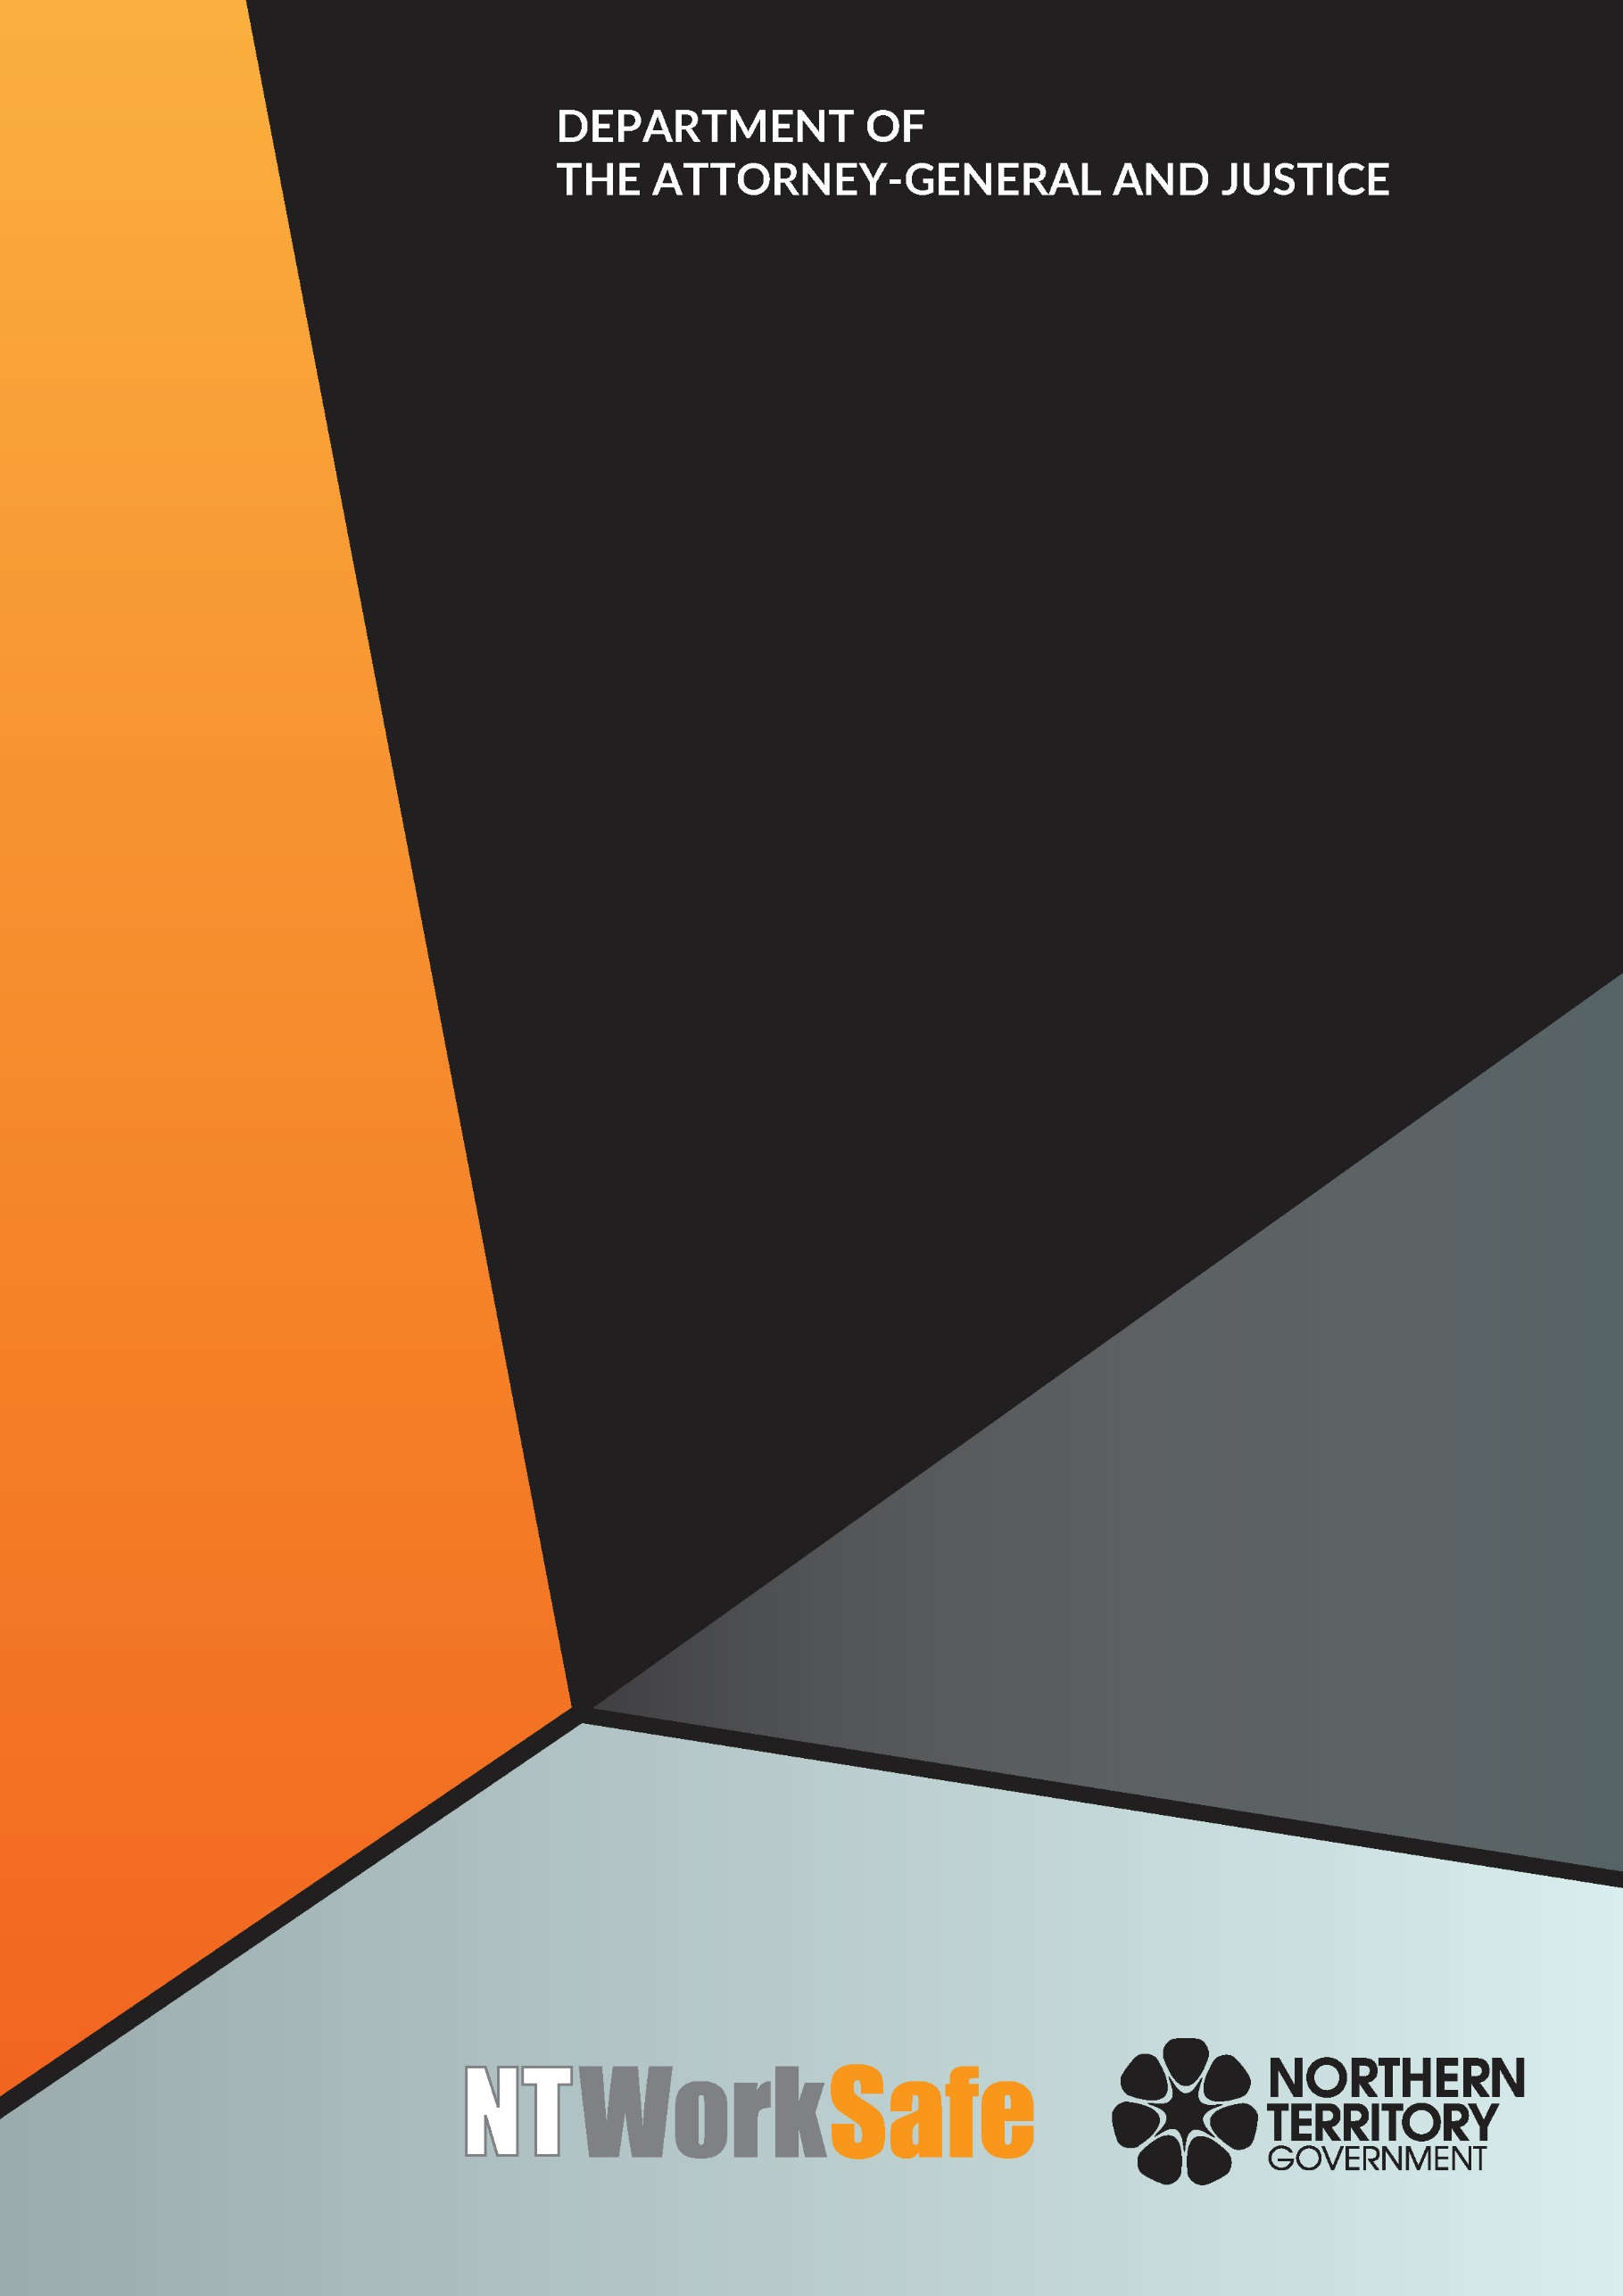

Electricity Safety Regulator
  - Annual Report
  - 2018-19

Contents
Role and Responsibilities of the Electricity Safety Regulator 3
Electricity Reform (Safety and Technical) Regulations 4
Work Health and Safety Legislation 4
Public Awareness and Advice 5
Safety Alerts 5
Bulletins 5
Activities of the Electricity Safety Regulator for 2018-2019 7

Role and Responsibilities of the Electricity Safety Regulator
The role of the Electricity Safety Regulator was established by the introduction of the Electricity Reform Act 2000 (the Act), which came into force on 1 April 2000.
The Electricity Safety Regulator is responsible for monitoring and regulating electrical safety and technical standards from the point of network connection at the premises to the outlet.
Section 8 of the Act states:
- The Electricity Safety Regulator has the following functions:
  - to monitor and regulate safety and technical standards with respect to electrical installations;
  - to perform any other functions assigned to the Electricity Safety Regulator under the Act.
- The Electricity Safety Regulator has the power to do all things that are necessary or convenient to be done for or in connection with or incidental to the performance of his or her functions.
The Electricity Safety Regulator also provides advice and assistance to licenced electrical workers as well as individual home owners, occupiers and persons conducting a business or undertaking.
From time to time, the Electricity Safety Regulator offers a general electrical safety advisory service with respect to:
• national performance standards for appliances and equipment;
• input into training courses involving regulation and standards for electrical work; and
• representation on the Electrical Regulatory Authorities Council.

Electricity Reform (Safety and Technical) Regulations
The Electricity Reform (Safety and Technical) Regulations (the Regulations) provide for the installation, testing and certification of electrical work carried out. Electrical contractors are required to:
• consult with their customers;
• provide an electrical installation that is fit for purpose;
• test the electrical installation to ensure it is safe to use; and
• provide their customers with a Certificate of Compliance for the work performed.
The Regulations include safe work practices to assist employers and safeguard electrical workers. Additionally, provisions are made for other persons to work or operate safely in proximity to electrical infrastructure.
In 2017-18, the Government established a tri-partite Electrical Safety and Licensing Reference Group to examine the Act and the Electrical Workers and Contractors Act 1978. The purpose of the review is to examine and provide direction to the Northern Territory Government about what amendments are necessary to address concerns in relation to electrical safety and electrical licensing. NT WorkSafe is participating in this review.

Work Health and Safety Legislation
On 1 January 2012, the Work Health and Safety (National Uniform Legislation) Act 2011 (WHS Act) and Regulations commenced in the Northern Territory. Part 4.7 of the Regulations – General electrical safety in workplaces and energised electrical work, addresses electrical safety in the workplace.
The Electricity Safety Regulator has directed that where Inspectors encounter a direct conflict between the two laws, the Act and Regulations will apply to technical non-compliance, and the WHS Act and Regulations will apply to work practice or process non-compliance.

Public Awareness and Advice
The Electricity Safety Regulator publishes Safety Alerts and Information Bulletins on the NT WorkSafe website as a means of providing information and advice. The following information products were available in 2018-2019.

Safety Alerts
- Electrical power tools on board fishing vessels (re-issued)
- Risk of fire in old power factor correction assemblies
- Using back-up generators with Solar PV installations
- Use of 240 volt submersible pumps
- Electrical safety risks in ceiling spaces
- Fire risk in older Polycom conference phone
- Electrocution risk for home DIY repairs
- Solar panel DC isolator fire risk
- Electric shock hazards associated with excessive sweating whilst using mains powered tools
- Christmas lights – electrical safety
- Working near energised high voltage cables
- Working with energised electrical lines
- Working at height around live electrical installations
- Incorrect installation of thermal insulation around electrical equipment and accessories

Bulletins
- Certificate of Compliance (CoC) Electrical Safety
- Electrical Contractor Information – Connection of New Installations
- Electrical Equipment and Gas Installations at Markets and Shows
- Electrical Hazards Associated with Underground Cables
- Electrical Installation Work on Mine Sites
- Electrical Safety – Notice of Non-compliance
- Electrical Safety in the Construction of Showers and Bathrooms
- Electrical Switchboard Panels and Meter Panels Containing Asbestos
- Equipotential Bonding for Pools and Spas
- Exemptions from the Wiring Rules or Electricity Reform Act 2000 and Regulations
- Installation of Thermal Insulation Around Electrical Equipment and Accessories
- Installation of Vertical Earth (Stake) Electrodes in the NT
- Managing Foil Ceiling Insulation Electrical Safety Risks – Householders & Tradespersons
- Portable Ladder Safety
- Relocatable Dwellings – Electrical Safety
- Replacing Consumer Switchboards in Existing Installations
- Residual Current Devices (Safety Switches)
- Safety Inspection and Testing of Electrical Equipment on Construction Sites
- Test and Tag of Electrical Equipment
- Union Right of Entry for Work Health and Safety Issues
- Voltmeter Measurements – Testing Foil Insulation in Domestic Dwellings
- Work Health and Safety – Incident Notification
- Worker Representation and Participation Guide
- Workers Right to Cease or Refuse Unsafe Work
- Working Close to Overhead Power Lines
- Working in Heat

Activities of the Electricity Safety Regulator for 2018-2019
Part 5 of the Act outlines the safety responsibilities and technical requirements which are monitored by the Electricity Safety Regulator. Below are some of the activities undertaken by the Electricity Safety Regulator under Part 5.
Regulatory Requirement | No | Description
Certificates of Compliance audited as per sections 67 and 68 of the Act. | 938* | Inspections and site visits
Complaints Investigated as per sections 67 and 68 of the Act. | 53 | Complaints
Report of accidents involving electric shock as per section 71 of the Act. | 63 | Electric Shocks
*38 auditing inspections were carried out by TechSafe, an independent electrical inspection company. These inspections were prescribed inspections carried out in the Northern Territory on new electrical installations, solar inspections, Alice Springs Hospital specialist installation inspections and switchboard upgrades. Compliance inspection numbers were reduced during 2018-19 due to staffing and the slight decrease in complaints and shocks.
Part 6 of the Act provides for specific enforcement powers. A summary of enforcement powers exercised by the Electricity Safety Regulator and authorised officers in 2018-2019 is provided in the following table.
Regulatory Requirement | No | Description
Exercise of specific powers under section 10 of the Act – Require Information | 0
Exercise of specific powers under section 11 of the Act – Disclose Information | 1 | Fire Investigation Reports
Exercise of specific powers under section 70 of the Act – Rectification by Direction | 19 | Owner/Operator  Non-compliance
Exercise of specific powers under section 70 of the Act – Rectification by Direction | 72 | Contractor  Non-compliance
Exercise of specific powers under section 78, 79 and 80 of the Act – Disconnection | 3 | Installations disconnected  3 x Solar PV Systems Maningrida

Part 7 of the Act provides for reviews and appeals. There were no applications for review made in the 2018-2019 financial year.
Regulatory Requirement | No | Description
Review of decisions as per section 83 of the Act – Review by Regulator | 0
Review of decisions as per section 84 of the Act – Appeals | 0
Review of decisions as per section 85 of the Act – Ministerial Intervention | 0
Dispensations as per section 87(4) of the  Act | 0
The Electrical Safety Unit of NT WorkSafe continued engagement throughout 2018-2019 with Northern Territory electrical contractors regarding implementation of emerging clean and renewable energy technologies.

