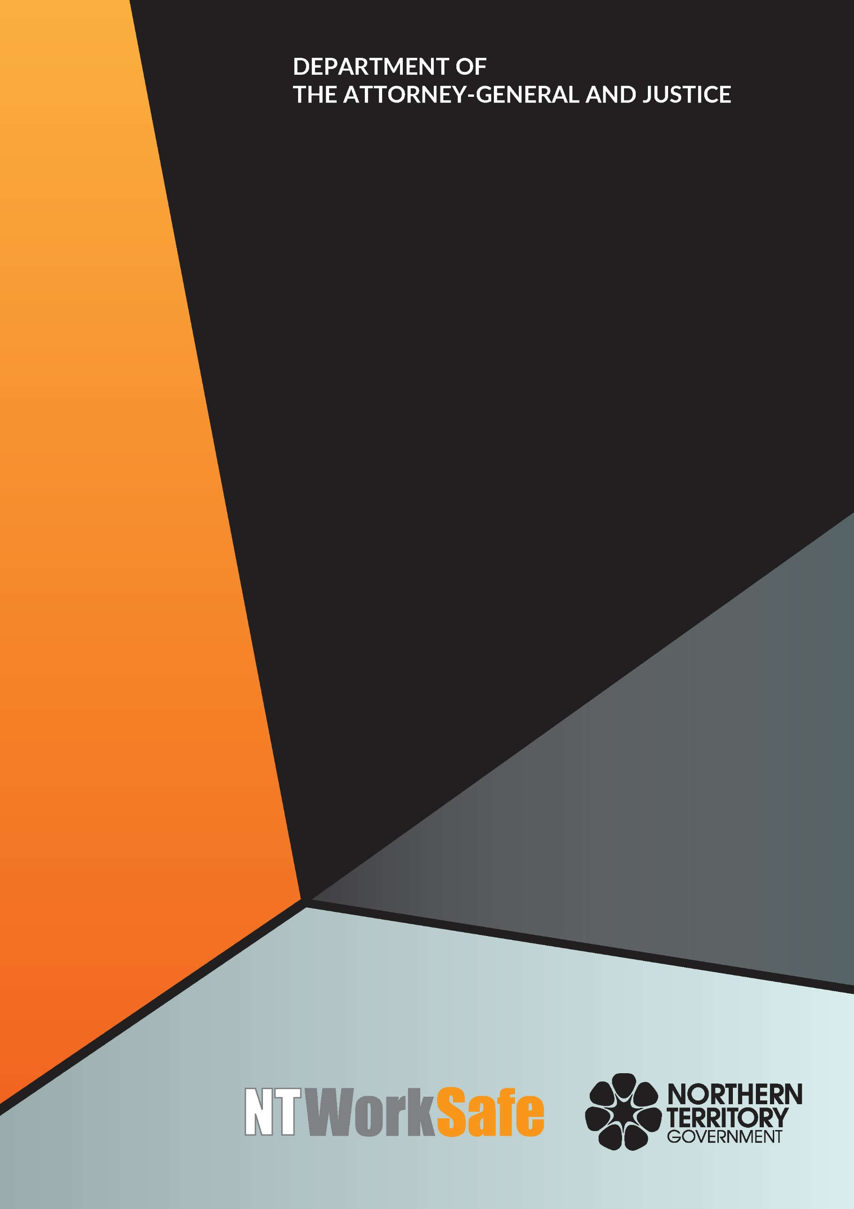
Work Health and Safety Advisory Council
  - Annual Report
  - 2018-19

Contents
Function and Purpose of the Advisory Council 3
Membership of the Advisory Council 4
Council Members for 2018-2019 4
Ms Andrea Moriarty, Construction Industry - Chair 4
Ms Melissa Garde, NT WorkSafe – Acting Work Health Authority 4
Mr Thomas Mayor, Construction, Forestry, Maritime, Mining and Energy Union – Deputy Chair 5
Ms Marita Wilson – Construction Industry 5
Mr Adam Giuliani – Unions NT 5
Mr George Roussos – Legal Industry 5
Mr Tim Loth – Aboriginal Health Industry 6
Ms Tracy Allen – Construction Industry 6
Ms Erina Early – United Voice 6
Ms Kirrily Freson – Community Services Industry 6
Ms Skye Lee – Community Services Industry 7
Mr Sean O’Connor – Remote and Indigenous Employment 7
Activities of the Advisory Council for 2018-2019 8

Function and Purpose of the Advisory Council
The Work Health and Safety Advisory Council (WHSAC) is a tripartite body, established to provide advice on the administration of the Work Health and Safety (National Uniform Legislation) Act (the Act) and standards of work health and safety in the Northern Territory.
In accordance with schedule 2(3) of the Act, the functions of the Council are:
- to keep under review the operation of this Act;
- to make recommendations to the Minister on possible changes to:
- the administration of this Act; or
- standards of work health and safety in the Northern Territory;
- at the request of the Minister, to investigate and report to the Minister on matters relating to work health and safety; and
- to perform any other advisory functions relating to work health and safety as the Minister directs.

Membership of the Advisory Council
Schedule 2(4) of the Act outlines membership of the Council as follows:
  - The Council consists of:
    - the person constituting the Authority under section 4(3) of the Work Health Administration Act; and
    - not more than 10 other persons appointed by the Minister.
  - The members appointed under subclause (1)(b) must:
    - include persons with a wide range of experience extending as far as possible across all major industry sectors in the Territory; and
    - as far as practicable, consist of equal numbers of representatives of organisations representing employees.
There is no legislative requirement for meetings to be held on a regular basis.

Council Members for 2018-2019

Ms Andrea Moriarty, Construction Industry - Chair

(Appointed 3 May 2018)
Ms Moriarty is a Director of Killarney Homes and the current Vice President of the Master Builders Association NT. Ms Moriarty has been involved with residential construction for the past 11 years. Prior to this Ms Moriarty was a Registered Nurse with a focus on Health Education earning a Graduate Diploma in Mental Health and Renal Health. Over the years Ms Moriarty has been involved with Workplace Health and Safety in both public and private enterprises.

Ms Melissa Garde, NT WorkSafe – Acting Work Health Authority
Ms Garde was appointed as the Acting Work Health Authority on 29 January 2019 and is also the Acting Executive Director of NT WorkSafe, the Electricity Safety Regulator and the Chief Inspector under the Radioactive Ores and Concentrates (Packaging and Transport) Act. Ms Garde is also the Northern Territory member of Safe Work Australia and the Heads of Workplace Safety Authorities.

Mr Thomas Mayor, Construction, Forestry, Maritime, Mining and Energy Union – Deputy Chair

(Appointed 3 May 2018)
Mr Mayor has been working as the Northern Territory Branch Secretary for the Maritime Union of Australia a division of the Construction, Forestry, Maritime, Mining and Energy Union for the past 8 years. Maritime Union of Australia has a high union density in the maritime industries. Mr Mayor and his members are experienced in effectively managing work health and safety concerns in the marine related industry.

Ms Marita Wilson – Construction Industry

(Re-Appointed 3 May 2018)
Ms Wilson is the Work Health Safety and Environment Manager for the Halkitis Brothers Group. Ms Wilson has 10 years’ experience on major local projects including the Strategic Indigenous Housing and Infrastructure Project (SIHIP) and the Darwin Correctional Centre at Holtze.

Mr Adam Giuliani – Unions NT

(Appointed 3 May 2018)
Mr Giuliani served in the Australian Defence Force for 20 years’, completing tours in East Timor and Iraq. Following voluntary discharge Mr Giuliani was employed in the Mining, Construction and LNG Construction industries. Mr Giuliani is currently employed with Unions NT as the Project Officer for Work Health and Safety.

Mr George Roussos – Legal Industry

(Appointed 3 May 2018)
Mr Roussos is a partner of Roussos Legal Advisory and has a broad experience in matters including regulatory, insurance, compensation claims and commercial disputes. Mr Roussos holds degrees in Law, Economics and Business Administration. Mr Roussos has served on a number of Committees and Business Associations including a term as President of the Northern Territory Chamber of Commerce.

Mr Tim Loth – Aboriginal Health Industry

(Appointed 3 May 2018)
Mr Loth is the Human Resource Manager for Ngaanyatjarra Health Service in Alice Springs. Mr Loth is the Work Health and Safety lead within the organisation. Mr Loth has over 20 years’ experience in Human Resources, Work Health and Safety, Community and Indigenous Relations from the Aboriginal Health, Mining and Electricity Generation Industries.

Ms Tracy Allen – Construction Industry

(Appointed 3 May 2018)
Ms Allen has over 10 years’ experience in the Asbestos and demolition industry and is currently employed with Northern Trade Solutions (NTS) for the past five years. Ms Allen is the Work Health and Safety Manager for NTS and project manages in Asbestos removals. Ms Allen holds certification in Asbestos A and B class Supervision.

Ms Erina Early – United Voice

(Appointed 3 May 2018)

Ms Early is employed as the Branch Secretary for United Voice NT. United Voice is the largest union in the Northern Territory (NT) representing workers in areas of security, disability, hospitality, health and aged care, corrections, paramedics, fire fighters, early childcare, aboriginal health, NT Public Sector health services, regional councils, mining and Aboriginal organisations.

Ms Kirrily Freson – Community Services Industry

(Appointed 8 May 2019)
Ms Freson is employed as the Human Resource Manager for Anglicare NT. Ms Freson has 15 years’ experience in the Human Resources industry with knowledge in the private, not for profit and community controlled sectors. Ms Freson holds qualifications and credentials in Social Science, Human Resources, Training and Assessment and Community Sector Management.

Ms Skye Lee – Community Services Industry

(Resigned 26 November 2018)
Ms Lee is the Assets, Infrastructure and Maintenance Manager for Somerville Community Services. She oversees Work Health and Safety for the organisation including chairing quarterly meetings, reviewing and updating policies and procedures, and implementing changes where necessary. Ms Lee holds a Certificate IV in Occupational Health and Safety.

Mr Sean O’Connor – Remote and Indigenous Employment

(Resigned 21 June 2019)
Mr O’Connor is based in remote Nhulunbuy, East Arnhem Land and has coordinated Work Health and Safety for Yolngu Business Enterprises for the past five years and is also the Work Health and Safety Manager for Miwatj, Employment and Participation. He has diplomas in Occupational Health and Safety and Environmental Management. Mr O’Connor has ten years’ experience in the Northern Territory off-shore mining, gas and oil sector.

Activities of the Advisory Council for 2018-2019
The Council met on five occasions during 2018-2019:
- 13 August 2018;
- 21 September 2018;
- 7 December 2018;
- 22 March 2019; and
- 28 June 2019.
Key issues and items the Council addressed or considered included:
- Health and Safety Representative (HSR) E-Learning Training;
- Work Health and Safety Conference;
- Best Practice Review of Work Health and Safety in the NT conducted by Mr Tim Lyons;
- Silica Dust and associated diseases;
- Planning Workshop for the Council; and
- Reintroduction of Communiques for public access.
Planned Activities of the Advisory Council for 2019-2020
Proposed work to be undertaken by the Council in 2019-2020 includes:
- To consider and action four recommendations from the Best Practice Review of Work Health and Safety in the NT conducted by Mr Tim Lyons, referred to the Council:
  - Recommendation 4: That an Injured Workers and Family Forum be established, actively supported, and consulted by both NT WorkSafe and the Council;
  - Recommendation 5: That NT WorkSafe develop a more effective system to ensure that the families of victims of fatalities are supported, modelled on best practice used by police services;
  - Recommendation 17: That the Council monitor trends in relation to prosecutions in relation to the number of proceedings, success rate and penalties awarded.
  - Recommendation 21: That NT WorkSafe develop a comprehensive plan to support health and safety representatives and health and safety committees, and encourage uptake in industry, particularly within priority industry sectors.

