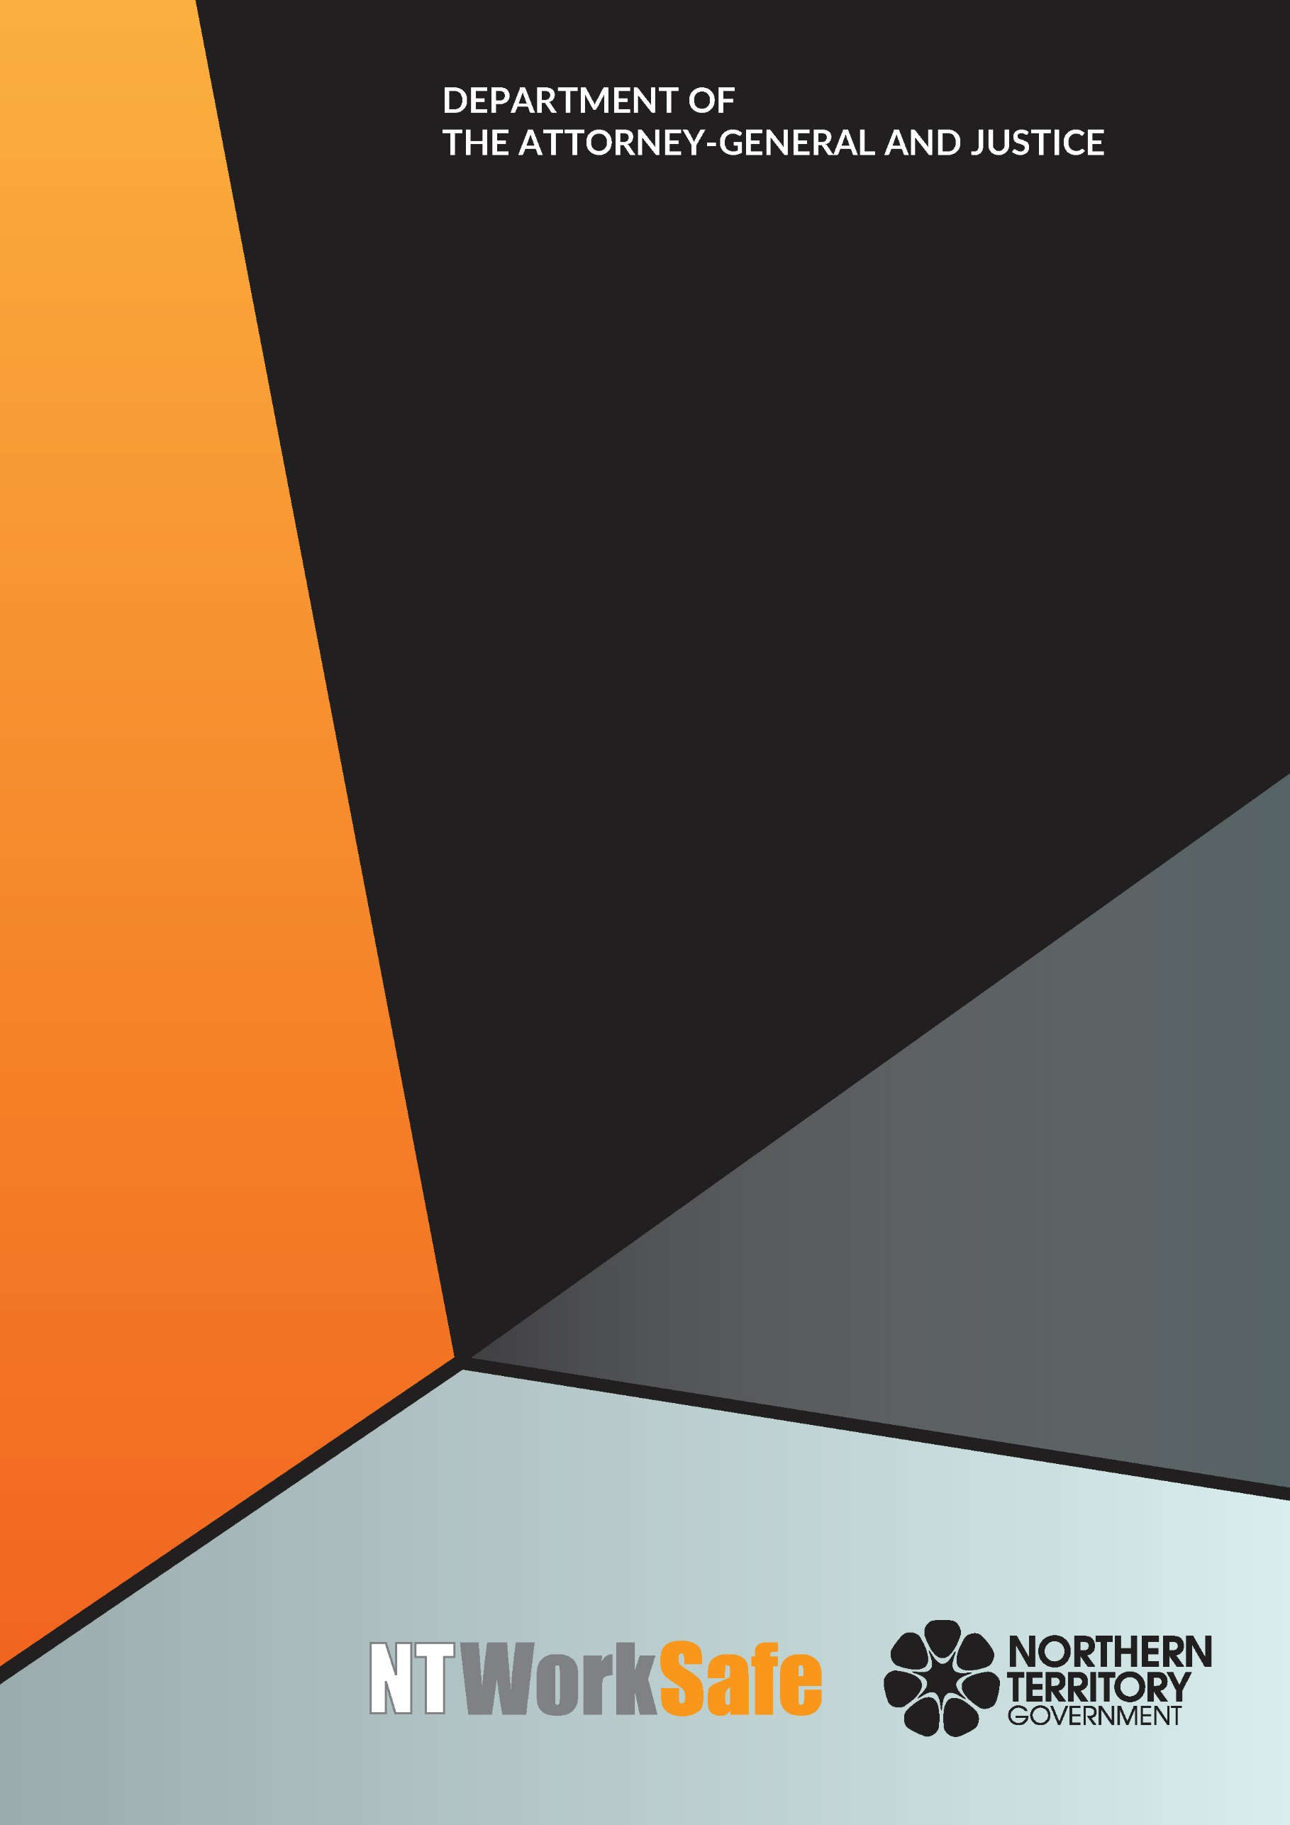
Work Health and Safety Advisory Council
  - Annual Report
  - 2017-18

Contents
Function and Purpose of the Advisory Council 3
Membership of the Advisory Council 4
Members of the Council for 2017-2018 5
Ms Andrea Moriarty, Construction Industry - Chair 5
Ms Neilia Humphries, Housing Industry Association – Chair 5
Mr Stephen Gelding, NT WorkSafe – Work Health Authority 5
Mr Thomas Mayor, Construction, Forestry, Maritime, Mining and Energy Union – Deputy Chair 6
Ms Marita Wilson – Construction Industry 6
Mr Adam Giuliani – Unions NT 6
Mr George Roussos – Legal Industry 6
Ms Skye Lee – Community Services Industry 7
Mr Sean O’Connor – Remote and Indigenous Employment 7
Mr Tim Loth - Aboriginal Health Industry….………………………………………………………………… 7
Ms Tracy Allen - Construction Industry …………..…………………………………………………………. 7
MS Early Early – United Voice 8
Mr Scott Lawton – Road Transport Industry 8
Mr Jeff Huyben – Accommodation and Food Industry 8
Mr Bryan Wilkins – Unions NT 8
Mr Bruce Anderson – Resource and Mining Industry 9
Mr Brian Fowler – Resource and Mining Industry 9
Mr David Hayes – Electrical Trades Union 9
Activities of the Advisory Council for 2017-2018 10
Planned Activities of the Advisory Council for 2018-2019 10

Function and Purpose of the Advisory Council
The Work Health and Safety Advisory Council (WHSAC) is a tripartite body, established to provide advice on the administration of the Work Health and Safety (National Uniform Legislation) Act (the Act) and standards of work health and safety in the Northern Territory.
In accordance with schedule 2(3) of the Act, the functions of the Council are:
- to keep under review the operation of this Act;
- to make recommendations to the Minister on possible changes to:
- the administration of this Act; or
- standards of work health and safety in the Northern Territory;
- at the request of the Minister, to investigate and report to the Minister on matters relating to work health and safety; and
- to perform any other advisory functions relating to work health and safety as the Minister directs.

Membership of the Advisory Council
Schedule 2(4) of the Act outlines membership of the Council as follows:
  - The Council consists of:
    - the person constituting the Authority under section 4(3) of the Work Health Administration Act; and
    - not more than 10 other persons appointed by the Minister.
  - The members appointed under subclause (1)(b) must:
    - include persons with a wide range of experience extending as far as possible across all major industry sectors in the Territory; and
    - as far as practicable, consist of equal numbers of representatives of organisations representing employees.
There is no legislative requirement for meetings to be held on a regular basis.

During the 2017-2018 financial year the tenure of the presiding Council ended and a new Council was appointed. On 13 February 2018, an invitation seeking nominations from interested persons and organisations to the Council due to the expiry of all members on 22 April 2018 was approved.
In accordance with Schedule 2(5) of the Work Health and Safety (National Uniform Legislation) Act, expressions of interest were invited through advertisements in the Northern Territory Gazette, the NT News, the Central Advocate and published on the NT WorkSafe website.
The nomination period ended on 7 March 2018 and the current Council was appointed on 3 May 2018. Three members of the former Council were reappointed along with seven new members who completed the Council.

Members of the Council for 2017-2018

Andrea Moriarty, Construction Industry - Chair

(Appointed 3 May 2018)
Ms Moriarty is a Director of Killarney Homes and the current Vice President of the Master Builders Association NT. Ms Moriarty has been involved with residential construction for the past 11 years. Prior to this Ms Moriarty was a Registered Nurse with a focus on Health Education earning a Graduate Diploma in Mental Health and Renal Health. Over the years Ms Moriarty has been involved with Workplace Health and Safety in both public and private enterprises.

Neilia Humphries, Housing Industry Association – Chair
(Resigned 27 November 2017)
Ms Humphries is the Executive Director of the Northern Territory branch of the Housing Industry Association (HIA), Australia’s peak residential building, renovation and development industry association. HIA has over 40,000 members nationally including builders, manufacturers, suppliers and building-related trades, with 400 members in the Northern Territory. Over many years Ms Humphries has been involved in the implementation and management of safety systems in industries including aviation, local government and vocational education and training.

Mr Stephen Gelding, NT WorkSafe – Work Health Authority
Mr Gelding was appointed as the Work Health Authority on 16 August 2014. He is the Executive Director of NT WorkSafe, the Electricity Safety Regulator and the Chief Inspector under the Radioactive Ores and Concentrates (Packaging and Transport) Act. Mr Gelding is also the Northern Territory member of Safe Work Australia and the Heads of Workplace Safety Authorities.

Mr Thomas Mayor, Construction, Forestry, Maritime, Mining and Energy Union – Deputy Chair

(Appointed 3 May 2018)
Mr Mayor has been working as the Northern Territory Branch Secretary for the Maritime Union of Australia a division of the Construction, Forestry, Maritime, Mining and Energy Union for the past 8 years. Maritime Union of Australia has a high union density in the maritime industries. Mr Mayor and his members are experienced in effectively managing work health and safety concerns in the marine related industry.

Marita Wilson – Construction Industry
(Re-Appointed 3 May 2018)
Ms Wilson is the Work Health Safety and Environment Manager for the Halkitis Brothers Group. Ms Wilson has 10 years’ experience on major local projects including the Strategic Indigenous Housing and Infrastructure Project (SIHIP) and the Darwin Correctional Centre at Holtze.

Adam Giuliani – Unions NT

(Appointed 3 May 2018)
Mr Giuliani served in the Australian Defence Force for 20 years’, completing tours in East Timor and Iraq. Following voluntary discharge Mr Giuliani was employed in the Mining, Construction and LNG Construction industries. Mr Giuliani is currently employed with Unions NT as the Project Officer for Work Health and Safety.
George Roussos – Legal Industry
(Appointed 3 May 2018)
Mr Roussos is a partner of Roussos Legal Advisory and has a broad experience in matters including regulatory, insurance, compensation claims and commercial disputes. Mr Roussos holds degrees in Law, Economics and Business Administration. Mr Roussos has served on a number of Committees and Business Associations including a term as President of the Northern Territory Chamber of Commerce.

Skye Lee – Community Services Industry
(Re-Appointed 3 May 2018)
Ms Lee is the Assets, Infrastructure and Maintenance Manager for Somerville Community Services. She oversees Work Health and Safety for the organisation including chairing quarterly meetings, reviewing and updating policies and procedures, and implementing changes where necessary. Ms Lee holds a Certificate IV in Occupational Health and Safety.

Sean O’Connor – Remote and Indigenous Employment
(Re-Appointed 3 May 2018)
Mr O’Connor is based in remote Nhulunbuy, East Arnhem Land and has coordinated Work Health and Safety for Yolngu Business Enterprises for the past five years and is also the Work Health and Safety Manager for Miwatj, Employment and Participation. He has diplomas in Occupational Health and Safety and Environmental Management. Mr O’Connor has ten years’ experience in the Northern Territory off-shore mining, gas and oil sector.
Tim Loth – Aboriginal Health Industry
(Appointed 3 May 2018)
Mr Loth is the Organisational Capability Manager for the Central Australian Aboriginal Congress in Alice Springs. Mr Loth is the lead Work Health and Safety Representative within the organisation. Mr Loth has over 20 years’ experience in Human Resources, Work Health and Safety, Community Relations from the heavy industry sector.
Tracy Allen – Construction Industry
(Appointed 3 May 2018)
Ms Allen has over 10 years’ experience in the Asbestos and demolition industry and is currently employed with Northern Trade Solutions (NTS) for the past five years. Ms Allen is the Work Health and Safety Manager for NTS and project manages in Asbestos removals. Ms Allen holds certification in Asbestos A and B class Supervision.

Erina Early – United Voice
(Appointed 3 May 2018)

Ms Early is employed as the Branch Secretary for United Voice NT. United Voice is the largest union in the Northern Territory (NT) representing workers in areas of security, disability, hospitality, health and aged care, corrections, paramedics, fire fighters, early childcare, aboriginal health, NT Public Sector health services, regional councils, mining and Aboriginal organisations.

Scott Lawton – Road Transport Industry
(Term of Appointment ended 22 April 2018)
Mr Lawton brings 25 years of experience to the road transport industry. He was nominated by the Traffic Management Association of Australia, which has a particular focus on improving traffic safety in the Northern Territory. Mr Lawton is an experienced Site and Project Manager, Estimator and Operations Manager who has managed key sites in Darwin. Mr Lawton runs Diggamen Civil Contracting, which was founded in Darwin in 2006 and expanded into Alice Springs in 2009.

Jeff Huyben – Accommodation and Food Industry
(Term of Appointment ended 22 April 2018)
Mr Huyben is the Resort General Manager at Chifley Alice Springs Resort, which comprises accommodation, conference and food business units. He is responsible for overseeing all operations including human resources, finance, payroll, sales and marketing and the day to day management of 70 staff.

Bryan Wilkins – Unions NT
(Resigned 14 February 2018)
Mr Wilkins is employed by Unions NT and was previously the NT organiser of the Australian Manufacturing Workers Union (AMWU). AMWU represents workers in a range of industries including manufacturing, automotive, construction, mining, printing and technical services. As an organiser with AMWU, Mr Wilkins provided advice to members on Work Health and Safety and Workers Compensation matters.

Bruce Anderson – Resource and Mining Industry
(Term of Appointment ended 22 April 2018)
Mr Anderson has worked as a health and safety professional for 27 years. His experience covers construction, mining and on and off-shore drilling. Mr Anderson has been with INPEX for the past 10 years and has recently relocated to the Northern Territory to take up the position of Onshore Health, Safety and Environment Manager at Bladin Point.

Brian Fowler – Resource and Mining Industry
(Term of Appointment ended 22 April 2018)
Mr Fowler was nominated by the Minerals Council of Australia; he is the General Manager NT and Sustainability, Arafura Resources. Mr Fowler has an extensive knowledge of work health and safety matters in the Northern Territory minerals sector, and is able to network effectively with a diverse range of stakeholders.

David Hayes – Electrical Trades Union
(Term of Appointment ended 22 April 2018)
Mr Hayes was nominated by Unions NT. He has extensive experience in the electrical industry having worked on domestic, commercial, industrial, hazardous facilities, mining and major project sites over his 25 years as a licenced electrician. Mr Hayes has a particular interest in work health and safety; has been an elected health and safety representative over many years; and holds a Certificate IV in Occupational Health and Safety.

Activities of the Advisory Council for 2017-2018
The Council met on four occasions during 2017-2018:
- 31 August 2017;
- 30 January 2018;
- 5 April 2018; and
- 13 June 2018.
Key issues and items the Council addressed or considered included:
- Traffic management standards in the Northern Territory;
- Work Health and Safety education for school students and young workers;
- Organisational culture of safety in the workplace;
- Nature of worker with a focus on low literacy and language barriers; and
- Health and wellbeing – monitoring the national approach by Heads of Workplace and Safety Australia.

Planned Activities of the Advisory Council for 2018-2019
Proposed work to be undertaken by the Council in 2018-2019 includes:
- Health and Safety Representative (HSR) E-Learning Training
- Work Health and Safety Conference

