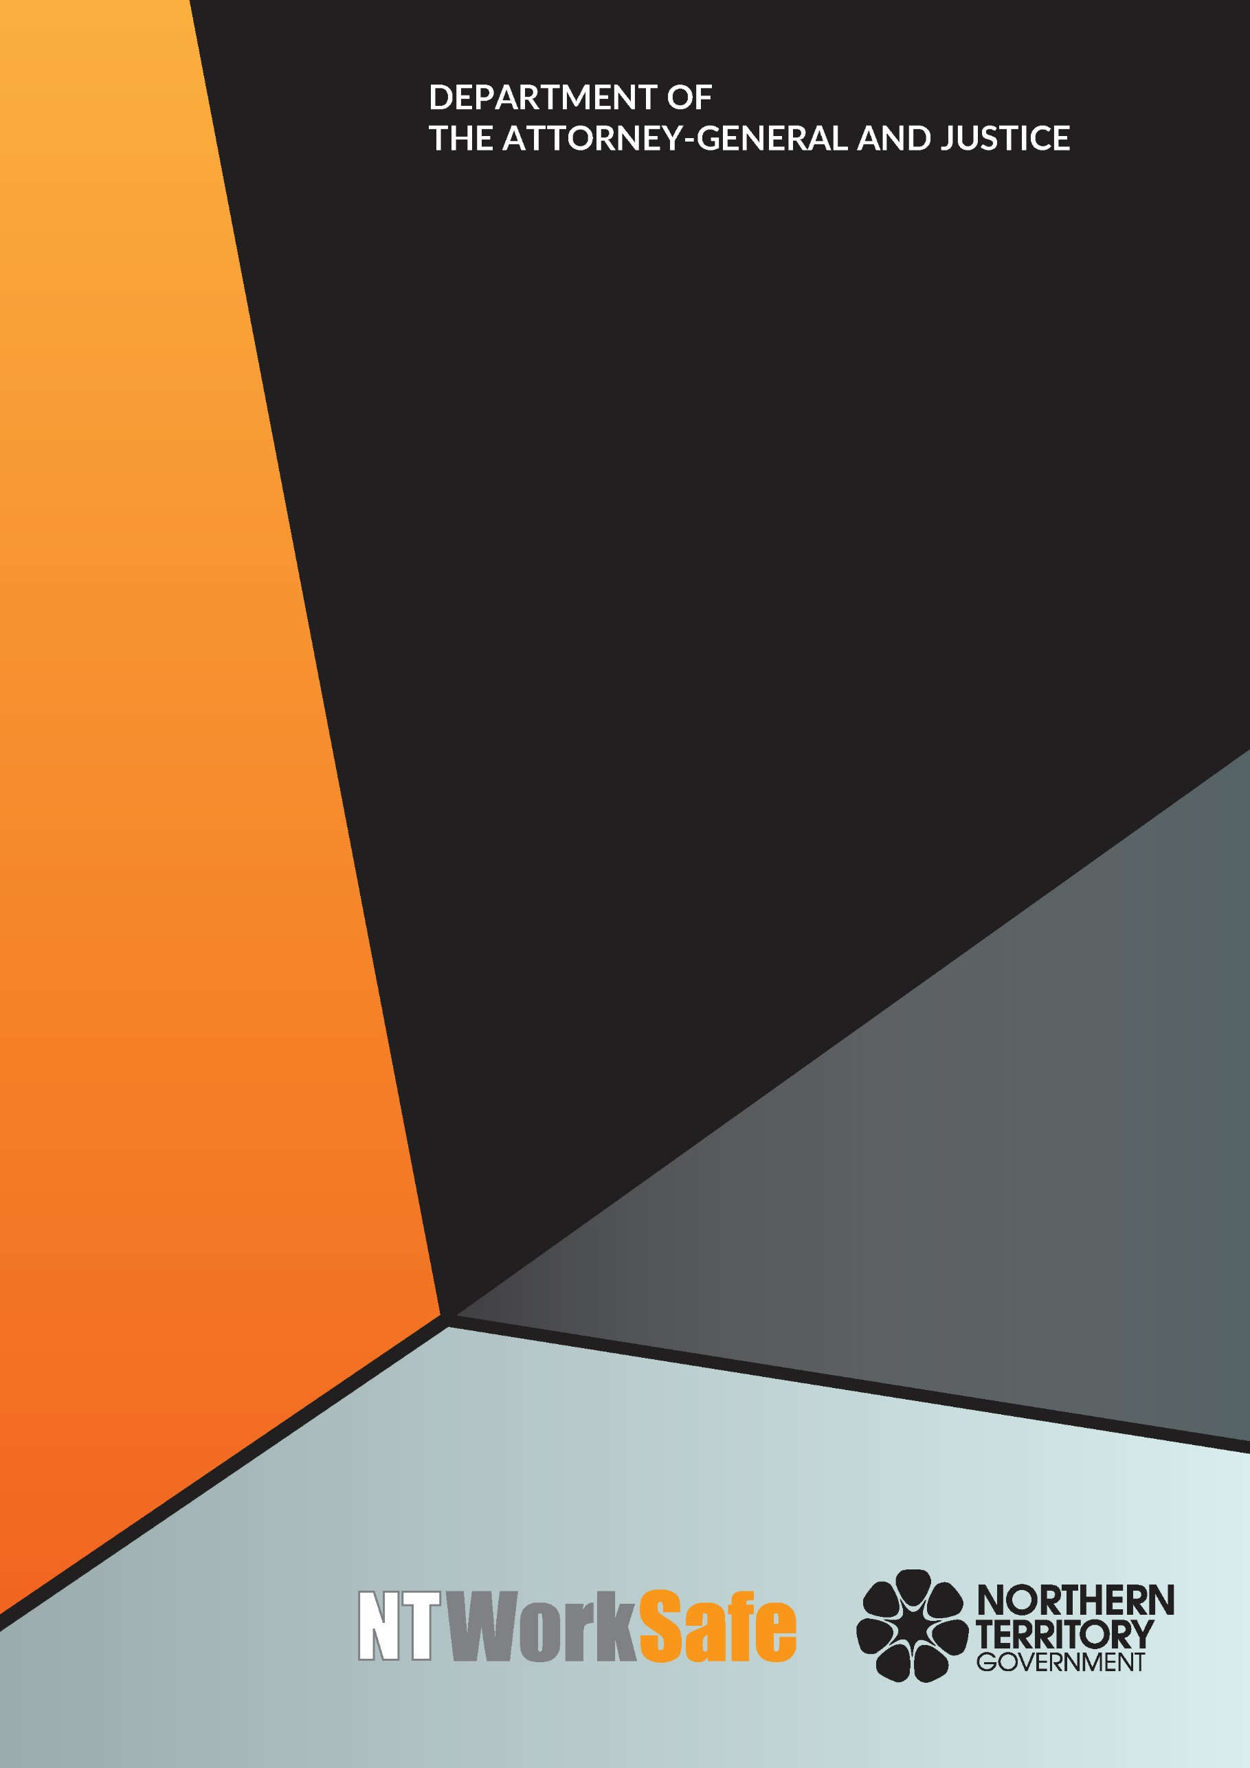
Workers Rehabilitation and Compensation Advisory Council
  - Annual Report
  - 2018-19

Contents
Function and Purpose of the Advisory Council 3
Membership of the Advisory Council 4
Council Members for 2018-2019 4
Ms Cathy Spurr, Halfpennys Lawyers – Chair 4
Ms Peggy Cheong, Hunt & Hunt – Deputy Chair 4
Ms Melissa Garde, NT WorkSafe – Acting Work Health Authority 4
Mr George Roussos, Roussos Legal Advisory – Member 4
Mr Colin Chilcott, Insurance Council of Australia – Member 5
Dr Gerry A Goodhand, Australian Medical Association - Member 5
Mr Robb Moffat, Insurance Council of Australia – Member 5
Mr Brett Hagan, Chamber of Commerce - Member 5
Ms Donna-Lee Mewburn, Advanced Personnel Management - Member 5
Ms Erina Early, United Voice NT – Member 6
Mr Joel Bowden, Unions NT – Member 6
Mr Thomas Mayor, Construction, Forestry, Maritime, Mining and Energy Union - Member 6
Activities of the Advisory Council 2018-2019 7
Planned Activities of the Advisory Council for 2019-2020 8

Function and Purpose of the Advisory Council
In accordance with section 9 of the Return to Work Act 1986, the functions of the Council are to:
- keep the operation of the Return to Work Act 1986 under review;
- make recommendations to the Minister on possible improvements to the administration of the Return to Work Act 1986, or the statutory scheme for the rehabilitation and compensation of injured workers in the Northern Territory;
- carry out investigations, at the request of the Minister, into questions about the rehabilitation and compensation of injured workers and to report to the Minister on the results of the investigations; and
- perform any other advisory functions relating to workers’ rehabilitation and compensation as the Minister directs.
The Council comprises the person constituting the Work Health Authority under section 4(3) of the Work Health Administration Act 2011 and up to 10 other members appointed by the Minister.
Council members must represent stakeholders of the Northern Territory Workers’ Compensation Scheme, including balanced representation from a wide range of industry sectors, employer and worker interests, and insurers. Membership of the Council must also include persons with expertise in the rehabilitation of injured workers.
During the 2018-2019 financial year the tenure of the presiding Council ended and a new Council was appointed. On 14 November 2018, an invitation seeking nominations from interested persons and organisations to the Council due to the expiry of all members on 14 March 2019 was approved.
In accordance with section 10 of the Return to Work Act 1986, expressions of interest were invited through advertisements in the NT Government Gazette, Northern Territory News, the Centralian Advocate and published on the NT WorkSafe website.
The nomination period ended on 28 November 2018 and the current Council was appointed from 19 March 2019. Nine members of the former Council were reappointed along with one new member who completed the Council.

Membership of the Advisory Council

Council Members for 2018-2019

Ms Cathy Spurr, Halfpennys Lawyers – Chair
(Reappointed 19 March 2019)
Ms Spurr has been a member of the Workers Rehabilitation and Compensation Advisory Council since 2009 and is the current Chair of the Council. Ms Spurr is a partner at Halfpenny’s Lawyers and works predominantly on cases related to workplace injury, personal injury and medical negligence. Ms Spurr acts on behalf of workers and unions and plays a key role in representing the interests of injured workers. Ms Spurr has extensive experience dealing with complex workers compensation matters.

Ms Peggy Cheong, Hunt & Hunt – Deputy Chair

(Reappointed 19 March 2019)
Ms Cheong is the Director of Hunt & Hunt Lawyers and has practiced in the Northern Territory for over 20 years. Ms Cheong has an interest in the ongoing development and evolution of work health and safety, workers compensation and rehabilitation. Ms Cheong is the current Chair of the Ethics Committee of the Law Society of the Northern Territory.

Ms Melissa Garde, NT WorkSafe – Acting Work Health Authority
Ms Garde was appointed as the Acting Work Health Authority on 29 January 2019 and is also the Acting Executive Director of NT WorkSafe, the Electricity Safety Regulator and the Chief Inspector under the Radioactive Ores and Concentrates (Packaging and Transport) Act 1980. Ms Garde is also the Northern Territory member of Safe Work Australia and the Heads of Workplace Safety Authorities.

Mr George Roussos, Roussos Legal Advisory – Member
(Reappointed 19 March 2019)
Mr Roussos is a partner of Roussos Legal Advisory and a strong advocate of the Northern Territory workers’ rehabilitation and compensation system. He is a current member of the Scheme Monitoring Committee; a past president of the NT Chamber of Commerce and Industry; former Chair of the Workers Rehabilitation and Compensation Advisory Council and was one of the consultants engaged to undertake a review of the (now repealed) Workers Rehabilitation and Compensation Act.

Mr Colin Chilcott, Insurance Council of Australia – Member
(Reappointed 19 March 2019)
Mr Chilcott is the Regional Underwriting Manager, Workers Compensation for QBE Insurance and the nominee of the Insurance Council of Australia. Mr Chilcott has been a member of the Council since 2010 and was Deputy Chair from 2015 to 2017. Mr Chilcott has extensive experience with the Northern Territory workers compensation scheme.

Dr Gerry A Goodhand, Australian Medical Association - Member
(Reappointed 19 March 2019)
Dr Goodhand has been the Australian Medical Association nominee on Council since 2011. He is a general practitioner who regularly works with patients who are workers’ compensation claimants.

Mr Robb Moffat, Insurance Council of Australia – Member
(Reappointed 19 March 2019)
Mr Moffat is the Executive Manager, Western Region Workers Compensation Claims for GIO and the nominee of the Insurance Council of Australia. Mr Moffat has over 26 years of experience within the Northern Territory and Western Australian Personal Injury Schemes with particular focus on Workers Compensation.

Mr Brett Hagan, Chamber of Commerce - Member

(Reappointed 19 March 2019)
Mr Hagan was nominated by the Chamber of Commerce NT to represent employer interests on the Council. Mr Hagan has been involved with the Chamber of Commerce NT since the mid 1980’s and has held a position on their board since 2012. Mr Hagan has worked in the insurance industry since 1980 and has experience with claims, underwriting and account management.

Ms Donna-Lee Mewburn, Advanced Personnel Management - Member
(Reappointed 19 March 2019)
Ms Mewburn is an occupational therapist who has worked as the Northern Territory Manager for Advanced Personnel Management (APM) since 2006. Ms Mewburn has developed her knowledge and skills within the workers’ compensation and rehabilitation industry in her role with APM, providing support to relevant stakeholders such as injured workers, employers, treatment providers and insurers. Ms Mewburn has been a National Council Member of the Australian Rehabilitation Providers Association (APRA) since 2009. This position has provided opportunities to gain understanding of workers’ compensation issues within other jurisdictions across Australia.

Ms Erina Early, United Voice NT – Member

(Reappointed 19 March 2019)
Ms Early is employed as the Branch Secretary for United Voice NT. United Voice is the largest union in the Northern Territory (NT) representing workers in areas of security, disability, hospitality, health and aged care, corrections, paramedics, fire fighters, early childcare, aboriginal health, NT Public Sector health services, regional councils, mining and Aboriginal organisations.

Mr Joel Bowden, Unions NT – Member

(Appointed 19 March 2019)
Mr Bowden is the General Secretary for Unions NT, a peak body for unions in the Northern Territory. Mr Bowden hold a Bachelor of Education and Masters in Business Administration and is currently studying a Bachelor of Law.

Mr Thomas Mayor, Construction, Forestry, Maritime, Mining and Energy Union - Member

(Appointed 16 April 2018 – 14 March 2019)

Mr Mayor has been working as the Northern Territory Branch Secretary for the Maritime Union of Australia a division of the Construction, Forestry, Maritime, Mining and Energy Union for the past 8 years. Maritime Union of Australia has a high union density in the maritime industries. Mr Mayor and his members are experienced in effectively managing work health and safety concerns in the marine related industry.

Activities of the Advisory Council 2018-2019
The Council met on four occasions during 2018-2019:
- 02 August 2018;
- 08 November 2018;
- 07 March 2019; and
- 06 June 2019.

Key issues and items the Council addressed or considered included the:
- the Alternative Employer Incentive Scheme;
- Permanent Impairment Assessments for Progressive Disease (Cancer);
- Independent Medical Examinations (IMEs);
- Regulations and Recovery for medical fees for Workers Comp – Hospital;
- Non-Cash Benefits;
- National Return to Work Strategy;
- National Certificate of Capacity;
- Interstate/Overseas Claims processing; and
- Workers Compensation premiums.

Planned Activities of the Advisory Council for 2019-2020
Proposed work to be undertaken by the Council in 2019-2020 includes:
- Non-compliance on Workers Compensation Policies;
- Monitoring Return to Work legislative changes;
- Recommended rates on premium percentage increases; and
- Hospital fees charged to injured workers prior to acceptance of claim.

