  - Guide

Electrical equipment and LP gas installations at markets, shows and sporting events
Disclaimer
This publication contains information regarding work health and safety. It includes some of your obligations under the Work Health and Safety (National Uniform Legislation) Act 2011 and the Dangerous Goods Act 1998 that NT WorkSafe administers. The information provided is a guide only and must be read in conjunction with the appropriate legislation to ensure you understand and comply with your legal obligations.
Contents
Introduction 5
Who has duties under the law? 5
Electrical safety 6
Assess the risks 7
Implement risk controls 7
Fire protection 8
Gas safety 9
Purchasing gas equipment for commercial use at markets and shows 9
Transporting of gas cylinders 9
Transporting in enclosed vehicles 9
Transporting in open vehicles 10
Setting up gas cylinders 10
When setting up gas cylinders the following shall be considered or adhered to: 10
Regulators 11
Gas hoses 11
Gas System examples 12
Setup for an appliance with a low mh/h consumption rate. 12
Set-up for use with one appliance or more than one appliance connected via a manifold. 13
A two cylinder set-up for large LP Gas consumption. 90 mj/h plus 15
Examples of hoses, regulators and appliances not suitable for use by stall holders 16
Appliances 17
Examples of camping or leisure products that are not suitable for commercial use. 18
Acceptable for commercial use 19
Preferred crate set up 20
Mobile Catering Vehicles: Including, catering caravans, trailers, transportable kitchens and self-propelled vehicles. 21
Maximum quantity of LP Gas for caravans. 21
LP Gas installation requirements. 21
Outdoor group of temporary structures 22
Group of temporary structures 22
LP Gas cylinders in groups of temporary structures with LP Gas cylinder 23
Using LPG cylinders safely at indoor public events 24
Limits for LPG volumes indoors 25
Appliances and Ventilation 25
What you should do if there is a gas leak or you suspect you detect a gas leak. 26
In the event of fire: 26
Appendix A - Markets, shows and sporting events checklist 27

Introduction
This Guide provides information on how to manage electrical and Liquefied Petroleum (LP) gas risks at indoor and outdoor markets, shows and sporting events.
To comply with the Work Health and Safety (National Uniform Legislation) Act 2011 and Regulations and the Dangerous Goods Act 1998 and Regulations, stallholders must meet certain requirements in the Northern Territory.
Further information can be found in the following Australian Standards available from the SAI Global website.
- AS 1596 - LP Gas - Storage and handling.
- AS1851 - Maintenance of fire protection systems and equipment.
- AS 1869 - Hose and hose assemblies for liquefied petroleum gases.
- AS 2658 - Liquefied Petroleum (LP) Gas - Portable and mobile appliances.
- AS 3000 – Electrical installations – Wiring rules.
- AS 3002 – Electrical installations – Shows and carnivals.
- AS 3760 - Testing of Electrical Equipment.
- AS 5601 - Gas installations – Part 1 General installations.
- AS 5601 - Gas installations – Part 2 LP Gas installations in caravans and boats for non-propulsive purposes.
A checklist in Appendix A may assist stall holders in achieving compliance.

Who has duties under the law?
Everyone in the workplace has a work health and safety duty of care under the Work Health and Safety (National Uniform Legislation) Act 2011. This includes:
- The event organiser (referred to as a PCBU)
- The stall holder (referred to as a PCBU)
- The workers on site.
The main duties for duty holders are set out below in Table 1.
Table 1 Duty holders and their obligations
Who | Duties
A person conducting a business or undertaking  This includes stall holders | A person conducting a business or undertaking (PCBU) must ensure, so far as is reasonably practicable, that workers and other people are not exposed to health and safety risks arising from the business or undertaking.  A ‘PCBU’ is a term that includes all types of working arrangements such as organisations, partnerships, sole traders or small business owners. For example a builder, a manufacturing business, a fast food franchisee and a self-employed person operating their own business are all persons conducting a business or undertaking.  A PCBU who has management or control of a workplace must ensure, so far as is reasonably practicable, the workplace, the means of entering and exiting the workplace and anything arising from the workplace is without risks to health and safety.
Workers and others | Workers and other people at the workplace must take reasonable care for their own health and safety, co-operate with reasonable policies, procedures and instructions and not adversely affect other people’s health and safety.
Emergency Plans | Duty to prepare, maintain and implement emergency plan  A person conducting a business or undertaking (PCBU) at a workplace must ensure that an emergency plan is prepared for the workplace that, that provides for the following:  - emergency procedures, including:  - an effective response to an emergency; and  - evacuation procedures;  - notifying emergency service organisations at the earliest opportunity; and medical treatment and assistance; and  - effective communication between the person authorised by the person conducting the business or undertaking to coordinate the emergency response and all persons at the workplace.
Duty to notify of incidents | Ensure that the regulator is notified immediately after becoming aware that a notifiable incident arising out of the business or undertaking has occurred.  Information regarding incident notification can be found on the NT WorkSafe website.
Organisers of public events | Organizers of public events have a legal duty of care to provide a safe work environment. Event organisers have a duty of care to manage risks associated with stall holders using LP Gas through a process of identifying, assessing and management of those risks. Referenced material and photographs in this document show what compliance looks like.

Electrical safety
There are many safety risks associated with electrical equipment at markets, shows and sporting events particularly if they are of a temporary nature. Therefore, particular care should be taken by the event organiser to ensure that adequate controls are in place to protect members of the public from the safety risks pertaining to such equipment.
Some hazards may include:
- Equipment faults which may cause fires and cause electric shock injury;
- Tripping over chords;
- Overloading of circuits causing excessive temperatures possibly resulting in a fire;
- Lack of insulation or damaged insulation on leads;
- Temporary wiring is not buried at appropriate depth;
- Temporary wiring is not protected from mechanical damage;
- Equipment is too close to overhead power lines;
- fire or explosion, where electricity could be the source of ignition in a potentially flammable or explosive atmosphere due to confined areas;
- The ingress of rain water, liquids, dusts and high humidity causing electric shock;
- Contact with live parts if modifications or repairs to electrical equipment was undertaken by unauthorised person (leading to electric shock, burns or fire);
- Missing labels or warning signs;
Hazards are more likely to occur when portable electrical equipment and extension leads, particularly when they are frequently moved, as plugs, sockets, electrical connections and cables are particularly prone to damage.
Electrical equipment should be visually inspected before and after use. Any damaged equipment should be immediately removed from the workplace, tagged “out of service” and then be repaired by an appropriately qualified person. If the component cannot be repaired then the component should be replaced.
A risk assessment of identified hazards should be undertaken.

Assess the risks
The PCBU, including stall holders or mobile catering owners, should evaluate the risks for each identified hazard associated with the electrical equipment used. The degree and likelihood of employees being exposed to those hazards should also be assessed.
In assessing risks, employers should take into account the:
- type of equipment being used;
- environmental conditions;
- likelihood of damage to the equipment;
- risk of employees being exposed to energised parts;
- manufacturers' recommendations, for example whether the equipment is suitable for commercial use;

Implement risk controls
Once you have assess the risk consider the appropriate controls for your circumstance.
Some of the common controls include:
- Electrical equipment must be of an approved design that complies with Australian Standards. The use of homemade electrical equipment IS NOT acceptable.
- Ensure only competent persons, such as licensed or registered electricians, carry out modifications or repairs to electrical equipment;
- Domestic or industrial style power boards may be used in stalls and concessions provided each one is switched on and off directly from a power source (GPO).
- Do not use double adaptors. Power boards with an overload switch or a Residual Current Device (RCD) are the preferred devices.
- An extension cord may be used if the supply lead is not long enough to reach. Power boards should not be daisy chained i.e. do not supply one power board from another power board.
- All electrical equipment should have “test and tag” labels.
- Avoid overloading socket outlets including power board i.e. do not connect multiple power boards. This can overload a circuit and could result in a fire;
- All electrical equipment supplied through a socket outlet and used in a hostile environment such as a market, must be protected by a Residual Current Device (RCD) otherwise known as a safety switch. (RCDs) are required to be tested before being used. (press the test button to ensure the unit turns off)
- Avoid placing electrical cords in areas which can result in physical damage or provide a trip hazard. Extension cords run on the ground or at floor level in public traffic areas can be a tripping hazard. Power leads should be suspended on insulated lead stands or insulated lead hooks and arranged at least 2.4m above walkway levels so they do not obstruct pedestrian traffic.
- If extension cords or leads are suspended using trees then a catenary rope should be installed first and the extension cord or leads should be hung using insulated lead hooks.
- Do not hang extension cords or leads directly on to metal fencing. To avoid contact with the metal fence stall holders can use insulated lead hooks to separate the lead or power cord from the metal fence.
- If extension cords or leads are run on the ground then the extension cords must be provided with suitable protection. The extension cords or power leads should be installed so they are not subject to mechanical damage, water or abnormal temperatures.
- Use battery powered equipment instead of mains operated, where possible.
Further considerations include
- The event manager may impose conditions on stall holders and others which are above the legal standard.
- Vendors must be in attendance at their food preparation area and appliances when the appliances are energised and food is being prepared. It is not acceptable to set electric timers on appliances or switchboards and leave food and appliances unattended.

Fire protection
The provision of appropriate portable firefighting equipment is paramount to prevent escalation of fires. The incorrect type of fire extinguisher used on a certain type of fire could have fatal consequences e.g. if a water type fire extinguisher is discharged onto live electrical equipment.
The Northern Territory Police, Fire and Emergency Services recommend stalls using gas-fired appliances should have the following equipment:
- 1 x 2A: 30B: (E)Dry Chemical Fire Extinguisher (1.5kg)
- 1 x Fire Blanket of 1.2 x 1.8m in size (for stalls with deep fryer facility)
These are to be mounted in an accessible position and clearly visible. They must be regularly tested on a 6 monthly basis and records maintained of these inspections. The yellow pages provide a list of organisations providing this service under the heading “Fire Protection Equipment and Consultants”.
Note: All fire-fighting equipment to be maintained six monthly as per AS1851.

Gas safety
Liquefied Petroleum Gas (LP Gas) is a flammable gas stored in cylinders under pressure. Failure to apply strict precautions in the use of gas can result in major damage to property and injury to people.
Because we use gas everyday there is a tendency to overlook how potentially dangerous it can be.
The risks are greater when using gas in areas where there are large numbers of people such as markets, shows and sporting events.
All appliances, regulators, connectors and hoses must be of an approved design. Home-made gas appliances and equipment can be dangerous and is not acceptable.

Purchasing gas equipment for commercial use at markets and shows
Not all gas equipment can be used for commercial purposes. Leisure products such as camping gear and domestic BBQs are generally not designed for continuous commercial use and can be unsafe, if used in this manner.
However this type of equipment may be used if the appliance is approved by the manufacturer for commercial purposes.
When purchasing gas appliances for use at markets, shows and sporting events, you should firstly check with the supplier and request evidence that the equipment is Type A or commercially rated and then look for the Australian Gas Association marking that certifies this. The following labels show that the appliance has been approved by a certifying body.
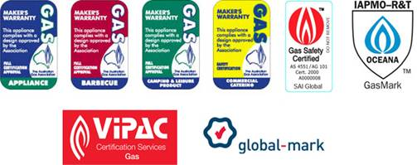
Figure 1: Australian Gas Association certification labels

Transporting of gas cylinders

Transporting in enclosed vehicles
The total quantity of LPG transported in a vehicle should not exceed 2 x 9 kg cylinders. All gas cylinders transported must be upright, secured, gas tight, leak checked and fitted with a screw plug.
Gas cylinders, full or empty, should not be stored inside vehicles. Any LPG cylinders that are transported inside a vehicle should be removed from the vehicle as soon as possible and stored in a well ventilated and secure area.

Transporting in open vehicles
In accordance with the Transport of Dangerous Goods by Road and Rail Regulations, no more than 250 litres of LPG can be transported in a non-commercial vehicle, e.g. 10 x 9 kg cylinders or 2 x 45 kg cylinders.
- a 9kg cylinder equates to approximately 22 Lts
- a 45kg cylinder equates to approximately 108 Lts

Setting up gas cylinders
Gas cylinders must be tested every 10 years at an approved test centre. Gas cylinders over 10 years that have not been tested or have not passed must not be used. The date your gas cylinder was last tested can be found stamped on the rim of the gas cylinder.
Leakage of LP Gas cylinders is a risk. LP Gas is heavier than air and will accumulate at low points within a structure or facility and is slow to disperse. If at any stage a leak is identified, it is important that the gas supply is immediately isolated. This can be best achieved by closing the gas cylinder valve.
Gas cylinders shall be stored with all valves closed when not in use and during transportation.
The connections in the LP Gas supply system that do not require a NT Licence gas fitter to connect or disconnect are:
- the hand wheel connection Prest-O-Lite (POL fitting) to the LP Gas cylinder; and
- the quick release connections. Eg. Bayonet or Quick connect gas fitting.

When setting up gas cylinders the following shall be considered or adhered to:
- Supply of LP Gas from more than one source may create a hazard if there is ever a need to turn off the gas supply to the group of gas appliances in an emergency.
- The LP Gas system must be originally installed and commissioned by a NT licensed gasfitter. An NT licenced gasfitter will issue you with a Certificate of Compliance (COC) and attach the compliance plate to the LP Gas system. This may be on a crate or on a caravan wall.
- Check that the Certificate of Compliance and the attached compliance plate. If you connect the wrong gas crate supply to an appliance or appliances the gas appliances may no longer be effective.
- Visually inspect the LP Gas cylinders and all gas components for signs of damage before connecting to the appliance. Do not use the system if components are faulty.
- LP Gas cylinders must be kept upright in a well-ventilated area located away from any excessive heat or physical impact.
- All LP Gas cylinders must be prevented from falling over. A vented crate shall be used to secure the LP Gas cylinder. The regulator is to be separately attached and secured to the crate. The crate must be placed on a firm, level surface.
- Do not position the LP Gas cylinders or any components that are connected to the LP Gas cylinder so they block walkways, entrances / exits or hinder the escape of people in an emergency situation.
- All connections, hoses or fittings must be gas tight and sound. Finger tight is not enough and may leak.
- Before operating any gas appliances, all connections in the system must be checked to ensure the connections are tight and free of gas leaks. The use of an ammonia free soap and water or ammonia free detergent solution is the safest method to check for gas leaks.

Regulators
Regulators provide control over the delivery rate and pressure within a LP gas system. Regulators are an important safety feature of any gas installation. All LP Gas supply to appliances at markets, shows and sporting events shall use a low pressure dual stage regulator.
The LP Gas cylinder regulator must be low pressure (3 kPa maximum outlet pressure) with all appliances operating. A LP Gas cylinder regulator should be rigidly fixed to an adequate support that is independent of the cylinder. The regulator is to be mounted with the diaphragm vertical and the vent pointing vertically downwards. The regulator vent should be at least 1m away from a source of ignition. Regulators shall be connected to the LP Gas cylinder in accordance with AS/NZS 5601 and AS/NZS 1596.
The regulators on the LP Gas supply system should be visually inspected before and after use to identify any damage or defects. Do not energise the LP Gas system if you identify any fault or damage on either regulator. Engage a Licensed NT gasfitter to replace or adjust your regulator/s.

Gas hoses
To provide a safe working environment all hose connections from the appliance to the LP Gas cylinder regulator should be at the rear of the appliance. This should prevent tripping hazards for the operator, staff or members of the public.
A flexible hose, connected from the regulator to the gas appliance should be no longer than 3 metres. The hose type should meet the relevant Australian Standard and suitable for the appliance and application in accordance with AS/NZS 1869.
Hose connections shall be permanently attached to the appliance. If this is not possible a quick connect or bayonet connection should be installed at the appliance.
An approved flexible copper pigtail or flexible hose is to be used to connect the regulator to the LP gas cylinder. This hose also has an excess flow valve that slows the flow of gas should the hose be damaged.
Because of the temporary nature of market type stalls, flexible hoses are subject to greater damage from increased handling. You should regularly inspect the condition of hoses and engage a licensed NT gasfitter to replace the hose if it is damaged or deteriorated in any way.
Some flexible hoses have a life span of 5 – 6 years after the date of manufacture. Hoses may need to be periodically replaced. Contact your gas supplier, licensed NT gasfitter or the flexible hose manufacturer for details or clarification.

Gas System examples

Setup for an appliance with a low mh/h consumption rate.
- One LP Gas cylinder supply
- One appliance
- 15 mm hose
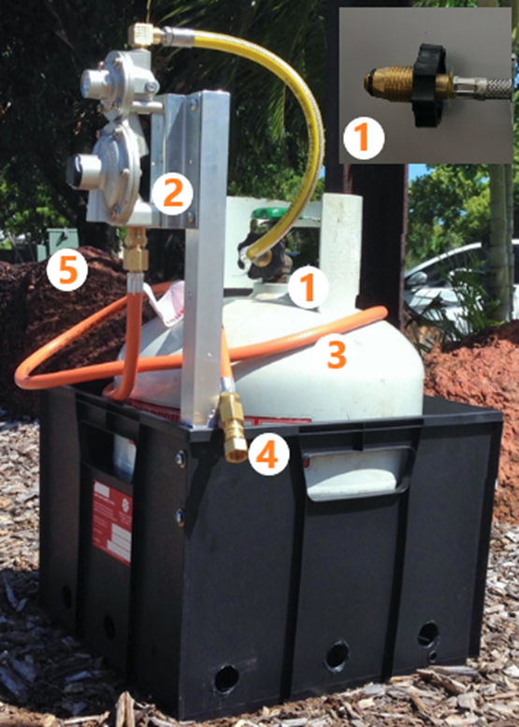
Figure 2: One LP Gas Cylinder for one appliance with low consumption rate
- The flexible hose pigtail has a hand wheel and an integral excess flow valve that restricts gas should the hose be damaged. The wheel POL connection fitting has a rubber “O” ring to assist with sealing the connection. Before fitting the connection check that the “O” ring is in good condition and fit for purpose.
- Two stage regulator that reduces cylinder high pressure to appliance low pressure of 2.7kpa.
- The hose assembly is 15mm diameter and no more than 3m in length.
- The quick connect at the outlet of the hose may be attached to the appliance.
Regulator vent should be at least 1m away from source ignition.

Set-up for use with one appliance or more than one appliance connected via a manifold.
- One gas cylinder supply
- Multiple appliances
- 20 mm hose
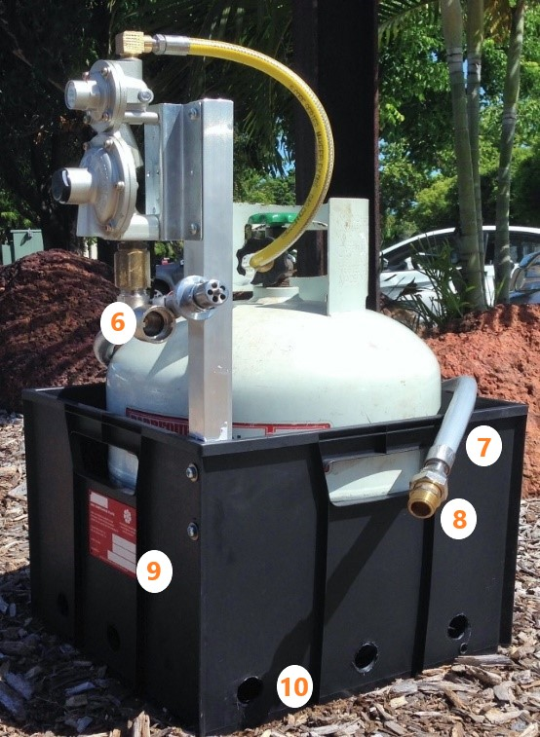
Figure 3: one LP gas cylinder for multiple appliances via manifold
- This bayonet / quick connection is permanently connected to the regulator.
- This set-up has a 20mm diameter hose for appliances with higher gas usage.
- The hose should be connected permanently to the appliance.
- A NT Compliance plate
- The crate housing the cylinder has 3 X 25mm ventilation holes on each side.
- Quarter turn isolation valve.
- Hose from the appliance isolation valve with quick connect hose assembly is attached permanently to the appliance

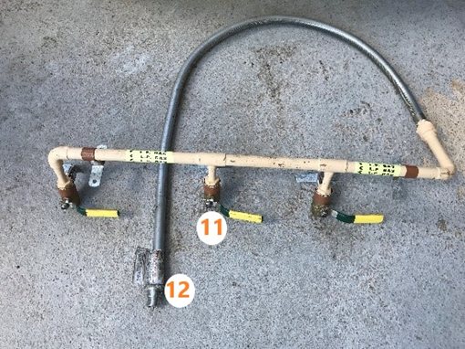
Figure 4: Manifold example with isolation valve
The photograph above shows a manifold system with an appliance isolation valve and a quick connect fitting for use when multiple appliances are required from one supply.
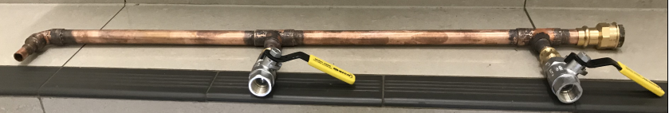
Figure 5: multiple appliance manifold
The photograph above shows a multiple appliance manifold. Any unused connections must be mechanically sealed.

A two cylinder set-up for large LP Gas consumption. 90 mj/h plus
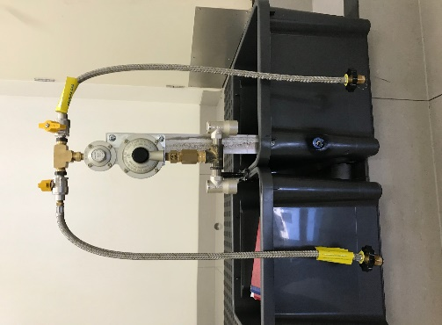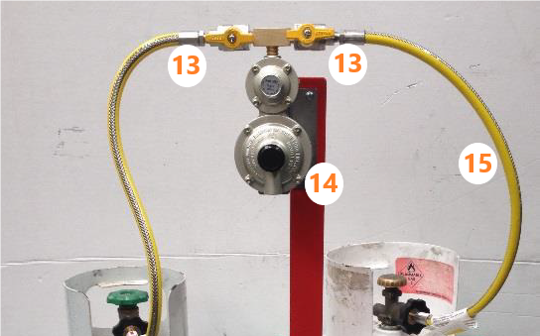
Figure 6: Two cylinder set-up for higher LP gas usage eg. 90 mj/h and over.
- A quarter turn isolation valve is used to isolate each cylinder as required.
- A manifold is required to connect a 20mm hose to the regulator. A quick connect fitting is required at this point. The outlet of the hose is permanently connected to the mannifold. See figure 4 above.
- Flexible pigtail hose with a hand wheel.

Examples of hoses, regulators and appliances not suitable for use by stall holders
Figure 7: Examples of unsuitable and possibly very dangerous appliance installations.
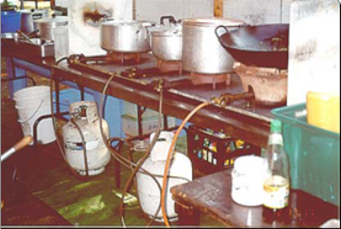
- Poor ventilation around the appliances.
- Uncertified appliances for use with a high pressure regulator.
- Unsecured appliances on bench top.
- Incorrect high pressure regulators
- Too many gas cylinders inside the facility.
- Gas cylinders too close to a source of combustion. Under the burners.
- Burner too close to a combustible surface
- Hoses at the front of the appliance.
- Gas cylinders not secured to prevent toppling.
Figure 8: An example of an unsuitable gas appliance.
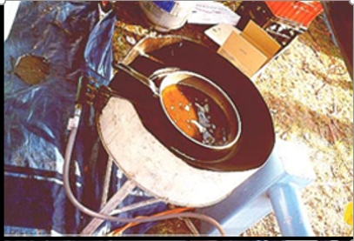
- Poor ventilation around the appliances.
- Uncertified / homemade appliance.
- The use of high pressure regulator.
- High pressure burner
- Unsecured appliance.

Figure 9: An example of an unsuitable set-up.
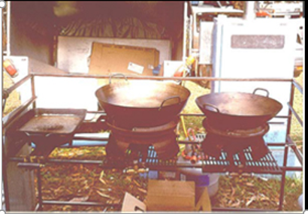
- Uncertified homemade appliances.
- The appliances are using high pressure regulators and high pressure burners.
- Unsecured appliances.
- Combustible materials in the vicinity of the burners.

Figure 10: An example of an unsuitable appliance installation.
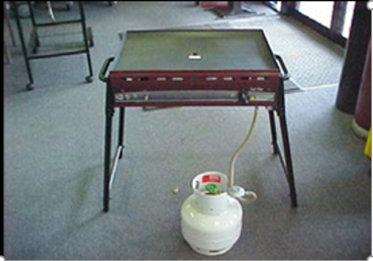
- Domestic barbecue set up inside a building.
- Manafacturers operating instructions to be referred to.
- Ventilation issues must be considered.
- Domestic barbecue regulator.
- The appliance is set up close to an access and egress point.

Appliances
- Ring burners and portable wok burners are not suitable for use at events unless the burner is certified, suitable for low pressure use and has an integral pan support.
- Appliances on benches need to be secured to prevent movement and should only be used on a non-combustible surface.
- Do not leave any LP Gas appliance unattended if the burner/s have been lit or if the cooking is in progress.

Examples of camping or leisure products that are not suitable for commercial use.

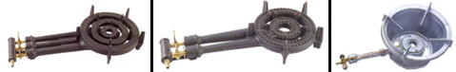
These burners are not secured. Pots and pans can be unstable when they are sitting on the burners. These burners use a high pressure gas regulators and operate on high pressure gas supply. They are not suitable for use in the market environment.
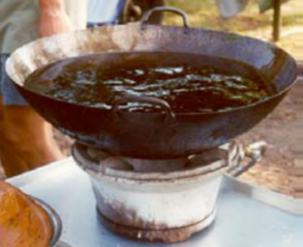
This burner is not certified. The wok contains too much oil and the burner has not been secured. The wok is unstable.
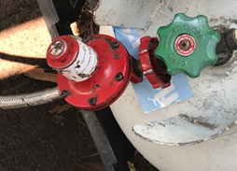
This regulator is a single stage / higher pressure regulator and not suitable for use in the market environment.
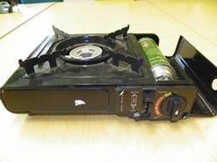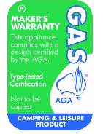
Gas cartridge cookers are not suitable for commercial use and are only approved by the AGA for camping and leisure use.

Acceptable for commercial use
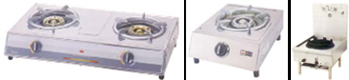
The burners in the above photograph are certified and suitable for use with low pressure regulators.
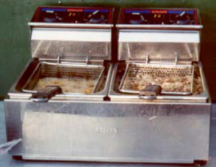
This deep fry appliance is certified and suitable for use with a low pressure regulator.
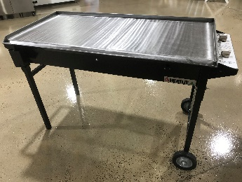
A certified and suitable heavy duty hot plate barbecue.

Preferred crate set up
Two stage regulator
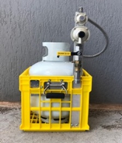
This ¼ turn isolation valve is advised to be installed however not compulsory.

A bayonet connection or Quick connect device.
It can be used to shut off the gas in case of an emergency. It is also used to connect and disconnect the appliance without using hand tools.

This testing point is advised to be installed however this is fitting is not compulsory.

Compliance plate issued by a licensed NT gasfitter for the LP Gas system is compulsory.
This gas supply system has a quarter turn cylinder isolation valve, test point, quick connect fitting, compliance plate and carry handle.
Talk to your local NT Licensed gasfitter for advice and installation.

Mobile Catering Vehicles: Including, catering caravans, trailers, transportable kitchens and self-propelled vehicles.

Maximum quantity of LP Gas for caravans.
Regulation 209 of the Dangerous Goods Act 1998 requires:
- Unless otherwise approved, a fuel gas system installed in a caravan shall be not be connected to a gas cylinder having a capacity exceeding 10 kg.
- Unless otherwise approved, the maximum quantity of LP Gas in gas cylinders that may be installed or carried in or on a caravan is 20 kg.
Further information can be found on the Mobile food vehicles NT Department of Health website.

LP Gas installation requirements.
- LP Gas appliance installations for catering purposes are required to conform to Australian Standard AS/NZS 5601. Part 1 and 2.
- Supply from more than one source may create a hazard if there is ever a need to turn off the gas supply to the group of gas appliances in an emergency.
- The mobile catering vehicle shall be fitted with a fire blanket and a suitable portable extinguisher.
- An NT compliance plate is to be securely positioned on the mobile catering vehicle in a readily accessible and visibly positioned, beside the vehicle identification plate or beside the gas equipment storage compartment. The Certificate of Compliance should identify the certified appliances make / model, pipework used and LP Gas cylinder identification.
- An interstate equivalent compliance plate or a certificate that has been issued from an interstate regulatory system that ensures that the Mobile Catering Vehicle complies with the appropriate installation standard is acceptable in the NT for the duration of the event.
- Example: A mobile catering vehicle with an internal LP Gas appliance.
  - The LP Gas supply is connected to an LP Gas manifold consisting of two 9kg cylinders secured externally to the trailer or two 9 kg installed in an appropriately ventilated compartment. The compartment must be sealed so LP Gas cannot enter the trailer.
  - Fully annealed copper tube from the LP Gas cylinder regulator outlet to the appliance is to be installed underneath the trailer and is to be protected from damage. All joints must be accessible. When installing commercial appliances refer to AS/NZS 5601.1.
- Only approved fittings, hose connections and pipework are permitted on mobile vehicles.
  - Fittings not to be used include:
- Rubber ring crimp
- Crox joints
- Compression fittings with non-metallic olives
- Compression fittings with metallic olives if not approved for use with gas in the manufacturer’s instructions
- Long screw connections
- Capillary fittings containing soft solder
- Plain nipples.
- A changeover valve can be used on the regulator or two cylinder quarter turn isolation valves.
- An emergency isolation valve is installed inside the mobile catering vehicle in an easily accessible and safe location to shut off all the LP Gas appliances inside the vehicle. The emergency isolation gas valve is to be identified with appropriately ladled and fixed signage.
- All appliances shall be certified to AGA certification or an equivalent certification.
- All appliances shall be fitted with flame failure safeguard systems to all burners.
- The mobile catering vehicles should have adequate natural ventilation while the LP gas appliances are burning gas.
- Licensed NT Gasfitters who install and commission LP Gas systems in mobile catering vehicles need to be aware of the ventilation requirements regarding the gas consumption to ensure the safe operation of appliances. Licensed NT Gasfitters need to ensure adequate ventilation is available to eliminate the possibility of contaminated flames producing Carbon Monoxide and / or reducing safe oxygen levels in the workplace.
- If permanent mechanical ventilation is required to be installed to meet the ventilation requirements then the ventilation system must be interlocked with the LP gas supply system.
- Mechanical extraction such as an exhaust range hood may also be required to be installed inside the vehicle to remove steam, smoke, products of LP gas combustion and greasy vapour from the cooking area. This is a NT Department of Health requirement. Contact the NT Department of Health for clarification or for further information.

Outdoor group of temporary structures

Group of temporary structures
Where there are temporary structures at a public venue grouped together, such as a group of marquees, stalls or tents at a show, there should only be a maximum of 10 structures using LP Gas in any such group.
Groups of temporary structures using LP Gas should be separated by at least 15 metres.
The intervening space may be occupied by temporary structures in which no flammable gas or liquids are kept. See figure 1 below.

LP Gas cylinders in groups of temporary structures with LP Gas cylinder
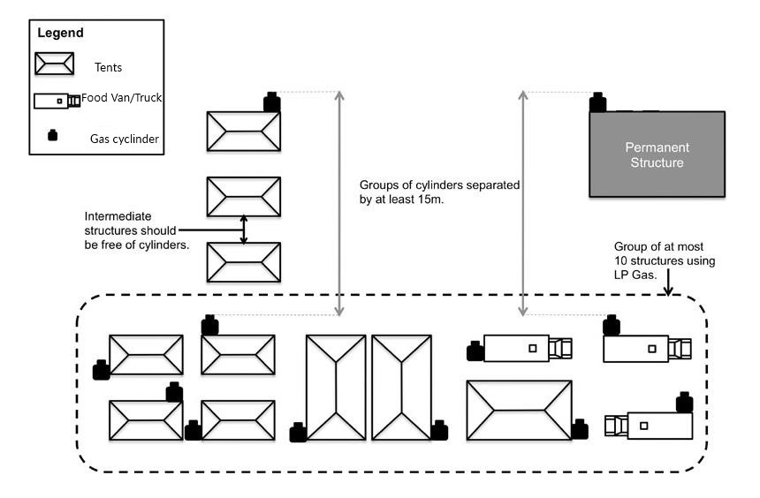
Figure 11: Examples of adequately ventilated outdoor areas
Adequately ventilated outdoor areas may include
- protected places.
- public places.
- open air installations.
- temporary structures e.g. tents, marquees, booths and under awnings.
For temporary structures there must be a minimum of two open sides. Any extra flow of air can assist with combustion or for dispersing burnt gas. If it is possible vendors should consider opening the other sides or the lower sections of the marquee or tent. This will allow for the natural, cross flow of air through the work area. There should be no obstructions in the tent, marquee or booth to block the free flow of air.
The free flow of fresh air at a low level could assist with dispersing any possible LP Gas leak.
An LP Gas appliance installed indoors may require additional ventilation to function correctly. There would be a need to risk assess that activity. Refer to Using LP Gas safely at indoor public events.
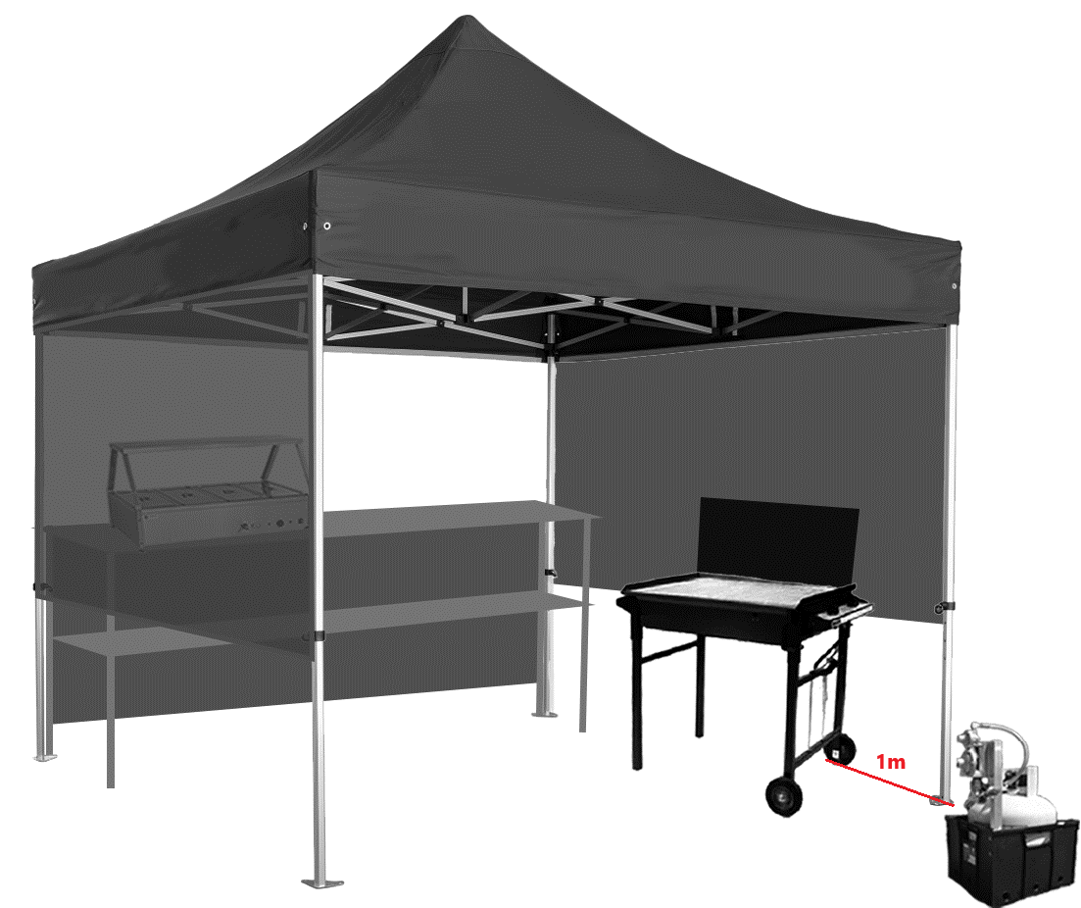
Figure 12: Adequately ventilated stall setup. Keep the regulator vent away from source of ignition by at least 1m

Using LPG cylinders safely at indoor public events
This section of the guide is to clarify the use of small LP Gas cylinders indoors at public events such as the Darwin Convention Centre, V8 Super Cars and some Food Stalls at Markets.
The use of LP Gas cylinders indoors is not recommended. LP Gas cylinders are filled with a highly flammable gas that burns or explodes if there is a leak and a source of ignition. LP Gas is heavier than air. It can accumulate on the ground and can pool in low points. If the cylinder leaks the liquid gas will expand rapidly and can cover a large indoor area very quickly.
As cylinders are regularly disconnected and reconnected proper care is needed to ensure the connections and hoses do not leak.
The organisers of the event and the building management have a responsibility to provide a safe workplace. The organisers have a duty to manage the risks at their event. They are required to identify, assess and apply suitable controls to manage the risks associated with the use of LP Gas.
Members of the public will need to be separated from LP Gas supply cylinders, LP Gas appliances and ancillary LP Gas equipment.
Members of the public will need to be given safe access and egress should an emergency situation arise. An emergency plan should be in place as part of the event management plan.

Limits for LPG volumes indoors
The typical domestic cylinder holds 9 kg.
Section 4.4.4 of Australian Standard (AS) 1596 specifies the maximum allowable volumes. An indoor event would be classed as a “protected and public place” so table 2.1 of AS 1596 applies. This states that “10 kg per 10 m2 floor area, up to a maximum total quantity of 30 kg”. Also there must only be one cylinder per appliance unless the appliances are manifolded.
When not in use the cylinder valve should be firmly closed to prevent leaks.
When the appliance is no longer required the LP Gas cylinders should be disconnected and taken to a well ventilated outdoor area for secure storage to reduce the risk of fire and explosion should a leak develop.
Appliances fuelled by disposable butane gas cartridges should not be used at a Public Event. These appliances are only designed for camping and leisure activities.

Appliances and Ventilation
Gas appliances need adequate ventilation to ensure there is
- Sufficient air for combustion to prevent flame contamination.
- To dilute and disperse the products of the combustion.
- To prevent the accumulation of LP Gas from small leakages. This ventilation may avoid the risk of fire, explosion or potential asphyxiation.
It is recommended not to store or use, the LP Gas cylinder in an enclosed area i.e. an unventilated cabinet or small room.
If a LP gas appliance does not display a certification badge, is only certified for an specific activity or is only certified for outdoor use then it is not to be used at an indoor public event. If in doubt please contact NT WorkSafe for more information.
All LP gas appliances shall be located on a flat non-combustible stable surface unless otherwise certified by the appliance manufacturer. Appliances on benches shall be secured to prevent movement or tipping.
LP Gas hoses should be connected to the appliance in a way that prevents entanglement and to avoid a possible tripping hazard. Hoses shall be certified and suitable for the gas application. The hoses must be as short possible. The hoses must not exceed 3 metres in length and be of continuous length i.e. no connectors are to be used to join hoses together. Hoses shall only supply one appliance each. Hoses should not be kinked or strained and be in good condition. Regulators on cylinders shall be in good working order.
Before using any LP Gas appliances it is recommended that the connections including the cylinder valve be checked for leaks.
If there is to be multiple LP Gas appliances connected to a single LP Gas cylinder they must be installed by an NT licenced gasfitter in accordance with Australian Standard requirements (usually manifolded by hard pipework, isolation valves and pigtails).
The crate storing LP Gas cylinders shall be stable, well ventilated, fit for purpose and the location is not likely to block safe access / egress or cause damage.
If the LP Gas equipment is not in good condition or does not function correctly, you should not use the equipment and ensure that the LP Gas cylinder valve is closed.
If you smell gas turn off the gas valve at the LP Gas cylinder if it safe to do so and evacuate the immediate area.
You may need to consult a Licensed NT gasfitter to locate and repair the gas leak.

What you should do if there is a gas leak or you suspect you detect a gas leak.
In the event of gas leakage or suspected gas leak:
- Immediately turn off the gas supply at the LP Gas cylinder if it is safe to do so.
- If it is not safe to turn off the gas, follow fire or emergency evacuation plan instructions.
- Extinguish all naked flames and ignition sources.
- Turn off all LP Gas appliances.
- Do not switch any electrical appliances on or off.
- Open doors and windows to increase the ventilation in the area.
- Do not use the LP Gas cylinder or appliance system until it has been tested and made safe.

In the event of fire:
- Call the NTFRS immediately and inform them that LP Gas cylinder(s) are on the premises.
- Turn off the LP Gas supply if practicable and safe to do so.
- Evacuate the premises.

Appendix A - Markets, shows and sporting events checklist
This checklist can help you achieve compliance with the Work Health and Safety (National Uniform Legislation) Act 2011 and Regulations and the Dangerous Goods Act 1998 and Regulations 2018.
Project Details
Event location:
Business Name:
Name of responsible person:
Contact phone number:
Name of person completing this checklist:
Gas Inspection
Inspection date: |  |  |  |  | Re-inspection due date:
Compliance Plate No.:
Date tested: |  |  |  |  | Gasfitter licence number:
Size of cylinder in operation: |  |  |  | kg | Number of gas cylinders:
Fire equipment
Inspection date: |  |  |  |  | Re-inspection due date:
Inspected by:
Portable electrical equipment inspection by competent person/electrician
Inspection date: |  |  |  |  | Re-inspection due date:
Inspected by:
Consider the following | Yes | No | Comments/Action
General
Do staff know what to do in an emergency?
Has someone been trained in the use of a fire extinguisher?
Has someone been trained to change the LP gas cylinders?
Gas Cylinders
Is the cylinder within the 10 year test period?
Is a compliance plate fitted to the LP Gas system?
Is the cylinder in good condition?
Have the connections been tested for leaks?
Are cylinders secured or crated?
Have you checked that the cylinder is not blocking a walkway or an emergency exit path?
Have you checked the cylinder quantity is not exceeded? Only one cylinder per appliance, more than one appliance requires a manifold.
Have you checked the cylinder size is not exceeded?
Are all portable gas appliances correctly secured and placed on a firm, level surfaces?
Are the cylinders that are to be used located away from flammable materials, possible physical damage and ignition sources?
Gas Regulators and hose connections
Are the dual stage regulators fitted rigidly?
Are the regulators in good condition?
Is the regulator vent pointing downwards and at least 1m away from a source of ignition?
Do twin gas cylinders have a changeover valve on the regulator?
Do twin gas cylinders each have a quarter turn isolation valve fitted?
Are the hoses certified?
Are the hoses and fittings in good condition?
Are they protected from accidental damage?
Are the hoses no more than 3m in length (no joiners)?
Are quick connect /bayonet fittings fitted on appliances and hoses?
Is the rubber “O” ring on the pigtail connection in good condition?
Are crimped rubber “O” ring fittings used on the food van?
Gas Appliances
Is the gas appliance that is being used certified for use? Eg. An appropriate A.G.A label
Are the appliances in good working condition?
Are the appliance flame failure safety devices operating correctly?
Will the gas appliance be in an appropriately well-ventilated location?
Is the appliance positioned at the correct clearances from LP Gas cylinders regulator vent?
Is an external appliance being used in an internal location?
Is the appliance supply pressure limited to 3kpa?
Are appliance identification details recorded on the Certificate of Compliance?
Are isolating valves and appliance knobs in good condition, operational, fit for purpose and correctly identified?
Is the hose permanently connected to the appliance?
Fire Safety
Do you have a 1.5kg (E) Dry chemical fire extinguisher?
Has the extinguisher been recently tested and the tag stamped? 6 months
Is the extinguisher mounted and clearly visible?
Do you have 1 x fire blanket clearly visible (where deep fryers are used)?
Electrical safety
Have the electrical appliances been inspected and passed for use? (tested and tagged)
Have RCDs been tested on site, before use. (push test button)?
Have all extension leads been inspected and passed for use? (tested and tagged)
Are the extension leads from the distribution box to the stalls heavy-duty 15 amp?
Are overhead leads supported at a minimum of 3m intervals?
Are portable power boards individually switched?
Are extension leads on the ground or floor?
Are the leads creating a tripping hazard in and around the workplace?
Is there safe clear access to the power supply switch board if there is an emergency?
Have the electric power supply boards on site been tested and tagged?
Does the food preparation van or caravan have double pole switching?

Indoor installations of appliances at public events checklist
Consider the following | Yes | No | Comments/Action
Does the compliance plate on the LP Gas supply match the certificate of compliance?
Can the appliance move or tip if it is accidently knocked?
Does the appliance have an Australian Gas Association or similar approval label?
Is there any damage to the appliance or any of the burner controls or rail cocks?
Is the appliance complete? Are there any components missing from the appliance?
Have you calculated the size of the indoor area in cubic metres that is housing the appliance?
Have you identified the volume of gas in mega joules per hour that could be consumed by the appliance? This information can be found on the manufacturer compliance plate.
Will there be adequate ventilation to ensure complete combustion of the appliance burner?
Will there be adequate ventilation to dilute and disperse the products of combustion?
A regulator can temporarily vent due to an over pressure incident. Will there be adequate ventilation in the area to dilute the fuel gas?
Is there any mechanically assisted ventilation in the vicinity of the appliance? The mechanically assisted ventilation cannot interfere with the burner flame or burner operation.
Are there electronic smoke detectors in the building?
Have the electronic smoke detectors and alarms been isolated?
If the smoke detectors and alarms have been isolated have the appropriate people in management and control of the event been notified?
Have alternative firefighting strategies for that area around the LP Gas appliance been considered and put in place?
Who will be responsible for re-energising the electronic smoke detectors once the gas appliance has ceased operation?
Has an emergency evacuation plan been completed?
Have the fire extinguishers in the immediate vicinity been checked to see if their inspection tag is in date?
Is the extinguisher appropriate for the activity and for the fuel being used?
Have tripping hazards been identified in the area?
Is the appliance a safe distance from combustible surfaces.
Have you checked for any possible sources of ignition in the immediate vicinity of the LP Gas storage area?
Are the LP Gas cylinders adequately secured to prevent them from tipping over?
Are the cylinders protected from mechanical damage?
Have the appliance control rail cocks been checked for safe operation?
Are there safe operating instructions with the appliance for the operator to refer to when lighting, cleaning or shutting down the appliance?
Does the operator know how to safely isolate the appliance and the LP Gas supply if there is an emergency?
Has the installation been tested for gas leaks? This includes the cylinders, connections, hoses / fitting lines and the appliance before lighting the appliance?

NT WorkSafe
Work Health and Safety
Toll-free: 1800 019 115
Email: ntworksafe@nt.gov.au
Fax: 08 8999 5141
Workers Rehabilitation and Compensation
Toll-free: 1800 250 713
Acknowledgment
We would like to thank the following industries for their contribution to this Guide
- Ausplumb NT Pty Ltd
- Arafura Catering Equipment
- BBQ Galore Darwin
- Mindil Beach Sunset Market Association

