Guide to Fatigue Management for Heavy Vehicle Drivers

  - Northern Territory
Disclaimer
The information provided in this guide is for the purpose of providing information to PCBUs, officers, executives, leaders, managers, supervisors, workers, employees and others about the management of fatigue as a risk to health and safety under the Work Health and Safety (National Uniform Legislation) Act 2011 (NT).
NT WorkSafe recommends readers of this guide to exercise skill and care with respect to the use of the information set out herein. This is not a substitute for independent professional / expert advice and recipients should obtain professional advice relevant to their particular needs and circumstances.

Document title | Guide to Fatigue Management for Heavy Vehicle Drivers
Contact details | NT WorkSafe
Approved by | Peggy Cheong – Executive Director
Date approved | 7 December 2023
Document review
TRM number

Version | Date | Author | Changes made
V1.0 | 6 December 2023 | D. McElholum

Acronyms | Full form
AFTD | Assessing Fitness to Driver
HVNL | Heavy Vehicle National Law and Regulations
PCBU | Persons Conducting a Business or Undertaking
WHS | Work Health and Safety

Preface
The Northern Territory Government has not adopted the fatigue management aspects of the Heavy Vehicle National Law and Regulations (HVNL).
As a result, fatigue management in the Northern Territory is regulated by NT WorkSafe under the Work Health and Safety (National Uniform Legislation) Act 2011 (the Act) and the Work Health and Safety (National Uniform Legislation) Regulations 2011 (the Regulations).
This guide is not a Code of Practice. It is designed and intended to provide guidance to the road transport industry in the Northern Territory to develop, review and implement appropriate driver fatigue management systems to safeguard the health and safety of heavy vehicle drivers and others by eliminating or minimising, so far as is reasonably practicable, the risks related to fatigue. The guide should complement and support the due diligence processes of a Person Conducting a Business or Undertaking (PCBU) to ensure the fatigue management systems of the organisation are appropriate and fit for their purpose.
While this guide was developed with the focus of providing assistance to the Northern Territory heavy vehicle road freight transport industry and is intended to provide specific guidance to this sector, it should be noted that the guidance set out in this guide could also be useful to businesses or individuals developing systems to manage the risk of driver fatigue in other industry sectors.
Compliance with the Act and the Regulations may be achieved by following another method, if it provides an equivalent or higher standard of work health and safety than what is set out in this guide.
This guide has been developed with input from:
- Department of Infrastructure, Planning and Logistics
- Northern Territory Road Transport Association
- Northern Territory Cattlemen’s Association
- Transport Workers Union
NT WorkSafe wishes to acknowledge the input of the above organisations in its preparation of this guide and thank them for their assistance in the preparation of this document.
Contents
Preface 4
Introduction 6
Which vehicle does this guide apply to? 6
What is fatigue? 6
Causes of fatigue 6
Sleep and fatigue 6
The Body Clock (circadian rhythm) 6
Duty to manage the risk of fatigue 7
Person Conducting a Business or Undertaking 7
Officers 7
Workers 8
Interstate fatigue management systems 8
Matters for inclusion in fatigue management systems 10
Discretion in observing recommended maximum work time 11
Additional considerations for fatigue management systems 13
Medical assessments 13
Fatigue detection technology 13
Records for fatigue management systems 14
Attachment A 15
Sample Fatigue Management System Plan 15
Attachment B 19
Example of fatigue management system checklist 19
Attachment C 21
Risk assessment process – fatigue 21
Attachment D 23
Example of driving record to be completed and retained by PCBU 23
Attachment E 24
Recognising when fatigue sets in –common warning signs of fatigue 24
Attachment F 25
Common fatigue related risks 25
Attachment G 26
Examples of Dos and Don’ts of fatigue management for heavy vehicle drivers 26

Introduction
This guide provides information to owners, operators and drivers of heavy vehicles on how to manage the risk of fatigue. Fatigue is a major hazard for drivers of heavy vehicles in the road transport industry and other road users. Due to their increased size, crashes involving heavy vehicles are more likely to result in serious injury or death.

Which vehicle does this guide apply to?
This guide applies to heavy vehicles. For the purposes of this guide, heavy vehicles in the Northern Territory are considered to be all vehicles, including mobile plant type vehicles, with a gross vehicle mass of more than 4.5 tonnes.

What is fatigue?
In a work context, fatigue is a state of mental and/or physical exhaustion which reduces a person’s ability to perform work safely and effectively. Effects of fatigue on a driver include:
- slower reaction time
- impaired coordination and judgement
- micro sleep (falling asleep for several seconds)
For further information, refer to Attachments E and F.

Causes of fatigue
It is important to understand that both work and non-work related factors can contribute to and increase the risk of fatigue. Examples of these factors include:
Work related | Non-work related
- Work Schedules (hours of work, breaks)  - Inadequate recovery time between shifts  - Job demands  - Environmental factors | Inadequate sleep due to:  - Family responsibilities  - Health issues  - Lifestyle choices

Sleep and fatigue
Adequate sleep is fundamental to our health and wellbeing, with adults requiring from 7 to 9 hours of sleep each day. Not having sufficient sleep over several days can build up, known as a sleep debt, leading to heightened fatigue risk. Similar to a financial debt, a sleep debt needs to be paid back.

The Body Clock (circadian rhythm)
Circadian rhythms are physical, mental and behavioural changes that follow a 24-hour cycle. These natural processes respond primarily to light and dark and affect most living things. Circadian rhythms dictate multiple processes in the body, including alertness or sleepiness. Feeling tired as the sun starts to set may be a sign of synchronized circadian rhythm. The body’s internal clock is naturally aligned with the cycle of day and night. In practice, this means that the risk of a vehicle accident increases during periods usually associated with sleep in an individual’s body clock.

Duty to manage the risk of fatigue
Fatigue is a hazard, and everyone in the workplace has a duty under the Act to ensure fatigue does not create a risk to health and safety.
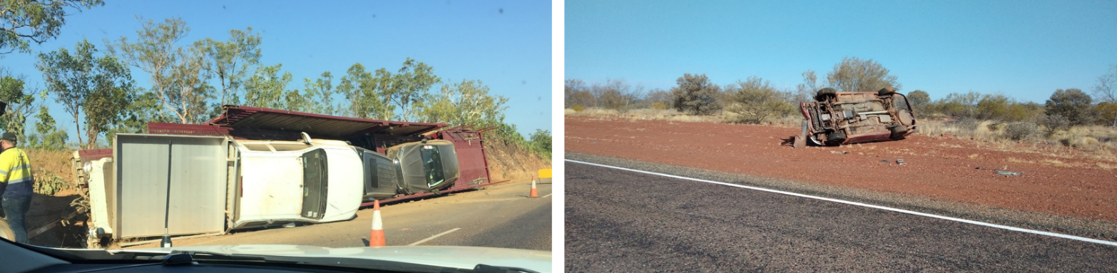
Person Conducting a Business or Undertaking
A PCBU has the primary duty (Section 19 of the Act) to ensure, so far as is reasonably practicable, workers and other persons are not exposed to health and safety risks arising from the business or undertaking. This includes ensuring, so far as is reasonably practicable:
- provision and maintenance of a work environment without risks to health and safety
- provision and maintenance of safe systems of work, and
- monitoring the health of workers and the conditions at the workplace for the purpose of preventing illness or injury of workers arising from the conduct of the business or undertaking.
The duty on the PCBU is not removed by a worker’s preference for certain shift patterns for social reasons, their willingness to work extra hours or to come to work when fatigued. The PCBU should adopt risk management strategies to manage the risks of fatigue in these circumstances.
A PCBU can be a:
- company
- unincorporated body or association
- sole trader or self-employed person, or
- individuals who form a partnership.

Officers
Officers such as company directors, must exercise due diligence (Section 27 of the Act) to ensure the business or undertaking complies with its work health and safety duties.
This includes taking reasonable steps to ensure the business or undertaking uses appropriate resources and processes to manage the risks associated with fatigue.

Workers
As stated earlier, non-work related factors can contribute to fatigue, so workers must take reasonable care for their own health and safety and must not adversely affect the health and safety of other persons (Section 28 of the Act).
Workers must also comply with any reasonable instruction and cooperate with any reasonable policy or procedure relating to fatigue at the workplace, such as policies on fitness for work. Workers should talk to their manager or supervisor to let them know when they are fatigued. Workers should also avoid undertaking safety critical tasks when they know it is likely they are fatigued.
For the purposes of this guide, the term ‘workers’ refers Heavy Vehicle Drivers, including Owners/Drivers.

Interstate fatigue management systems
With the exception of the Northern Territory and Western Australia, the HVNL, which regulate heavy vehicle fatigue management, have been adopted nationally.
If you operate across borders into other jurisdictions, excluding Western Australia, you must comply with both the work health and safety legislation in that jurisdiction, as well as the fatigue management requirements under the HVNL.
If you operate into Western Australia, you must comply with that state’s work health and safety specific fatigue management requirements, when you are in that state.
The Northern Territory does not impose additional work health and safety obligations to other jurisdictions in Australia. A system that appropriately manages driver fatigue and satisfies the requirements and duties under both road transport and work health and safety legislation in another state or territory can also be implemented for operations in the Northern Territory.
If you have decided to implement a fatigue management system that is compliant with Western Australia or the HVNL regulated states for your operations in the Northern Territory, you will most likely have an appropriate system in place for managing the risk of fatigue in the workplace that is in line with the information set out in this guide.
Developing fatigue management systems
You must have a fatigue management system for your operations in the Northern Territory and you must be able to monitor that fatigue management system for compliance.
To develop and implement a fatigue management system, you need to provide information, education and training to your workers in relation to fatigue risks, regularly consult with your workers and ensure that your fatigue management systems are addressing the risks.
In formulating a fatigue management system aimed at management of fatigue risks, you need to consider a whole range of factors, some of which are set out below:
- the purpose of having a fatigue management system for your business/organisation;
- understand the structure of your organisation and have detailed knowledge of the functions, aims, and activities of your business;
- an appropriate and accurate definition of “fatigue” as this forms an integral part of the management system;
- have in place a fatigue management policy;
- ensure the policy aligns with the needs of your business, work tasks and people;
- include a clear and accessible methodology as to how the management system is to be applied;
- ensure that responsibilities for implementing the fatigue management system, managing fatigue in the workplace monitoring and ensuring compliance with the fatigue management system are clearly defined and allocated to person/persons authorised and resourced to make the appropriate decisions;
- clear understanding of the driving hours and distances of the PCBU’s workers, required to meet the functions and objects of the business/organisation;
- workers who are responsible for the rostering and scheduling of driving duties are informed, trained and supervised as to what they have to take into account in preparing and allocating rosters and schedules;
- ensure that workers engaged to drive heavy vehicles as their main work duty are informed, trained, resourced and understand the effects of fatigue as a risk to their health and safety and the health and safety of others, and that they can recognise the signs indicative of fatigue;
- risk assessment checklist/risk management plan for fatigue;
- your workers’ driving hours, in particular if such driving hours become excessive due to external factors;
- rest hours available to your workers prior to and in the course of a lengthy period of driving heavy vehicles;
- the length and number of breaks available to your workers in the course of a lengthy period of driving heavy vehicles;
- ability of your workers to maintain communication with their supervisors, managers and the workplace or office generally throughout and at all times during a lengthy period of driving heavy vehicles, as well as how to mitigate the risks if they are out of communication range;
- other job tasks and roles’ potential impact on drivers fatigue, including consignors, consignees, loaders, persons responsible for scheduling and rosters, supervisors and managers;
- ensure workers engaged to drive heavy vehicles have regular medical health checks to assess and confirm their fitness to drive.
For more detailed information as to what should be included in a fatigue management system, please refer to the attached documents:
- Safety Fatigue Management System Plan – see attachment A;
- Risk management plan/process – see Attachment B;
- Example of Fatigue Management System Checklist – see Attachment C;
- Example of driving record to be completed and retained by PCBU – see Attachment D.

Matters for inclusion in fatigue management systems
While there are a wide range of factors that you may need to consider for formulating a fatigue management system that is suitable and appropriate having regard to your particular business and organisation needs and functions, it is recommended that you take the following matters into account when putting together a fatigue management system.
These recommended matters for inclusion are not exhaustive and additional items may need to be considered based on the nature, design, operational requirements of your particular business. However, your fatigue management systems should include:
- policy and objectives and related documentation
- practical operating procedures including
  - timeframes
  - information
  - training
  - participation, supervision
  - record keeping
  - reporting
- hazard identification, risk assessment and mitigation control procedures
- safety assurance and / or promotion procedures, and
- change management procedures
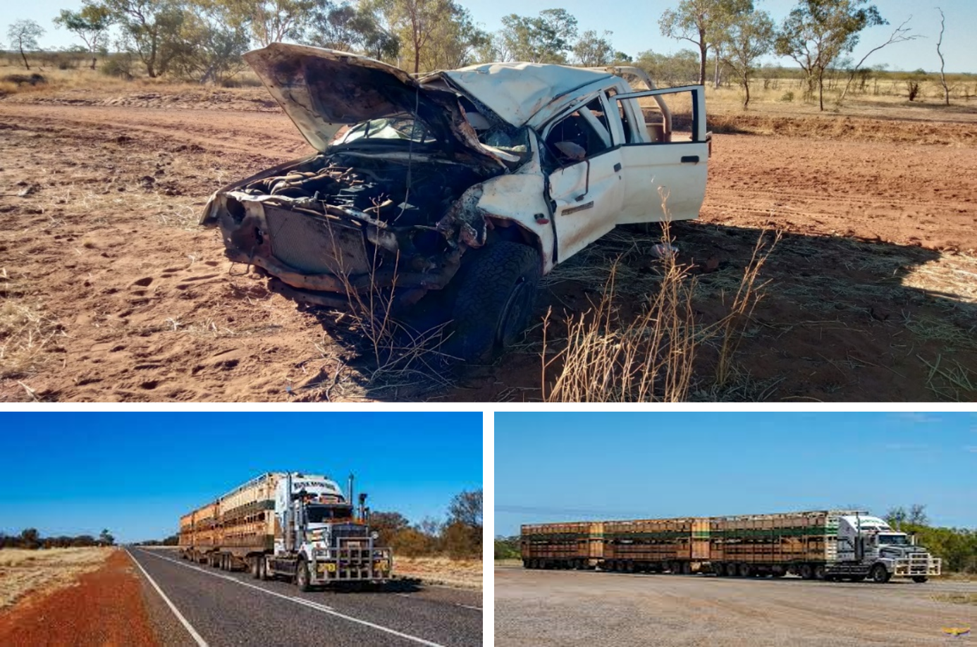
Do not become a statistic – make sure you reach your destination.
Recommended maximum work time
An important consideration in the management of fatigue for drivers of heavy vehicles is the overall length of time driving behind the wheel. There is little doubt that driving for long hours without regular breaks will lead to fatigue, notwithstanding other issues such as monotony, sufficient sleep compared to sleep debt and driver health may all have an effect on the onset and level of fatigue experienced by a driver.
It is important that drivers, at all times during a journey, carry out proper and ongoing evaluation of their journey, having regard to the prevailing conditions, the tasks involved and the driver’s circumstances. These factors will affect the rest periods required by the driver and will have an effect on the maximum hours that a driver should work on any day.
Maximum work time should therefore be observed during each and every episode of driving in the course of the driver’s journey, as this is a factor that is within the direct control of the driver.
The following work hours are the outer limits of driving work hours and minimum hours of rest, requiring robust fatigue management systems in place with continuous monitoring and compliance management systems in place to provide assurance of driver safety.
In circumstances where due to unforeseen circumstances, the maximum recommended work hours are exceeded, drivers must aim to rest for longer prior to resuming their work duties, reduce their sleep debt and mitigate their fatigue risk.
For the purpose of the recommended work time schedule below, please note:
Driving time refers to the time that a worker is engaged in the task of driving a heavy vehicle.
Break are breaks from the physical task of driving up to 30 minutes and can include checking of tyres, loading, unloading, refuelling, checking load restrains, toilet breaks and completing paperwork. Breaks of less than 30 minutes is still considered part of work time.
Work time includes driving, vehicle pre-starts, loading and unloading, checking the load and load restraints, refuelling, mechanical repairs or maintenance, completing paperwork, time spent operating plant that is integrated with the heavy vehicle (e.g. a crane), time spent operating plant that has been transported on the heavy vehicle (e.g. excavator), washing or cleaning the vehicle, and any other work tasks undertaken during the day, including such things as operating machinery or performing administrative tasks. Work time includes breaks of up to 30 minutes.
Non work time is considered to be breaks of at least 30 minutes spent on any activity that is outside the activities defined as work, including time spent napping in a parked vehicle, time away from the vehicle and any other activity that is not driving and not associated with driving. While naps can supplement sleep, they cannot replace restorative sleep. Naps of 15 to 20 minutes can in some instances improve alertness, communication and mood.
Discretion in observing recommended maximum work time
While the below sets out recommended maximum work times for drivers of heavy vehicles, adherence to these recommendations should be subject to a particular worker’s status and circumstances. If a worker/driver is experiencing signs of fatigue, they should immediately take steps to safely stop driving and rest. If experiencing fatigue regularly whilst driving, a worker/driver should discuss this with their employer. Employers should be supportive of a driver’s decision to stop working if fatigued, and work with their employee to identify and address why a fatigue event has occurred, or is regularly occurring. If possible, schedules should allow workers/drivers to work less and rest more, irrespective of the below recommendations.
Recommended maximum work time for one driver:
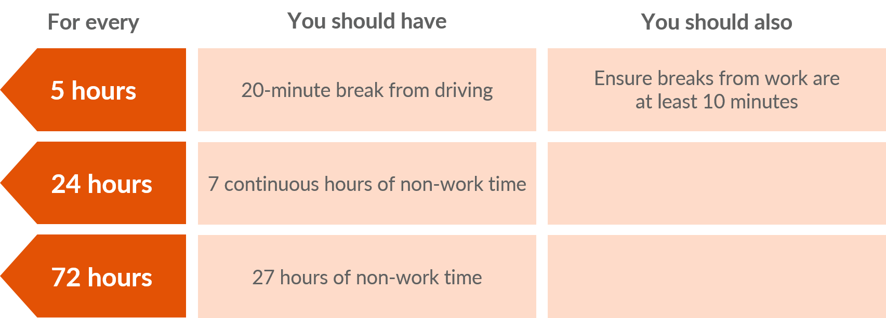
In addition to the above, one of the following options should be included:
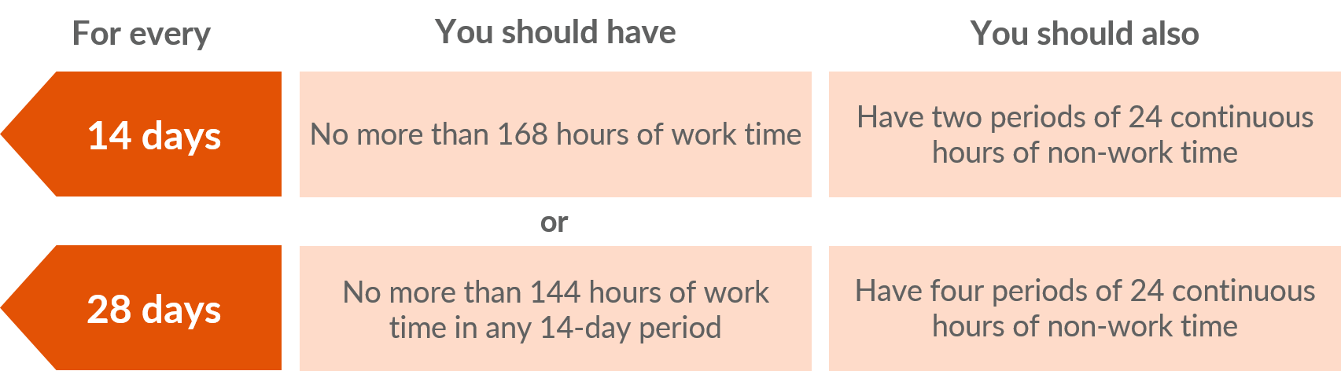
Recommended maximum work time for two-up driving:
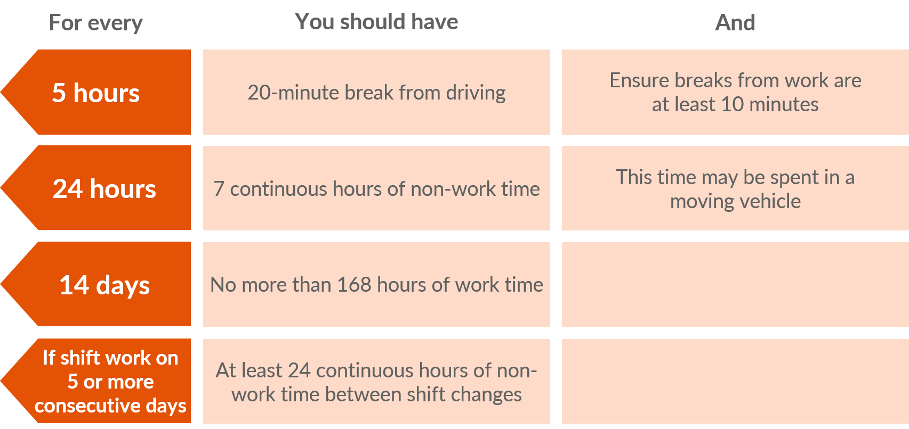
In addition to the above, one of the following options should be included:
Additional breaks should be taken and should be encouraged to be taken if and as required by drivers.
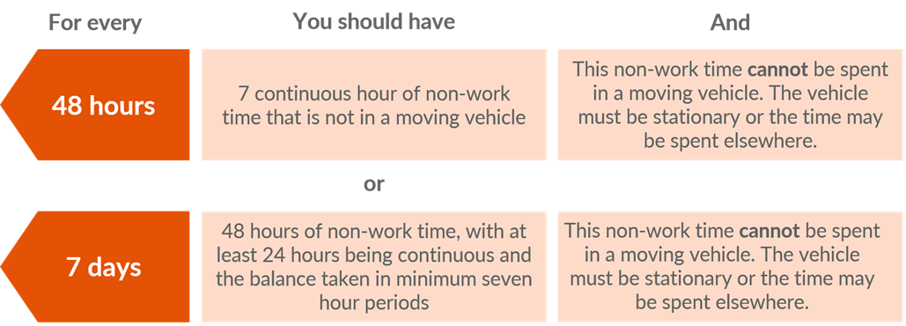

Additional considerations for fatigue management systems

Medical assessments
It is recommended that heavy vehicle drivers in the Northern Territory should be provided with a medical assessment for the purpose of assessing their fitness to drive for commercial and heavy vehicle operators. Regular medical assessments are useful as a fatigue risk management tool as each driver / worker are individuals who will have differing health status and requirements that may affect their ability to drive, as well as their response and tolerance of fatigue. (See Assessing Fitness to Driver (AFTD)).
The timing between medical assessments will depend on the individuals as well as the PCBU’s operational requirements, however, regular medical assessments are recommended, with a suggested time frame of every three to five years. Clearly, if a worker/driver has existing health issues, then more frequent medical assessments may be required.

Fatigue detection technology
Technology in vehicles to help manage the risk of fatigue is continuing to improve and is becoming more widespread. In particular, fatigue detection technology is becoming more common in commercial vehicles. Such technology may also assist in the management of the risk of fatigue for heavy vehicle drivers in this industry.

Records for fatigue management systems
The following records will assist you to formulate, implement and comply with your fatigue management system:
- safety plan checklist
- driving records
- time sheets
- medical records
- incident reports
- evidence of drivers experience, competence and qualifications, and
- records of health training and information provided to drivers.
Finally, for examples of Dos and Don’ts of fatigue management for heavy vehicle drivers, refer to Attachment G.
Attachment A

Sample Fatigue Management System Plan
The sample plan below is provided to assist PCBUs to develop an appropriate fatigue management system that is appropriate to their business or undertaking and their operational requirements. It can be used by any PCBU to assist them to develop a plan that will ensure that they are aware of the risk of fatigue to the health and safety to their workers in carrying out driving work. There are other fatigue management systems and plans available, the below is an example, there is no mandatory requirement to use this document.
Purpose
(PCBU name) aims to provide a safe and healthy working environment and safe systems of work.
This plan outlines the policies and procedures that are used by (PCBU name) to manage the risk of fatigue experienced by drivers of heavy vehicles in the Northern Territory.
This plan applies to all persons engaged by or working for (PCBU name).
This plan is based on recommended maximum driving hours (see related documents at paragraph 2).
1. Introduction
1.1 Location
Address |  |  |  |  | State |  | Postcode
Telephone |  |  |  |  | Email
Branches are located at
1.2 Organisational Structure
(PCBU name) is an |  |  | Describe type/size of PCBU organisation (e.g., private company, partnership, owner/driver)
2. Related Documents
NT WorkSafe Guide to Fatigue Management for Heavy Vehicle Drivers (“NT WorkSafe Guide”).
3. Definitions
Fatigue – a loss of alertness, which eventually ends in sleep. This loss of alertness is accompanied by poor judgement, slower reactions and decreased skill to events such as vehicle control.
4. Methodology
The use of a program of policies, staff induction, training, allocated responsibilities, effective scheduling and review at (PCBU name) will ensure that fatigue is adequately managed.
4.1.1 Fatigue Management Policy
Management of (PCBU name) is committed to providing a safe place of work for all employees. This is demonstrated, in part, by the implementation of this fatigue management system plan and in particular, by the signing of the Fatigue Management Policy.
To ensure compliance with this plan, management will ensure that regular risk assessments are undertaken of work scheduling. For regular or repeated trips, an initial risk assessment will be undertaken and regularly reviewed. A risk assessment will be undertaken for each irregular trip, or trip where some operating factor varies.
In addition, management will ensure that drivers complete records of work schedules and submit these records to schedulers. These records will be retained by management for a period of 5 years.
4.1.2 Responsibilities
For the purposes of managing fatigue in the workplace, the following responsibilities have been allocated.
4.1.3 Officer of the PCBU/Manager’
The Officer of the PCBU/Manager accepts responsibility for the implementation of this fatigue management policy.
4.1.4 Schedulers
Schedulers will ensure that consideration is given to the guidelines set out in NT WorkSafe Guide when rostering drivers in particular, factors set out in 4.2.2 below and/or the recommended maximum driving hours in the NT WorkSafe Guide.
4.1.5 Drivers
Drivers will ensure that they present themselves fit for work in accordance with the NT WorkSafe Guide and in particular the following:
- Drivers must present in a fit state free from alcohol and drugs;
- Drivers need to be rested prior to starting work;
- Drivers need to monitor their own performance, take regular periods of rest and avoid continuing work when tired.
4.2 Training
(PCBU name) is committed to ensuring that all drivers are competent to perform their tasks including:
- Fatigue management and health issues;
- Road rules and relevant legislation.
In addition, (PCBU name) will ensure that all drivers have an appropriate licence and a record of this will be kept on file for reference.
A record of individual driver training and competency will also be maintained.
4.2.1 Staff Induction
All staff are inducted in the implementation of this fatigue management policy and this will be done within 7 days of starting work. This will include being given a personal copy of this plan and being explained the contents by a member of management. The staff member, once they are sure they are fully familiar with the plan, will sign off and note the date they completed this task. This record will be kept on the staff member’s file.
4.2.2 Scheduling
(PCBU name) will ensure that all driver rosters are prepared having due regard to the NT WorkSafe Guide, in particular the recommended maximum work hours set out in the said Guide, as well as including consideration of the following:
- Driver to be given time to plan for long shifts;
- Unfamiliar or irregular work should be avoided;
- Consideration is given to increased risk factors between 1am and 6am;
- Flexible schedules allow drivers to take rests;
- When drivers return from leave, night time driving is minimised until drivers have adapted to long driving hours;
- Rosters are sympathetic to drivers rest habits and individual needs;
- Drivers should have at least two 24-hour periods of rest in every 14 days;
- Drivers need to take at least seven hours rest in any twenty four-hour period.
To assist in satisfying the above considerations, a risk assessment (see NT WorkSafe Guide Attachment C) will be carried out initially for regular trips, and for each new route/task or when an operating factor varies. Risk assessments for regular trips will be repeated as part of the review of this fatigue management system.
In addition, a record of driver’s daily work schedules will be completed by drivers and retained by management for a period of 5 years.
4.3 Health Assessments
(PCBU name) will ensure that drivers are fit and healthy for work by implementing the following:
- Drivers should undergo appropriate medical assessments as required under legislation or by management. Medical assessments are a legislative requirement for dangerous goods vehicle driver licences and commercial passenger vehicle driver licences.
- Lifestyle information/counselling is available to assist drivers presenting in a fit state and to promote health management.
- Drivers should be encouraged to have frank and open dialogue with their PCBU, managers, schedulers and other workers in relation to all matters that relate to and/or may affect the risk of fatigue, including (where appropriate) putting in place specific communications mechanisms or protocols for this purpose.
- Support services as well as any additional health assessments should be made to drivers who have been part of the first responder response/attendance at traumatic events.
4.4 Vehicle Standards
(PCBU name) will ensure vehicle standards are up to industry best practice standard and meet the general requirements of the NT WorkSafe Guide and in particular the following:
- Provide vehicles and other accommodation with appropriate facilities for rest. Schedulers must ensure that vehicles used for long haul trips have appropriate sleeping facilities in accordance with Australian Standards or that other appropriate accommodation is provided along the way;
- Provide air conditioned and heated vehicles where possible;
- Provide a working environment that meets Australian Standards for seating and sleeping accommodation.
4.5 Internal Review
An internal review is a check that ensures that the system outlined in this plan is operating as intended. A nominated person from (PCBU name) will conduct an internal review of the records in the following manner:
Initially, quarterly internal reviews are recommended;
Appropriate records must show the review process is being followed;
Copies of internal review reports and corrective action taken should be retained on file for a period not less than 5 years.
NOTE: These reviews are most important. If the need ever arises for the authorities to check your system, a record of regular internal reviews and any corrective action will show compliance with your system.

Attachment B

Example of fatigue management system checklist
Actions | Y / N | If Y, provide details on how, where, and / or when? If N, why not?
Fatigue Management Policy and System
Does PCBU have a fatigue management policy?
Has PCBU implemented a fatigue management system?
Are all PCBU’s staff inducted in the implementation and application of the fatigue management policy and fatigue management system?
Is PCBU’s fatigue management system provided to or readily available to all staff?
Is lifestyle information/counselling available to assist drivers to maintain an appropriate level of health and fitness that will facilitate their ability to work safely?
Persons responsible for scheduling and rosters
Have persons within PCBU responsible for preparation of driver rosters and trip schedules been advised and trained to prepare driver rosters and trip schedules pursuant to fatigue management policy?
Do persons within PCBU responsible for preparation of driver rosters and trip schedules undertake risk assessments on a regular basis to ensure rosters and trip schedules comply with fatigue management policy?
Do persons within PCBU responsible for preparation of driver rosters and trip schedules maintain a record of drivers’ working hours, duration of trips, meal and other breaks, and overnight stops?
Drivers
Are drivers aware that they must be fit for work before starting work by:
- presenting in a fit state free from alcohol and drugs;
- being rested prior to starting work;
- monitoring their own performance and take regular periods of rest to avoid working when tired.
Do drivers carry out regular risk assessments of their own fitness for work prior to starting work?
Are drivers given time to plan for long shifts?
Are drivers given clear instructions when unfamiliar work or irregular work hours are unavoidable (e.g. new destinations or carrying different loads)?
Are drivers given pre-employment and/or regular health assessments?
Drivers’ schedules / rosters
Is early morning driving avoided where possible taking into account the increased risk factors for driving between midnight and sunrise?
Is there adequate time allocated for sleep and rest during and following each trip?
Do drivers’ schedules/rosters take into account their need to take rests?
Where midnight to sunrise work exceeds two consecutive nights, are provisions made for the driver to recover sleep debt?
Heavy vehicles
Does PCBU and / or operator of vehicles follow a maintenance schedule for servicing vehicles?
Are vehicles used for long trips provided with appropriate sleeper cap or bunk? Or is other appropriate accommodation provided on long trips?
Are vehicles for long haul trips fitted with air conditioning and heating as appropriate?
Are vehicles for long haul trips through remote locations fitted with appropriate communication devices such as satellite phones to permit drivers to maintain contact with their supervisor and/or manager?
Review of fatigue management system
Is there a reporting mechanism for all staff and drivers to raise any incidents or concerns with their driving work and related fatigue issues?
Is there a routine procedure scheduled to review the fatigue management system to ensure it remains appropriate and is being implemented as intended?

Attachment C

Risk assessment process – fatigue
A risk assessment can assist in finding out:
- where, which and how many workers (including contractors and subcontractors) are likely to be at risk of becoming fatigued
- how often fatigue is likely to occur
- the degree of harm which may result from fatigue
- whether existing control measures are effective
- what action should be taken to control the risk of fatigue
- how urgently action to control the risk needs to be taken.
See Safe Work Australia’s Guide for Managing the Risk of Fatigue.
Sample Risk Assessment Guide – Fatigue Risk for Drivers of Heavy Vehicles
Consider the below factors in assessing the risks they may present in relation to driver fatigue with respect to each driving journey/trip. The list of relevant factors is not exhaustive and PCBUs may wish to add to them additional items which are particular to their business or undertaking.
No. | Relevant factor | Satisfactory / Unsatisfactory  (S/U) | Comment / Proposed Action
1 | Does driver have the appropriate licence?
2 | Are drivers given time to plan for the work schedule?
3 | Is driver sufficiently rested and fit for work?
4 | Are drivers returning from leave made aware of the risks of longer working hours?
5 | Is there adequate time allocated for sleep and rest following each trip?
6 | Has the driver been allocated at least 2 days off in the last 14 day period?
7 | Have appropriate rest periods been allocated in the last 14 days?
8 | Are drivers given clear instruction when unfamiliar work is to be undertaken (e.g., new destinations or carrying different loads)?
9 | Are minimum vehicle accommodation standards maintained?
10 | Is early morning driving avoided where possible in consideration of increased risk factors between midnight and sunrise?
11 | Do schedules take into account the need for drivers to take rests?
12 | Where midnight to sunrise work exceeds two consecutive nights, are provisions made for the driver to recover sleep debt?
This risk assessment is undertaken by:

……………………………………………………….. ………………………………………………………… …………………………………….
Name Signature Date
Driver Participation: Yes No

……………………………………………………….. ………………………………………………………… …………………………………….
Name Signature Date
Verified (Manager, Supervisor, etc., if applicable):

……………………………………………………….. ………………………………………………………… …………………………………….
Name Signature Date

Attachment D
Example of driving record to be completed and retained by PCBU
Driver name: |  | Driver Licence Number: | State/Territory of licence:
Driver contact details: |  | Record location/Base: | Week ending:
Date  Click or tap to enter a date.  Registration No. | Start Time  Resting from Work to  Resting from Work to  Resting from Work to  Finished Work |  |  | Daily Total  Work:  Rest:
Date  Click or tap to enter a date.  Registration No. | Start Time  Resting from Work to  Resting from Work to  Resting from Work to  Finished Work |  |  | Daily Total  Work:  Rest:
Date  Click or tap to enter a date.  Registration No. | Start Time  Resting from Work to  Resting from Work to  Resting from Work to  Finished Work |  |  | Daily Total  Work:  Rest:
Date  Click or tap to enter a date.  Registration No. | Start Time  Resting from Work to  Resting from Work to  Resting from Work to  Finished Work |  |  | Daily Total  Work:  Rest:
Date  Click or tap to enter a date.  Registration No. | Start Time  Resting from Work to  Resting from Work to  Resting from Work to  Finished Work |  |  | Daily Total  Work:  Rest:
Date  Click or tap to enter a date.  Registration No. | Start Time  Resting from Work to  Resting from Work to  Resting from Work to  Finished Work |  |  | Daily Total  Work:  Rest:

Attachment E

Recognising when fatigue sets in –common warning signs of fatigue
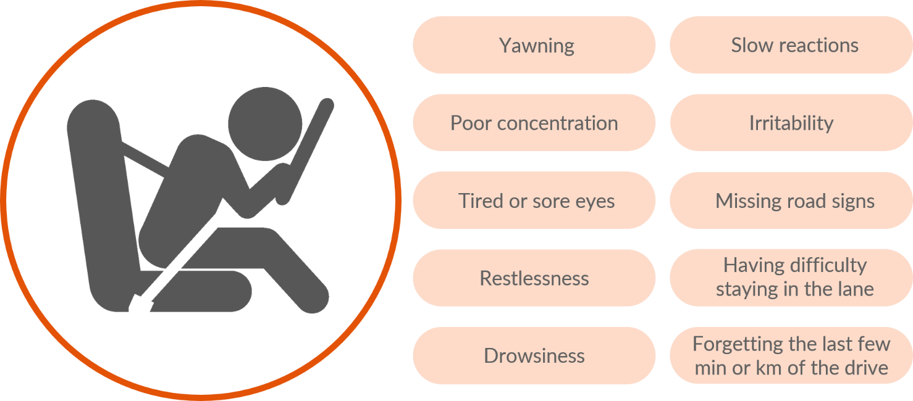

Attachment F

Common fatigue related risks
Work related risks | Non work-related risks
Over scheduling a driver for shift that exceeds the allowable work time based on work and rest hour options under fatigue management policy. | Drivers not being able to recognise and act on their fatigue warning signs.
Allocating driving timeslots that cannot be met without a driver skipping a rest break. | Drivers starting a shift already fatigued from factors in their personal life such as a new baby or excessive social activities.
Scheduling / rostering drivers to work combinations of day shifts and night shifts. | Drivers repeatedly not getting enough good quality sleep between shifts leading to accumulated sleep debt.
Loaders experiencing delays in vehicle loading which impact drivers’ work time. | Driver with poor health habits such as excessive smoking, drinking, and use of caffeine.
Consignors demanding unachievable delivery times. | Drivers with un-diagnosed or un-reported medical conditions that cause fatigue such as insomnia.
Transport PCBU not providing appropriate facilities to enable drivers to rest.
Transport PCBU payment schemes that incentivise drivers to skip rest breaks.

Attachment G

Examples of Dos and Don’ts of fatigue management for heavy vehicle drivers
If you are a heavy vehicle worker driving either a long distance or driving for an extended shift:
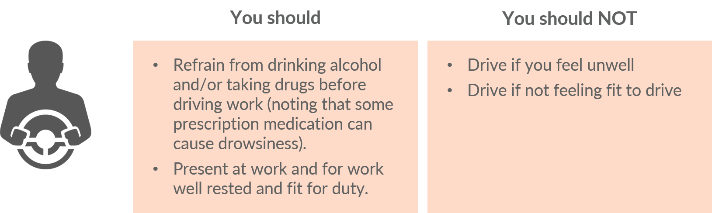
If you are a person in control of a business or undertaking:
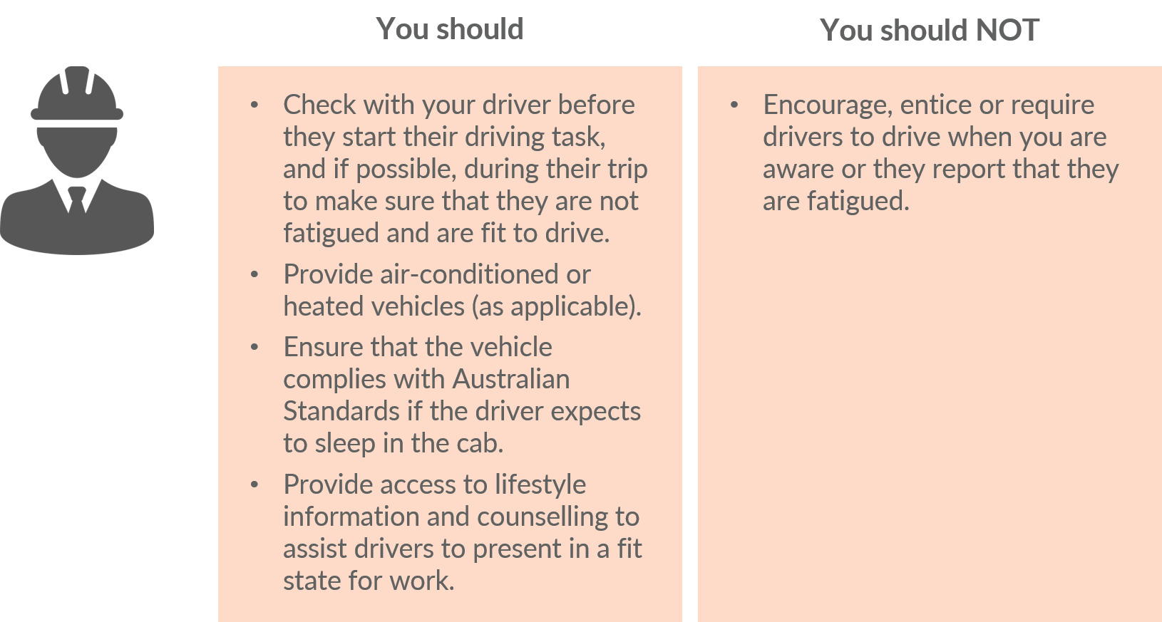
If you are responsible for scheduling:
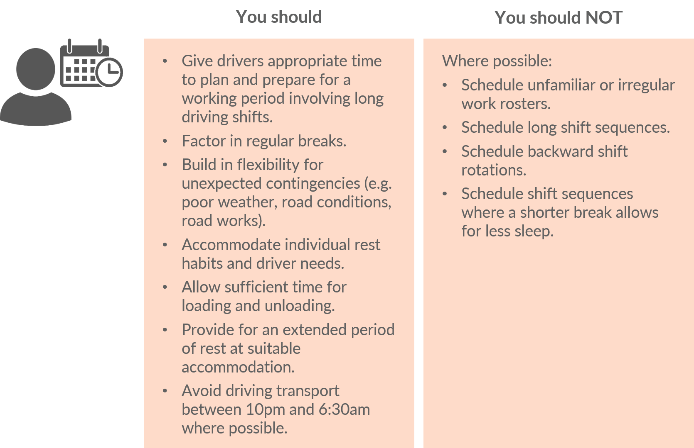
If you are responsible for rostering:
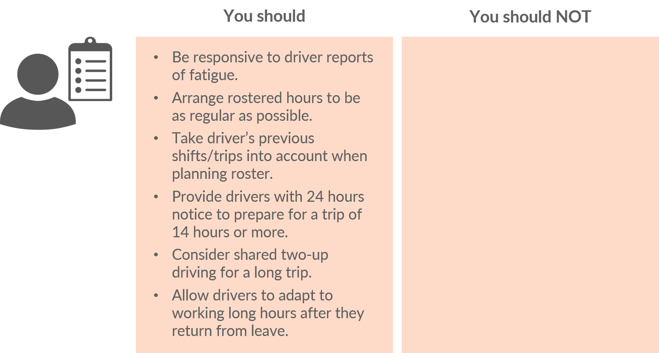

Lengthy period of driving means driving over a period of consecutive days and includes driving for more than usual work hours per day and / or driving outside the usual business hours on any day.

